2014-2018

Prepared by
Ashley A. Dayer, Ph.D., Private Consultant
www.ashleydayer.com
183 Breed Road * Locke, NY 13092 dayer@post.harvard.edu * 541-324-0281

Strategic Communications Plan

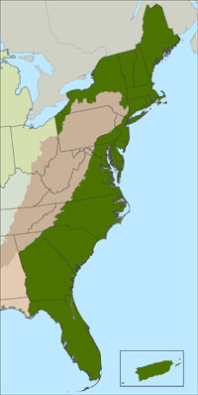
The mission of the Atlantic Coast Joint Venture to provide a forum for federal, state, regional and local partners to coordinate and improve the effectiveness of bird habitat conservation planning, delivery and evaluation in the Atlantic Flyway. ACJV focuses on the Atlantic Flyway of the United States from Maine south to Puerto Rico, including 18 states and commonwealths (see map to right). The JV’s total area is 283 million acres, which is 12% of the total area of the United States. It is the most densely populated region in the United States with a total of over 105 million people living in the area.
For more information: www.acjv.org

Five-Year Strategic Communications Plan
This Strategic Communications Plan is designed to help promote, coordinate and deliver bird habitat conservation that is founded on Strategic Habitat Conservation (SHC) principles. The plan will guide ACJV’s efforts to implement innovative and targeted communications campaigns over the next five years. It will advance the ACJV’s efforts to build public and private partnerships for bird conservation by outlining the core components of effective communications campaigns and providing a path for implementation. Furthermore, the plan will foster the Joint Venture’s achievement of technical expectations content outlined in the “Desired Characteristics for Habitat Joint Venture Partnerships” for Communications, Education, and Outreach (see Appendix A).
Recommended Citation
Dayer, A.A. (2014). Atlantic Coast Joint Venture Strategic Communications Plan 2014-2018. Communications Report 2014-01. Locke, NY.

Summary of the Strategic Communications Plan

Following a strategic communications planning approach, the ACJV has developed a Strategic Communications Plan for 2014-2018. This plan will guide the communications efforts of the ACJV staff, in collaboration with the ACJV Technical Committee, Management Board, and other partners.

The plan was informed by a discovery phase, assessing the state of ACJV communications; a needs assessment, where the Management Board and staff brainstormed opportunities for communications; and an audience assessment, which involved an online request for partner feedback.

Based on the information gathered, communications campaigns were designed. For each goal, audiences, communications objectives, messages, and tactics and tools were defined. Evaluation metrics were then determined for each of the primary tools.

Six communication goals are highlighted for the ACJV that form the basis for communications campaigns.
- Develop and strengthen the JV partnership to conserve high-priority habitats throughout the Atlantic Coast region
- Garner federal support for conservation that benefits the Atlantic Coast region
- Foster partner involvement in ACJV science activities
- Foster partner involvement in ACJV planning activities
- Support habitat delivery based on bird conservation plans and tools for the Atlantic Coast region
- Conserve wetland (and associated upland) habitats in the Atlantic Coast region via federal habitat grant programs

Audiences are identified as those whose actions will influence achievement of a goal. These audiences are primarily partner groups and require two-way communication efforts. Twenty-one audiences were prioritized for communications efforts, including the Management Board, Technical Committee, Flyway Council, Bird Conservation Region partners, Division of Migratory Birds (Region 5) staff, Department of Interior and US Fish and Wildlife Service leaders, Congress, the Office of Management and Budget, the US Forest Service, Natural Resources Conservation Service, state fish and wildlife agencies, US Fish and Wildlife Service staff in Refuges, Ecological Services, and Partners for Fish and Wildlife, Landscape Conservation Cooperatives, Ducks Unlimited, Audubon, American Bird Conservancy, The Nature Conservancy, land trusts, universities, bird hunters, and bird watchers.

Communications objectives are provided for each of the goals. The table below displays the behavioral objectives for each goal. In order to achieve behavioral objectives, knowledge, attitudes, and skills objectives must be achieved.

Goal | Primary audiences | Behavioral Objectives
Goal 1. Develop and strengthen the JV partnership to conserve high-priority habitats throughout the Atlantic Coast region | -Management Board  -Tech Committee  -BCR partners | 1.1 Actively participates in Board & Tech and in JV committees & activities  1.2 Shares information about the JV within the organization/agency  1.3 Considers other partners who would be beneficial for Board and Tech Committee  1.4 Pools their resources to fulfill unmet needs for JV work (needs Board discussion)  1.5 Consider themselves partners in bird conservation with ACJV
 | -those uninvolved in JV-related organization/agency | 1.5 Consider themselves partners in bird conservation with ACJV
Goal 2. Garner federal support for conservation that benefits the Atlantic Coast region | -Congress  -DOI/FWS leaders  -OMB | 2.1 Support for Interior appropriations bill with JV, NAWCA, coastal grants, and Neotrop funding at agreed upon level
 | -(Non-federal) Management Board members | 2.2 Actively participate in Congressional outreach
Goal 3. Foster partner involvement in ACJV science activities | -Tech Committee  -LCCs  -USFWS | 3.1. Develop population & habitat objectives for representative species in all ACJV BCRs  3.2 Provide feedback and contribute to searching for the Science Needs process
 | -DOI/FWS leadership | 3.3 Support JV’s continued role in science  3.4 Contribute to JV science as collaborators and funders  3.5 Utilize science products to make decisions
Goal 4. Foster partner involvement in ACJV planning activities | - -Tech Comm.  - - Division of MB  - -BCR partners  -Universities | 4.1 Complete and update BCR plans throughout the Atlantic Coast region
Goal 5. Support habitat delivery based on bird conservation plans and tools for the Atlantic Coast region | -USFWS  -State agencies  -BCR partners  -ABC  -Audubon | 5.1 Participate in implementation of the Atlantic Flyway Shorebird Conservation Business Strategy in the Atlantic Coast region
 | -Tech Comm  -BCR partners  -State agencies | 5.2 Use the “Designing Sustainable Landscapes” decision support tool for conservation
 | -BCR partners  -State agencies  -USFWS | 5.3 Use the Integrated Waterbird Management & Monitoring (IWMM) results to guide wetland  5.4 Use BCR plans to guide conservation/Prioritize areas and species.

These communications objectives are written simply and can be applied to serve as the basis for messaging. Additionally, several primary messages are provided for each goal (see table below).

Goals | Overarching Messages
Goal 1. Develop and strengthen the JV partnership to conserve high-priority habitats throughout the Atlantic Coast region | - You, the partners, are the Atlantic Coast Joint Venture (ACJV).  - ACJV is only as successful in bird conservation as partners are engaged and successful.  - A strong ACJV partnership will benefit all partners and bird and habitat conservation in our region.  - The strength of the ACJV partnership comes from the active participation in the Management Board, Technical Committee, and projects throughout the flyway.  - The ACJV has 25 years of demonstrated success through partnership activities.  - Active participation of all partners in the ACJV planning, science, and delivery activities will ensure we have shared goals moving forward, which is essential for conservation in the Atlantic Flyway.
Goal 2. Garner federal support for conservation that benefits the Atlantic Coast region | - Federal conservation programs and policies benefit bird conservation and people in the Atlantic Flyway.  - JVs are one of the most efficient federal programs when it comes to results relative to funding. Over their more than 25-year history these public-private partnerships leveraged every dollar of Congressional funds 36:1, helping to conserve 20.5 million acres of habitat.  - Each federal conservation program addresses a distinct (and complementary) component of conservation needs in the region.  - Conservation programs in the ACJV are critical to address challenges, particularly due to coastal development and sea level rise.  - These programs support ACJV partner projects to sustain a safe and resilient coastal area for people and wildlife.
Goal 3. Foster partner involvement in ACJV science activities | - ACJV science needs and activities are driven by the partners involved in the Technical Committee.  - Members of the Technical Committee are critical participants in addressing science needs and setting population and habitat objectives of the JV.  - One of the key outcomes of JV science is population and habitat objectives, which can help guide conservation activities.
Goal 4. Foster partner involvement in ACJV planning activities | - Bird Conservation Region Plans distill all existing relevant information and make it available at a usable scale.  - BCR plans are available for nearly all of the JV region.  - It is essential to update older BCR Plans to incorporate the latest science information and your expertise.  - Partner involvement is key to BCR planning efforts.
Goal 5. Support habitat delivery based on bird conservation plans and tools for the Atlantic Coast region | - Conservation plans and tools are available to aid in conservation activities and management in the region.  - The Atlantic Flyway Shorebird Conservation Business Strategy defines priority species, areas, and strategies for land management activities on ACJV partner lands.  - The Integrated Waterbird Monitoring and Management will help us prioritize areas of the Atlantic Flyway for over-wintering and migrating wetland birds.  - The BCR Plans step-down continental bird conservation plans and help prioritize focal areas for conservation in each BCR.  - The Designing Sustainable Landscapes tool helps prioritize areas for conservation along the Atlantic Coast.
Goal 6. Conserve wetland (and associated upland) habitats in the Atlantic Coast region via federal habitat grant programs | - ACJV partners have been leaders in obtaining federal dollars to conserve wetlands and associated upland habitats.  - ACJV staff can offer support to strengthen partner grant applications.  - Through the ACJV partnership, organizations can connect with collaborators to build strong grant project proposals with high match ratios.

Tactics and tools are recommended for each of the goals and their associated communications objectives and audiences. The tactics and tools span a variety of approaches to engaging audiences, including educational (webinars, tours/demos, one-on-one), informational (website, enewsletter, elevator talk/talking points, introductory packet about ACJV, factsheets, year-end report, press releases/media relations), promotional (direct emailing), social media (Facebook), and organizational (establish committees, teleconferences, web/video conferences). Recommendations for how to design and deliver the tactics and tools, as well as a timeline for working on them, are provided. The primary implementer of this plan will be the ACJV’s ½ time Communications and Outreach Coordinator. Given the extent of communications needs, JV staff and partners will also need to contribute to communications efforts.

Evaluation allows for determination of whether communications objectives have been met and offers feedback for adapting further communications to be more effective. The evaluation metrics and tools are outlined and should be developed in concert with the communications tactics and tools.

Table of Contents
Summary of the Strategic Communications Plan iii
Introduction 2
Background to Strategic Communications 2
Capacity Building & Engagement Approach 3
State of ACJV Communications Prior to the Plan 3
Needs Assessment for Defining 5-Year Goals 4
Nominal Group: Opportunities for ACJV Communications 4
Audience Assessments 6
Communications Campaigns 9
Goals 9
Audiences 9
Communications Objectives & Messages 11
Tactics & Tools 24
Timeline 29
Evaluation 30
Resources 32
Appendix A. ACJV’s Status on the Desired Characteristics of JV Matrix for Communications, Education, and Outreach. 33

Introduction

Background to Strategic Communications
Communications is a process of idea exchange and imparting information. In effective communications, others understand you and you understand others in return. The audience is defined as the receiver of the message a source wishes to communicate. Yet, the audience also becomes a source of messages back to the original source. Adapting to the feedback from an audience greatly improves communications efforts.

Communications plays a key role in the Strategic Habitat Conservation (SHC) approach, which guides the work of Joint Ventures. This adaptive management approach includes biological planning, conservation design, conservation delivery, and monitoring and research. Communications can be considered a part of the conservation delivery activities of SHC. Further, the strategic communications approach itself can be thought of as following a similar process to SHC with the phases of communications planning, communications design, communications delivery, and evaluation.

Strategic communication integrates communication efforts with all of the work of the Joint Venture. In Strategic Communications, the planning process allows for prioritization of biological (or overall) objectives of the Joint Venture that should be addressed through communications efforts. Identification of the key audience(s) necessary to address the overall objective of the Joint Venture then allows for development of the communications goals and objectives. Developing appropriate communications objectives by audience often involves extensive audience assessment in order to fully understand the audience and the most effective means to communicate with them. These communications objectives lay the foundation for the messages of the communications campaign, as well as the tactics and tools, which together compose the communications design phase. The communications delivery involves the implementation of the tactics and tools, through the appropriate channel to the target audience. Evaluation is the monitoring phase for the communications campaign, providing information on results and how the effort might be improved, which adaptively feeds back into communications planning.
Figure 1: Strategic Communications. Adapted from Bogart, Duberstein, & Slobe (2009)

Communications
Planning
Evaluation
Communications
Design
Communications
Delivery

Capacity Building & Engagement Approach
The strategic communications approach employed for this plan’s development emphasized engagement and participation of staff and key stakeholders. In line with the Joint Venture’s culture of partner collaboration, the Management Board, staff, and other partners played a critical role in developing the plan. They attended workshops, participated in teleconferences and web-conferences, provided feedback as part of the audience assessment, and reviewed drafts of the communications plan and its components. This “engagement” approach not only ensures a more relevant and useful communications plan, but also builds the communications and strategic planning capacity of the Joint Venture, and the communication skills of board, staff and partners.

State of ACJV Communications Prior to the Plan
Since 2005, the JV’s communication activities have been led by the ACJV Outreach Coordinator. The primary ACJV communications tools include a website, e-newsletter, brochure, state-specific factsheets, and Facebook. Additional factsheets and documents are created on a project-specific basis. Primary audiences include USFWS staff and leadership, the Management Board, the Technical Committee, North American Wetland Conservation Act (NAWCA) grant recipients and potential recipients, Congressional staffers, conservation initiative/project collaborators, and other partners.
The JV’s website is very extensive and informative, including one of the most comprehensive lists available online of bird conservation plans and resources. While the website was most recently re-designed in 2006 using Dreamweaver, there are now even more user-friendly ways to present such information (e.g., Resource Directories) and interact with users (e.g., sign-up’s for the newsletter).
The e-newsletter is sent out 3-4 times per year. In recent years the e-newsletter was sent to 500-600 recipients, who are primarily USFWS staff, JV Management Board, JV Technical Committee, NAWCA recipients, Congressional staffers, and other partners. In 2013 the list was updated and grown to 1027 recipients.
The brochure and state-specific factsheets are attractive with compelling images, graphics, and statistics. These tools are primarily used for Congressional outreach. Secondarily, they are provided to new and potential partners and used for internal USFWS outreach.

Needs Assessment for Defining 5-Year Goals
The staff considered the communications planning process an opportunity to re-assess their communications approach, thinking through whether the JV is communicating with its key audiences, using the most effective tools, and making as much progress towards priorities through communications as possible. They recognized that the planning process may result in changing the course of how communications is conducted by the JV.
The staff members were interested in the communications plan being closely tied to ACJV’s Workplan, which ties to the JV’s Biological Priorities and Strategic Plan, which guide the work of the staff and partners. Most of the activities in the workplan have communications components; in some cases they are stated and in other cases they are implied or may need articulation.
The current short-term priorities for ACJV staff are described as:
- Conserve wetland (and associated upland) habitats via federal habitat grant programs
- Support the Atlantic Flyway Shorebird Business Strategy
- Develop/promote products of the Southeast “Designing Sustainable Landscapes” project
- Complete/update bird conservation region (BCR) plans throughout the ACJV
- Develop/support partnerships to conserve high-priority habitats in each BCR
- Coordinate Technical Committee(s) input into ACJV science activities
- Implement the Integrated Waterbird Management & Monitoring (IWMM) project
- Develop population & habitat objectives for representative species in all ACJV BCRs
- Develop ACJV Strategic Communications Plan

Nominal Group: Opportunities for ACJV Communications
To initiate communications planning, a workshop with Management Board members and staff was hosted in July 2013 in Mystic, Connecticut. The purpose of the workshop was to define communication opportunities, needs, and goals. The outcome of the workshop was a needs assessment to serve as a foundation to the development of the Strategic Communications Plan.
The workshop began with a nominal group process to define the opportunities for JV communications that are most important to take advantage of with the communication plan. A nominal group is a decision-making technique for groups that takes everyone’s ideas into consideration and also allows for efficient decisions on priorities through a vote. The nominal process focused on the question of “What are the opportunities for communications for the ACJV?” The participants brainstormed brief responses to this question on their own and then shared them with the group to develop a complete list. The group then discussed the list to ensure there were no duplicates and everyone understood each item’s meaning. In total 84 opportunities were identified and discussed. The list was reduced to 75 opportunities by removing or combining those that were redundant. The opportunities were then ranked by the participants on an individual basis. Each participant was allowed six points total for his or her ranking of the top three priorities (number of points being 3, 2, and 1 to their top three priorities).
Table 1. Number of prioritization points given for opportunities for JV Communications efforts 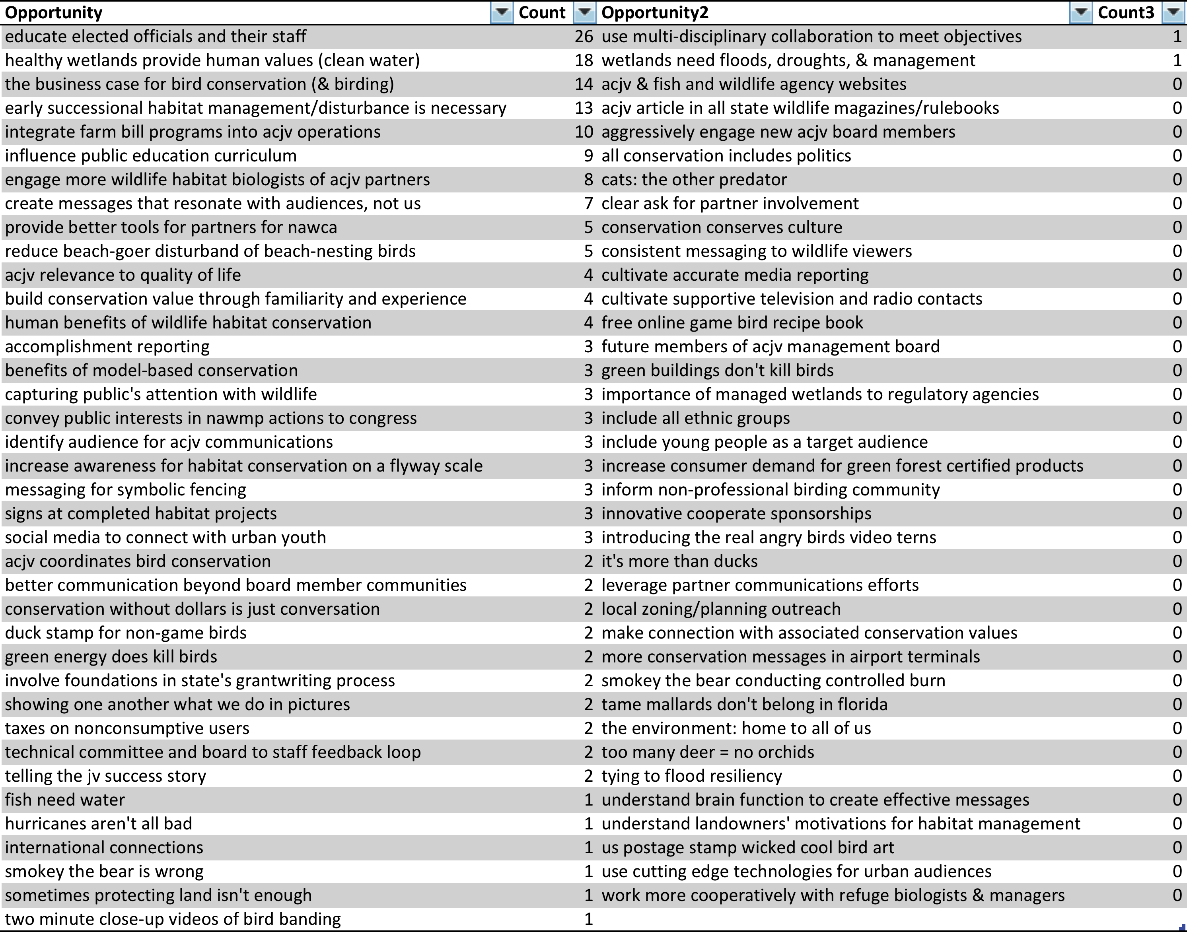
Forty of the 75 items were ranked by at least one person, as shown in Table 1. The two most prioritized items were “educate elected officials and their staff” and “healthy wetlands provide human values (clean water)”. These items were used to inform the subsequent sections of the Communications Plan (e.g., the first two items are linked closely to two of the goals that guide communications).

Goals
Next at the workshop, the overall Joint Venture goals to be addressed through communications were confirmed. Prior to the workshop, Ashley Dayer reviewed the Joint Venture’s guidance documents. From these documents, she compiled a goals list for the Joint Venture. The Needs Assessment participants reviewed the list, and the goals were edited.
- Develop and strengthen the JV partnership to conserve high-priority habitats throughout the Atlantic Coast region
- Garner federal support for conservation that benefits the Atlantic Coast region
- Foster partner involvement in ACJV science activities
- Foster partner involvement in ACJV planning activities
- Support habitat delivery based on bird conservation plans and tools for the Atlantic Coast region
- Conserve wetland (and associated upland) habitats in the Atlantic Coast region via federal habitat grant programs

Communications Working Group
After the workshop, from August 2013 through April 2014, a Communications Working Group guided the creation of the remaining components of the Communications Plan. The Working Group was led by Ashley Dayer with Management Board members Gary Casabona (Natural Resources Conservation Service), Dan Forster (Georgia Department of Natural Resources), Margaret Griep (USDA Forest Service), Rick Jacobson (Rhode Island Division of Fish and Wildlife), and Bernie Marczyk (Ducks Unlimited), as well as staff members Mitch Hartley (ACJV Coordinator) and Debra Reynolds (ACJV Communications and Outreach Coordinator). Through phone and web meetings they determined audiences, reviewed the results of the audience assessment, articulated communications objectives, crafted messages, discussed what communications tools will be created, and determined how communications efforts will be evaluated. Additionally, the working group prioritized communications efforts and determined how to ensure adequate capacity.

Audience Assessments
Following the workshop, members of the Communications Working Group then listed audiences that would influence (or be able to take action to aid in) the accomplishment of each of these goals. Nineteen audiences were identified in total. Most of these audiences were partner organizations that were already part of an ACJV partner email list. In order to better understand their communications needs, we conducted an Audience Assessment by requesting feedback via email. Twenty-six questions were asked, regarding partner involvement with the ACJV, preferences for communications methods, the quality of the current ACJV communications, and characteristics of the partners.
Table 2. Questions for partner feedback
- In what ways are you currently involved with the ACJV?
- How long (in years) have you been involved with the ACJV?
- Compared to other partnerships or initiatives you are involved in, how would you compare your engagement with ACJV?
- Why are you involved (or would you be interested in being involved) with the ACJV partnership?
- What limits the extent to which you are able to be involved with the ACJV?
- How important do you find each of the following methods of communications for staying connected with the ACJV?
- In expanding communications in the future, which new methods would you be interested in the ACJV using to stay connected with you?
- How often do you access the ACJV website?
- How would you rate the usefulness of the ACJV website?
- What could be done to improve the website?
- How closely do you typically read the ACJV e-newsletter?
- How would you rate the usefulness of the ACJV e-newsletter?
- We currently send out our e-newsletter three times per year and include 3-6 articles in it, as well as grants and meeting information. We are considering shortening our e-newsletter and sending it more frequently. What do you think about the frequency and length of the e-e-newsletter?
- What could be done to improve the e-newsletter?
- About how often do you access the ACJV Facebook page or read ACJV posts in your news feed?
- Why don't you access the ACJV Facebook page or read posts in the news feed?
- How would you rate the usefulness of the ACJV Facebook page and posts?
- What type of content do you like to see from the ACJV on Facebook?
- What could be done to improve the ACJV Facebook page?
- How much of interest is each of the following types of information to you?
- What state(s) and/or US territories do you work in?
- What is your affiliation?
- How important are each of the following types of conservation to your organization/agency's mission?
- What percentage of your work focuses on birds and/or bird habitat?
- Which groups of birds you work with?
- Which ecosystems/habitats do you work in?

Results
Nearly 300 partners responded to the request for feedback, providing a wealth of valuable information. The partners represented all 18 states and U.S. territories in the ACJV, as well as all of the types of partner organizations and agencies. These partners have been involved in the ACJV from less than 1 year to 25 years, with the average being 8.8 years.
Partners work on all types of conservation, including bird conservation, wildlife management and conservation, habitat conservation, public lands conservation, and private lands conservation. For more than half of the partners, birds and bird habitat are the focus of the majority of their work. The partners work with all groups of birds, with the most working with landbirds and the least working with upland game birds. The partners also work in a variety of habitats with the most working in wetlands and forests and the least working in coastal systems.
Compared to other partnerships or initiatives, most partners reported that they are just as engaged or less engaged with ACJV. The most important benefit of the ACJV partnership to the partners is that it puts partners’ work in the context of continental, national, and regional bird conservation, followed closely by the benefit of providing access to technical resources and expertise, providing an avenue to put science findings in the hands of conservation professionals, and presenting opportunities to have a shared voice for conservation.
Time is the greatest limitation for partners’ involvement, followed by two limitations that the JV’s future communications can aim to overcome: partners don’t know how to be involved or feel they haven’t been asked to be involved.
The most important communications methods for ensuring partners stay connected with the ACJV are email, e-newsletter, and the website. The majority of the partners rated the website as useful, offering various ideas for ways to improve it. These ideas included updating the state pages and JV activities, providing more links (e.g., to the Flyways), providing information about climate change, and including more on habitat and population objectives. There were also suggestions given about making the website less text-heavy and more dynamic, including partner contributions and live feeds from other web sources.
The majority of the partners also rated the e-newsletter as useful and reported that they read at least some of the articles in the e-newsletter closely. When asked, partners agreed that they would still be satisfied with the e-newsletter if it were shortened and sent out more frequently. They also provided some additional suggestions on how to improve the e-newsletter, such as incorporating more from partners on joint accomplishments, more on Technical Committee efforts, and more on results of habitat work.
Very few of the partners reported that they access the ACJV Facebook page or read ACJV Facebook posts. The primary barrier to their use of the ACJV Facebook page is that they do not use Facebook at all, followed by them not knowing ACJV has a Facebook page. The latter could be addressed by communications. For those who do use the Facebook page, they are most interested in seeing bird conservation information, followed by updates from the JV staff and partners. They provided suggestions for improvement, including offering success stories of ACJV partners, announcements, and press releases.

For future communications, partners would be most interested in seeing more factsheets, web/video meetings, and tours and demonstrations. Habitat conservation information is most of interest to ACJV partners, followed by partner science, partner successes, regional partner news, and JV staff or Tech Committee science.
This feedback is considered in the subsequent sections of the Communications Plan, especially in defining messages, communications tools, and suggestions for the communications tools.
Congress as an audience. Guidance for Congress as an audience was gathered separately from the partner feedback. We discussed the ACJV’s Congressional communications approach with a USFWS staff person for Congressional Affairs. Based on that conversation, we recommend that the ACJV take a more focused approach with Congressional communications, meeting with 6-8 key Congressional members each year and building relationships through regular communications with them. The ACJV should also consider visiting Congressional staff at their state or local offices and inviting them out in the field to visit key JV partner project sites. When providing communications materials, it may be worthwhile to use more web-based approaches rather than traditional factsheets. The ACJV should also coordinate their Congressional communications activities with the USFWS Regional Congressional affairs staff as well as partners.

Communications Campaigns
Communications campaigns were designed, building on the information gleaned from the Needs Assessment and Audience Assessment. For each goal, audiences, communications objectives, messages, and tactics and tools were defined. Evaluation metrics were then determined for each of the primary tools.

Goals
- Develop and strengthen the JV partnership to conserve high-priority habitats throughout the Atlantic Coast region
- Garner federal support for conservation that benefits the Atlantic Coast region
- Foster partner involvement in ACJV science activities
- Foster partner involvement in ACJV planning activities
- Support habitat delivery based on bird conservation plans and tools for the Atlantic Coast region
- Conserve wetland (and associated upland) habitats in the Atlantic Coast region via federal habitat grant programs

Audiences
Audiences for ACJV communications are defined as those with influence over the goals for communications. Nineteen audiences were identified as influencing the ACJV goals (Table 3). It should be noted that certain organizations within an audience group or certain individuals within an organization may vary greatly in influence over the accomplishment of ACJV goals.
Table 3. Audiences for each of the goals.
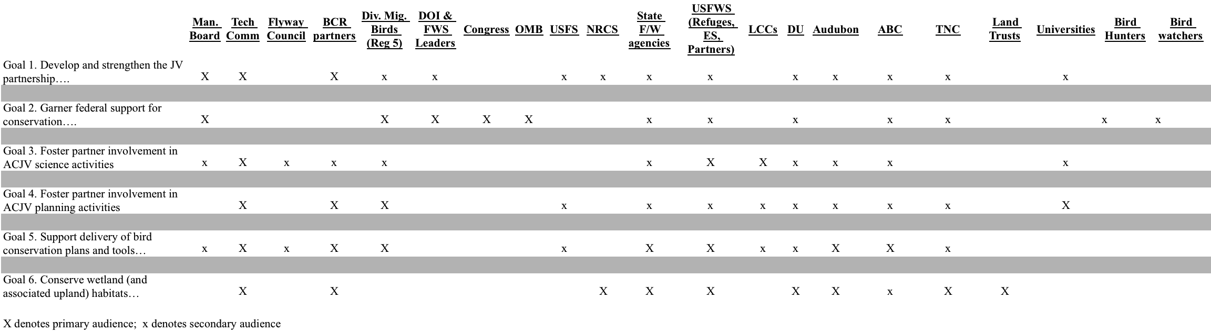

Communications Objectives & Messages
A communications objective takes the broad JV goals selected for communications and relates them to a segment of audiences, making them SMART. SMART is an acronym for well-developed objectives that are Specific (address who, what, where), Measurable (address when, how many), Achievable (something the JV can do), Realistic (possible with the resources the JV has), and Timely (to be accomplished within the specified time). Ultimately, the main communications objectives are behaviorally related, given that an audience behaving in a certain way will allow for the accomplishment of the goal. However, it may not be possible to change an audience’s behavior before first addressing their knowledge, attitudes, and skills. Each of these could serve as barriers if not sufficiently developed for the specific behavioral objective. Education and communications are often thought of as following a staircase of phases as shown in Figure 2, below. First, awareness must be raised (knowledge change), then concern increased (attitude change), then appropriate abilities developed (skill change), for ultimately action (behavior change). This is a simplified model of behavior change that is effective for thinking through communications planning.
Figure 2. Education and communications – a stair-step process leading to behavior change.
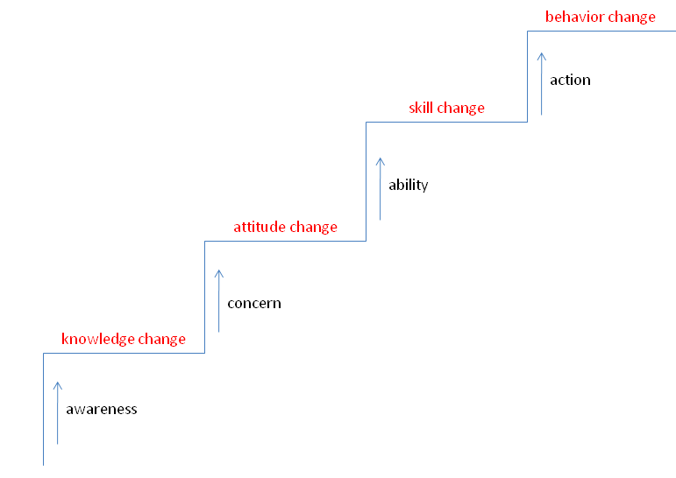

Making objectives measurable. All of these objectives can be made measurable (currently they are listed generically as “increase the percentage of…”) by providing specific percentages to target for each of the knowledge, attitudes, skills, or behaviors. These objectives serve as the foundation for an evaluation following the implementation of the communications campaign to determine whether the objectives have been reached.
To do so in a way that will be achievable and realistic, baseline measures are necessary. Audience assessments through surveys or interviews should be conducted to determine the current percentage of the audience group with the given knowledge, attitudes, skills, or behaviors. Then, the appropriate measurable objectives for a communications campaign could be determined. Remember, it will be challenging to get all of the audience members all the way up the “stairs” to a behavioral objective, so be realistic. Likely the number of audience members with a given knowledge objective met will be highest followed by attitudes, skills, and then behavior. Note that in conducting an audience assessment, a random sample from the audience could be selected if it is a large audience. It is strongly advisable to retain the services of a social scientist to determine the appropriate sampling scheme and survey design and implementation methods to ensure that the results are generalizable to the full population. The knowledge, attitudes, skills, and behavioral objectives for groups of audiences for each goal are listed below in Table 4.
Table 4. Objectives by audience segments for each of the goals for ACJV communications efforts.

Strongly Influential Audiences | Knowledge Objectives  Ensure that XX% of audience (with an emphasis on strongly influential organizations) knows that… | Attitudes Objectives  Ensure that XX% of audience (with an emphasis on strongly influential organizations) believe that… | Skills Objectives  Ensure that XX% of audience (with an emphasis on strongly influential organizations) is able to… | Behavioral Objectives  Ensure that XX% of audience (with an emphasis on strongly influential organizations)…
Goal 1. Develop and strengthen the JV partnership to conserve high-priority habitats throughout the Atlantic Coast region

-Management Board  -Tech Committee  -BCR partners | - the ACJV is a partnership working together for the conservation of native bird species in the Atlantic Flyway region of the U.S., covering all or part of 16 states and Puerto Rico.  - the “core” partners of the JV include those on the Management Board, who provide oversight to the JV; yet, the conservation work of the JV is accomplished by a much broader group of partners and partnerships throughout the region.  - JVs were created over 25 years ago to serve as partnerships for habitat conservation.  - JVs formed because partners realized they can achieve more conservation together rather than acting alone.  - JV staff capacity and fiscal resources are designed to support the JV partnership in science-based habitat conservation, serving as a hub for the bird conservation work of partners in the region.  - JV staff and partners develop outreach products to attract partners, support existing funding, seek new funding, and raise awareness of conservation needs with key audiences.  - the Technical Committee provides support to the JV partnership regarding scientific priorities, activities, and needs.  - the ACJV is known for helping partners successfully apply for NAWCA grants.  -funds for the Joint Venture do not fully cover the needs of the partnership (e.g., down one staff person; part-time GIS and communications support). | - the JV is a partnership and community that benefits bird conservation in the Atlantic Flyways.  - participation in the JV links you to conservation professionals and resources.  - being part of the collective effort offers a better chance of conservation victories than working alone.  - they are proud to be part of the  JV partnership.  - JV staff are available for you to turn to for bird conservation support in the region.  - participation in the Technical Committee provides an important partnership opportunity for organizations. | - explain what ACJV is.  - speak to shared JV goals and activities.  - identify ways they could partner in their own work to work toward shared JV goals.  - turn to JV staff and request tools that can aid in their JV hat wearing.  - direct interested and strong potential members to the JV.  - sign up to receive communications.  - use website to access information. | 1.1 Actively participates in Board & Tech and in JV committees & activities  1.2 Shares information about the JV within the organization/agency  1.3 Considers other partners who would be beneficial for Board and Tech Committee  1.4 Pools their resources to fulfill unmet needs for JV work (needs Board discussion)
-those uninvolved in JV-related organization/agency (or those conducting bird habitat conservation on the ground with NAWCA funds) | Same as above (other than resource limitations) | Same as above | Same as above | 1.5 Consider themselves partners in bird conservation with ACJV
Goal 2. Garner federal support for conservation that benefits the Atlantic Coast region

-Congress  -DOI/FWS leaders  -OMB | - JVs are one of the most efficient programs when it comes to results relative to funding. Over their more than 25-year history these public-private partnerships leveraged every dollar of Congressional funds 36:1, helping to conserve 20.5 million acres of habitat.  - JVs offer non-partisan solutions, real jobs for real people, adaptations for changing climate, and connecting people and nature.  - federal appropriations are the primary funding source for JV offices.  - NAWCA offers competitive grants to carry out wetlands conservation. In the ACJV region, 432 projects have been funded since 1991. $209 million in grant funds has leveraged another $763 in non-federal funds and $162 in federal funds for conservation.  - Coastal grants conserve important coastal areas. In the past 5 years (2009-2013), 40 Coastal grants have been awarded, impacting 23, 856 acres.  -the Neotropical Migratory Bird Act funds support conservation of neotropical birds and have supported projects in the ACJV and the wintering grounds for ACJV species. | - conservation in the ACJV is critical, particularly due to coastal development and sea level rise.  - these conservation funding sources are an efficient use of funds for bird conservation and the many other species that depend on these habitats.  - this conservation funding is a win-win for the people and the wildlife of the region.  - these conservation funding sources are complementary and competitive. Each provide essential funds to a distinct aspect of the conservation needs in the region.  - these conservation funds play a vital role in protecting ecosystem services American people rely on like water quality and resilient coastal environments. | - contact the JV staff or partners to learn more about how conservation funding benefit their states.  - justify their support of these conservation policies and programs to their constituents and other policymakers. | 2.1 Support for Interior appropriations bill with JV, NAWCA, coastal grants, and Neotrop funding at agreed upon level.
(Non-federal) Management Board members | - staff and federal partners of the JVs cannot lobby Congress. They can only provide information.  - the JVs visit the Hill each March. Those visits are more effective if partners are the leads for the visits, and JV staff provides technical support to them.  - developing a relationship with Congressional members and staff requires multiple contacts each year.  - the participation of NGOs in Congressional visits demonstrates that JVs truly are public-private partnerships, leveraging a variety of resources to benefit the region.  -hearing from their constituents is most important to Congressional members.  - being strategic about who is visited is more important that meeting with many policymakers.  - inviting policymakers out in the field to highlight projects that result from the JV partnership is very effective.  - the JV has numerous tools for Congressional outreach (e.g., exhibits, brochures, factsheets, and stats!) | - demonstrating benefits from the JV partnership and conservation program and policy funding is critical to Congressional support.  - a coordinated message from many partners can have much more impact than single messages coming from single organizations.  - having a relationship with Congressional members and staff can be valuable to the JV and JV partner organization.  - it is worthwhile for partners to promote the JV and other conservation programs. Funds for these programs lead to resources and support for partners.  - I am well prepared with many tools for Congressional communications. | - articulate the value of the sum of these programs to the partners in the JV.  - explain what the JV is and describe its activities.  - describe JV, NAWCA, coastal, and Neotrop grant programs and how they benefit the ACJV, wildlife, and people.  - collaborate with JV partners on crafting and delivering this message.  - identify opportunities for field visits or local outreach to policymakers throughout the year.  - use ACJV communications tools for policymaker visits. | 2.2 Actively participate in Congressional outreach
Goal 3. Foster partner involvement in ACJV science activities

-Tech Committee  -LCCs  -USFWS | -population & habitat objectives are targets or goals for how many of a species and how much habitat is needed.  -population & habitat objectives are based on biological science and also reflect social desires and public interests. | -population & habitat objectives are important to strategic habitat conservation (e.g., conservation design and implementation).  -members of the Tech Committee are critical participants in determining objectives and ensuring that the numbers reflect the partnerships’ desires.  -while staff support the Tech Committee, there is opportunity for partners to take leadership roles and undertake science on behalf of the JV. | -understand basic wildlife relationships and how to contribute information to models.  -how to participate in the process.  - how to describe the utility of objectives to their work. | 3.1. Develop population & habitat objectives for representative species in all ACJV BCRs
-Tech Committee  -LCCs  -USFWS | -the Science Needs list provides priorities for science needs in the JV.  -the process is bi-annual.  -the latest science needs are [insert summary based on most recent version]. | -having an established list of science priorities for the ACJV is valuable.  - the JV Science Needs are well thought out.  - establishing consensus on science needs is important.  -when science funding is available, this list of priorities can help in seeking funding. | - be able to speak to the latest list of Science Needs for the ACJV.  - pursue funding or seek opportunities to conduct this research. | 3.2 Provide feedback and contribute to searching for the Science Needs process
-DOI/FWS leadership | -the JV has a long history of quality applied conservation science.  -this JV research supports USFWS science needs (e.g., Refuge Realty, CCP planning, I & M, Ecological Services, Coastal Program).  -JV science supports LCCs (e.g., surrogate species, Designing Sustainable Landscapes project). | -JV science is unique and important to the USFWS.  -JV planning tools are valuable in the work of USFWS.  -collaborations on science with JVs works well (e.g., IWMM).  -contributing to JV science needs can help meet mutual needs. | -how to access the tools  -how to connect with JV staff.  -how to collaborate on science projects with the JV.  -how to work with JV to develop tools, applying their skills and perspectives. | 3.3 Support JV’s continued role in science  3.4 Contribute to JV science as collaborators and funders  3.5 Utilize science products to make decisions
Goal 4. Foster partner involvement in ACJV planning activities

- -Tech Comm.  - - Division of MB  - -BCR partners  - -Universities | -BCR plans distill the bird conservation information that exists at all levels so it is appropriate for the regions within the Atlantic Coast.  - ACJV staff and partners have completed BCR plans for nearly all of the JV region (except Florida).  -updating BCR plans will allow for incorporating the latest information, new threats (climate change, energy), and added forest bird focal areas. | -BCR plans are useful and are designed to make their work easier (e.g., SWAPs).  -BCR plans are the first and best guidance for bird conservation activities within the Atlantic Coast.  - using BCR plans benefit partners by distilling all information and saving time so they don’t have to review other bird plans at other scales.  -updating BCR plans ensures that the latest information is incorporated (e.g., DSL). | - how to access BCR plans.  - how to contribute to BCR plan updates.  - how to use BCR plans. | 4.1 Complete and update BCR plans throughout the Atlantic Coast region
Goal 5. Support habitat delivery based on bird conservation plans and tools for the Atlantic Coast region

-USFWS  -State agencies  -BCR partners  -ABC  -Audubon | -the Atlantic Flyway Shorebird Conservation Business Strategy demonstrates the need for a strong partnership effort to reduce shorebird declines and identified key projects in the Flyway.  - the shorebird strategy was created as partner effort, including JV staff and many partners.  - the information in the shorebird strategy is being distilled for ACJV partners to allow them to garner support, as well as a product to guide land managers in using the strategy. | - the shorebird strategy helps define priority species, areas, and strategies for land management activities on ACJV partner lands.  - using the shorebird strategy can help justify funding needs to conduct priority projects.  - it is critical to have involvement of more JV partners to ensure the habitat conservation and management projects succeed. | - access the strategy.  - identify what projects to be involved in and how  - justify their involvement in strategy-related projects.  - get funding support for projects (if needed).  - promote the shorebird strategy as the go-to document to guide shorebird conservation. | 5.1 Participate in implementation of the Atlantic Flyway Shorebird Conservation Business Strategy in the Atlantic Coast region
-Tech Comm  -BCR partners  -State agencies | - the Designing Sustainable Landscape tool, which includes habitat maps, data layers, and species-habitat models, identifies some of the most important areas for conservation | - the DSL helps prioritize areas for conservation and make good decisions for delivering habitat on the ground. | -access the DSL tool.  -use the DSL tool to make decisions. | 5.2 Use the “Designing Sustainable Landscapes” decision support tool for conservation
-BCR partners  -State agencies  -USFWS | -the IWMM is a model of the importance of different areas at the flyway scale to migrating and over-wintering wetland birds  -the IWMM Flyway model could be used for funding decisions (NAWCAA or Refuges).  -the IWMM Flyway model is based on the Strategic Habitat Conservation approach. | -the IWMM is an important example of the full cycle of Strategic Habitat Conservation.  -the IWMM Flyway Model is useful for helping make decisions about allocating resources to wetlands or prioritizing wetlands to protect.  -the IWMM Flyway Model helps you choose the right habitat in the right place at the right time. | -how to access the IWMM Flyway model.  -how to apply the IWMM Flyway model in decision-making. | 5.3 Use the Integrated Waterbird Management & Monitoring (IWMM) results to guide wetland conservation.
-BCR partners  -State agencies  -USFWS | -BCR plans distill the bird conservation information that exists at all levels so it is appropriate for the regions within the Atlantic Coast.  - ACJV staff and partners have completed BCR plans for nearly all of the JV region (except Florida). | -BCR plans are useful and are designed to make their work easier (e.g., SWAPs).  -BCR plans are the first and best guidance for bird conservation activities within the Atlantic Coast.  -using BCR plans benefit partners by distilling all information and saving time so they don’t have to review other bird plans at other scales. | - how to access BCR plans.  - how to use BCR plans. | 5.4 Use BCR plans to guide conservation/Prioritize areas and species.
Goal 6. Conserve wetland (and associated upland) habitats in the Atlantic Coast region via federal habitat grant programs

-BCR partners  -State agencies  -USFWS  -NRCS  -NGOs  -Land trusts  -DU  -Audubon | - grants are most competitive when they demonstrate multiple partners collaborating and include high match ratios.  - JV staff are available to help review grants and ensure that they are competitive.  - Bird Conservation Region plans and other JV science documents offer information that can ensure that grants are competitive. | - working with JV partners to write grants is a win-win for bird conservation and our organization.  - JV bird conservation plans and science documents are easy to use and access.  - JV staff are very accessible and willing to help with grants. | - how to contact JV staff for technical support on grants  - how to access BCR plans and JV documents for writing grant applications.  - how to find partners and adequate match.  - deadlines and how to apply for the grant programs. | 6.1 Write more effective grant proposals  6.2 More organizations submitting grant proposals within Atlantic Coast  6.3Those conducting land conservation: leverage conservation funds being used to serve as match and make grant proposals more competitive

Messaging. Each of the objectives has been written so that it can easily provide the basis for messaging. The primary message may be more simplistic than secondary messages that iterate the specifics in the objectives. For examples of potential primary messages for each of the goals, see Table 5, below. Knowledge and attitude objectives can generally be used as message themselves. Communications may also be supplemented with secondary messages that provide examples or simple facts or statistics. Additionally, persuasive elements can be employed to make messages play on humor or excitement or empathy or, when appropriate, fear. For skills and behaviors objectives, the message may also need to include tertiary information on how to build the skill or how to do the behavior.
Table 5. Overarching messages by goal.
Goals | Overarching Messages
Goal 1. Develop and strengthen the JV partnership to conserve high-priority habitats throughout the Atlantic Coast region | - You, the partners, are the Atlantic Coast Joint Venture (ACJV).  - ACJV is only as successful in bird conservation as partners are engaged and successful.  - A strong ACJV partnership will benefit all partners and bird and habitat conservation in our region.  - The strength of the ACJV partnership comes from the active participation in the Management Board, Technical Committee, and projects throughout the flyway.  - The ACJV has 25 years of demonstrated success through partnership activities.  - Active participation of all partners in the ACJV planning, science, and delivery activities will ensure we have shared goals moving forward, which is essential for conservation in the Atlantic Flyway.
Goal 2. Garner federal support for conservation that benefits the Atlantic Coast region | - Federal conservation programs and policies benefit bird conservation and people in the Atlantic Flyway.  - JVs are one of the most efficient federal programs when it comes to results relative to funding. Over their more than 25-year history these public-private partnerships leveraged every dollar of Congressional funds 36:1, helping to conserve 20.5 million acres of habitat.  - Each federal conservation program addresses a distinct (and complementary) component of conservation needs in the region.  - Conservation programs in the ACJV are critical to address challenges, particularly due to coastal development and sea level rise.  - These programs support ACJV partner projects to sustain a safe and resilient coastal area for people and wildlife.
Goal 3. Foster partner involvement in ACJV science activities | - ACJV science needs and activities are driven by the partners involved in the Technical Committee.  - Members of the Technical Committee are critical participants in addressing science needs and setting population and habitat objectives of the JV.  - One of the key outcomes of JV science is population and habitat objectives, which can help guide conservation activities.
Goal 4. Foster partner involvement in ACJV planning activities | - Bird Conservation Region Plans distill all existing relevant information and make it available at a usable scale.  - BCR plans are available for nearly all of the JV region.  - It is essential to update older BCR Plans to incorporate the latest science information and your expertise.  - Partner involvement is key to BCR planning efforts.
Goal 5. Support habitat delivery based on bird conservation plans and tools for the Atlantic Coast region | - Conservation plans and tools are available to aid in conservation activities and management in the region.  - The Atlantic Flyway Shorebird Conservation Business Strategy defines priority species, areas, and strategies for land management activities on ACJV partner lands.  - The Integrated Waterbird Monitoring and Management will help us prioritize areas of the Atlantic Flyway for over-wintering and migrating wetland birds.  - The BCR Plans step-down continental bird conservation plans and help prioritize focal areas for conservation in each BCR.  - The Designing Sustainable Landscapes tool helps prioritize areas for conservation along the Atlantic Coast.
Goal 6. Conserve wetland (and associated upland) habitats in the Atlantic Coast region via federal habitat grant programs | - ACJV partners have been leaders in obtaining federal dollars to conserve wetlands and associated upland habitats.  - ACJV staff can offer support to strengthen partner grant applications.  - Through the ACJV partnership, organizations can connect with collaborators to build strong grant project proposals with high match ratios.

When considering which objectives to focus on for messages, the JV should consider where the audience member is on the stairsteps for communications (Figure 2). Should the emphasis be on knowledge? Or are they already knowledgeable and aware? If so, should the emphasis be on attitudes? Or are they already concerned? If so, should the emphasis be on skills or actions? Think about their level of technical knowledge and how complex to be with the message. Are the audience members primarily scientists, managers, or not members of the conservation community at all?

Tactics & Tools
A variety of tactics and tools exist to contribute to achieving the JV’s communications objectives. In considering the appropriate tactics and tools for this Strategic Communications Plan, the Communications Working Group reviewed the JV’s current use of tactics and tools and also recommended whether tactics and tools would be appropriate for the ACJV to use in the future. We additionally considered any information about the tools from the partner feedback effort. We then linked the tactics and tools that the Working Group felt would be most appropriate with each of the goals and its objectives and key audiences (Table 6).

Table 6. Communications tactics and tools for each goal and set of objectives.
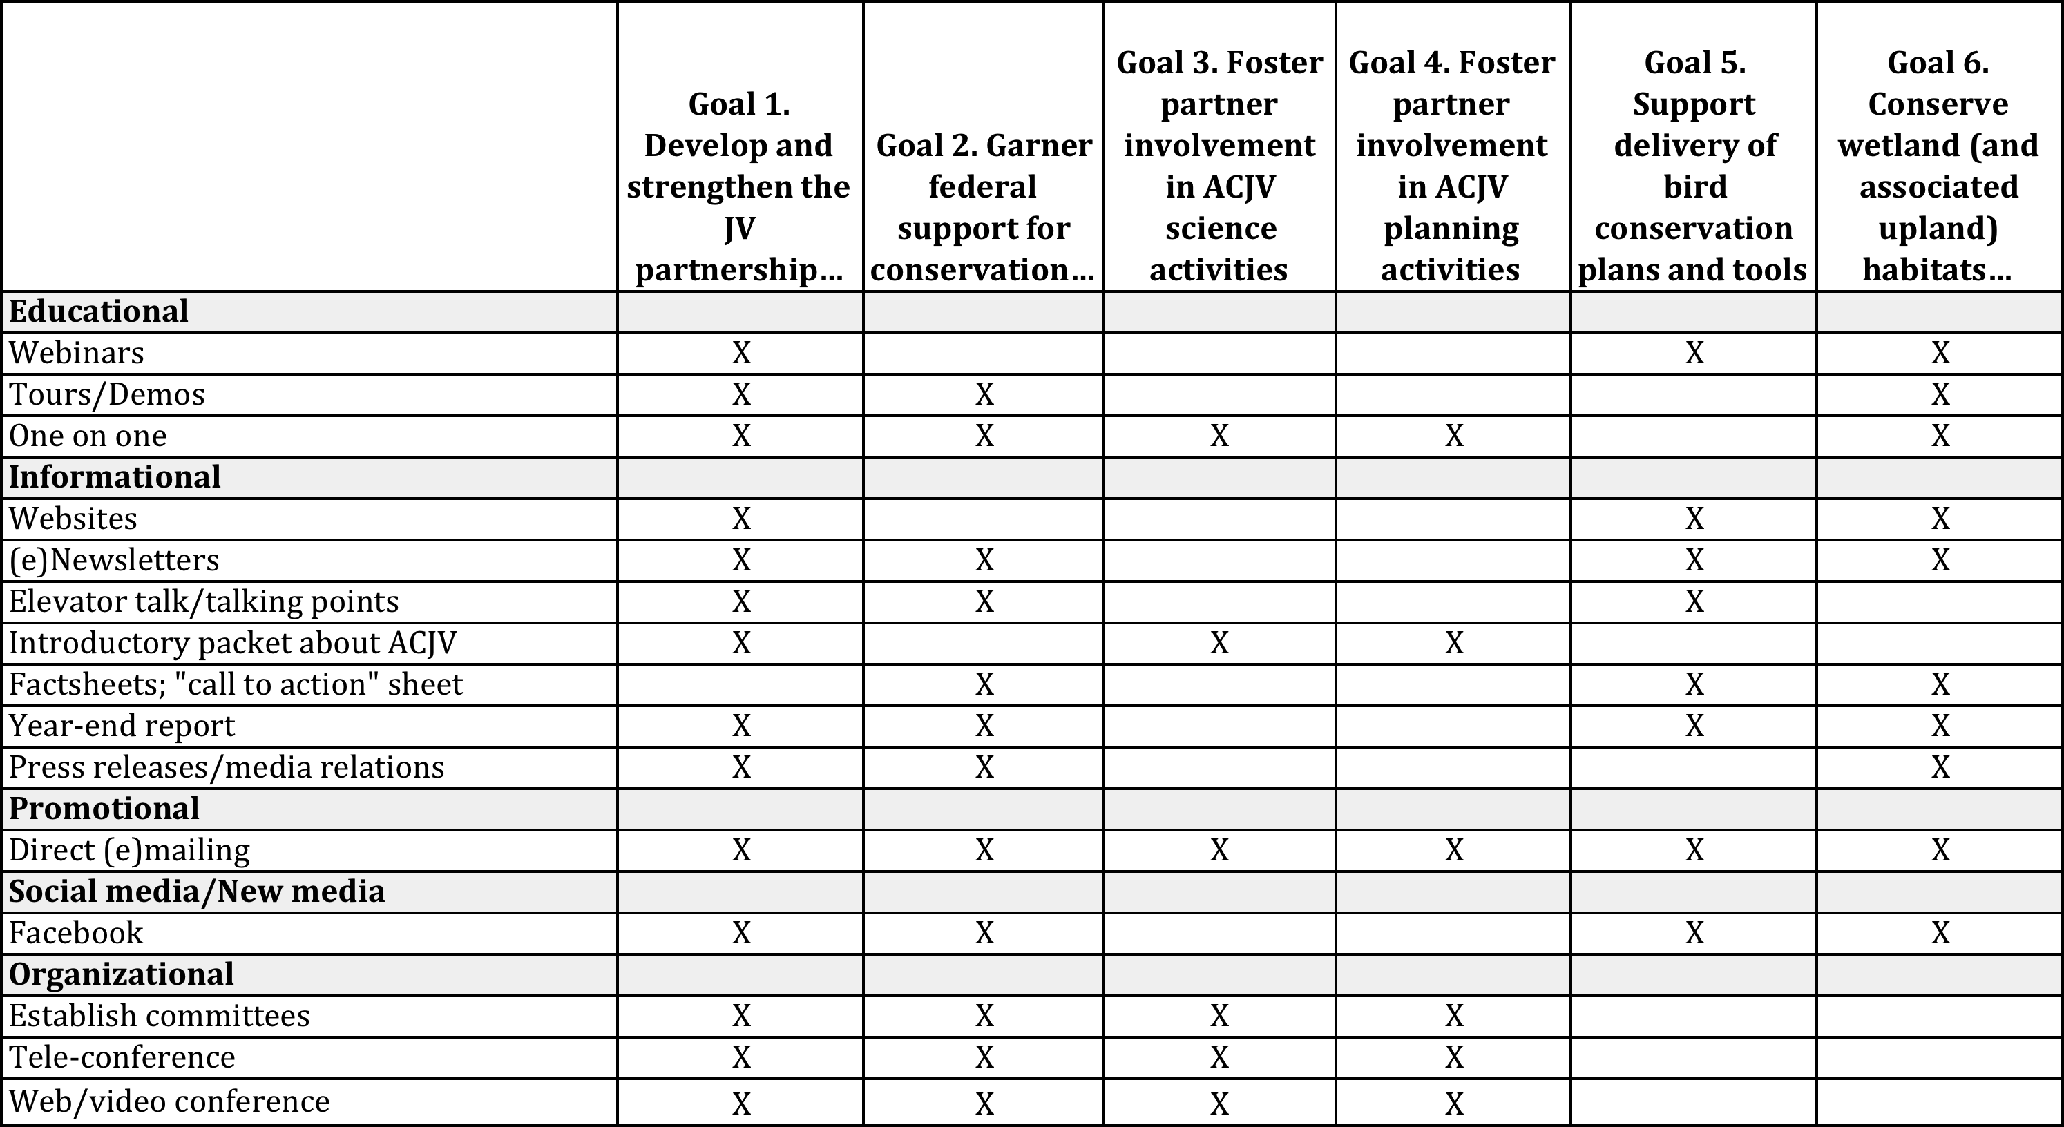

Designing & Delivering Tactics and Tools
We created broad recommendations for the design and delivery of each tactic and tool. Still, when implementing this plan and selecting the tactic or tool for delivering messages for a given audience, the JV should consider:

- Will the tool reach the audience and likely lead to achieving the goals and objectives?
- Will it transmit the message(s) well?
- Is there an existing tactic or tool available for our needs that we could use or edit?
- Is it cost effective and affordable to create this tool? Will it take a reasonable amount of time?
- Does the JV have the experience or skill for this type of communications? Or does a partner who could collaborate on the effort?

Recommendations:

- Webinars: Webinars should be provided each year that address communications needs, such as those on general topics like what the JV offers, as well as specific topics, such as using the Shorebird Strategy, submitting successful NAWCA grants, using IWMM resources. Webinars can build knowledge and skills of partners. Webinar tools are provided by the USFWS, and the ACJV staff members have skills in conducting these webinars.

- Tours/demos: A single tour or demo can meet both the goals of building the partnership and building federal support by inviting partners and Congressional staffers and agency leaders. To minimize the effort allocated to planning these tours and demos, it is suggested that one tour/demo each year could be in conjunction with the Management Board annual meeting field visit. All partners within the region, as well as media, should be invited to participate. For more information on how to conduct a tour, see the San Francisco Bay JV’s handbook. Additional tour/demo sites after year one could be strategically selected based on building relationships with Congressionals in their home districts or states.

- One-on-one communications: One-on-one communications are essential for nearly all of the goals. For example, for the goal of building the partnership, communications between and among Management Board, Technical Committee, & the JV staff are essential. At a minimum, these should occur at bi-annual meetings, with one of the meetings including interaction between the Management Board and Technical Committee. Additionally, one-on-one meetings will be important with both current and new Management Board and Technical Committee members, particularly as assignments change with agency or NGO staffing changes, to ensure roles are understood. For the goal of building federal support, face-to-face meetings in both D.C. and local offices are essential. These meetings should involve JV partners.

- Website: The website will be redesigned, working with a web developer, which will allow for a new content management system and advanced design. The new content management system will enhance usability by the user and the staff managing the website. The website redesign should consider the suggestions recommended in the partner feedback. The website can also incorporate all of the primary messages for each of the goals, as well as more specific information and resources. It can include calls to action, such as signing up for the e-newsletter.

- E-newsletter: The e-newsletter should be increased from 3 times/year to 4-5 times/year with fewer articles. The e-newsletter is now being sent using Mail Chimp, rather than its previous web-based format. Using Mail Chimp allows mailing list management and better tracking of readership. The mailing list should be revisited on an annual basis, such as it was in Fall 2013, to ensure it includes key partners. With a larger partner list, the e-newsletter can reach audience members associated with nearly every goal. Additionally, messaging should always clearly articulate the importance of the partnership and the partners’ activities, as opposed to focusing on the JV staff as the JV. If an article highlights a project, lists of partners involved should be included. Partners should be asked to author articles to highlight their successes and activities.

- JV elevator talk: The elevator talk should highlight key talking points about the JV mission, shared goals, structure, and value for staff, Management Board members, and Technical Committee members. They should all be able to deliver it to others when asked, “what is the ACJV?”

- Introductory packet: This packet should include essential background information about the ACJV, its history, and its administration, as well as key documents (e.g., Strategic Plan, work plan, Strategic Communications Plan). It should also delineate the role of staff, Management Board members, and Technical Committee members. It could also include a powerpoint presentation about the ACJV, such as that recently designed by the JV staff for a Management Board webinar. The packet could be available on the website for easy access.

- Factsheets: Factsheets can be created to accompany tours or face-to-face communications with key Congressional members and agency leadership, although it should be considered whether a small postcard should be given out with a link to web material instead. Factsheets should include a map of the state or district and where JV projects are located, as well as summary stats about the JV’s accomplishments (including acreage conserved and dollars leveraged). Partners within a given state or district should be listed to demonstrate the public-private partnership. Photos from the state or district (including those of people) should be highlighted. Compared to the current factsheets, these factsheets might be enhanced by reducing the amount of text for some of the audiences. Messaging may emphasize the benefits to local economies or other key constituencies. Factsheets could also be utilized to encourage use of bird conservation plans and tools. They can be provided as a supplement to webinars or trainings to ensure that audience members recall skills they are taught for using these resources.

- Year-end report: This annual report should highlight the successes of the JV partnership. In addition to providing summary statistics to emphasize the strength of partnership activities, it should highlight example projects where a strong partnership was necessary to get the work done (including quotes from partners in this manner). For each example project, lists of partners involved should be included. The year-end report can be distributed digitally, linked to the website, to track its readership. Additionally, it can be handed out in hard copy to Congressionals, agency leaders, and Management Board members.

- Press releases/media relations: Press releases and media relations can be conducted in coordination with USFWS External Affairs. They can be particularly important for building the partnership, by providing media attention for partner successes. They also can highlight the importance of policies and federal support. Partners may wish to write letters to the editor in key districts or states. When tours are given, the press should be invited. Policymakers follow the national news as well as the news for their state or district.

- Direct emailing: Using Mail Chimp, direct emails can be sent to the partner database or segments of it. Such emails can be sent for specific calls to action (e.g., using a new tool or participating in a workshop about a BCR plan revision). Care should be taken to not send too many emails to the partner database and to time them so they are not too close to the distribution of an e-newsletter.

- Facebook: ACJV should continue to provide information to their “fans” on Facebook, allocating a minimal amount of time each week to maintain the page. Additionally, the issue that many partners aren’t aware of the Facebook page (as identified in the audience assessment) should be remedied by adding a Facebook button prominently on the new website as well as in the e-newsletter. The content should emphasize bird conservation information and updates from the staff and partners, as prioritized in the audience assessment results.

- Committees: Committees currently exist to strengthen the partnership, including Technical Committee and Management Board. Need for other committees to enable the partnership to work together effectively. Additionally, the Congressional Committee is essential in working on the goal related to garnering federal support. This committee will strategize about and plan for tours and face-to-face communications necessary. Additionally, a member of this committee should participate in the Association of Joint Venture Management Board’s bi-annual meetings and serve as a liaison for the ACJV.

- Tele-conferences and web/video-conferences: These conferencing tools will be utilized by committees or their working groups to maintain communications. Web and video conferencing tools are becoming increasingly useful for remote collaborations, and these tools are available from the USFWS.

Timeline
The development of these tactics and tools will require focused effort from the ACJV’s half-time Communications and Outreach Coordinator, as well as support from other staff and partners. For example, we discussed above how the USFWS External Affairs staff and the staff of NGO partners (e.g., Ducks Unlimited and American Bird Conservancy) can be essential collaborators on designing and delivering Congressional communications. Additionally, contracts for web development, evaluation, or other support may be necessary. We developed a suggested timeline for implementation of these tools, focusing on how the Communications and Outreach Coordinator should focus efforts (Table 7).
Table 7. Implementation timeline, showing effort allocation on each of the tools, in the next 5 years.
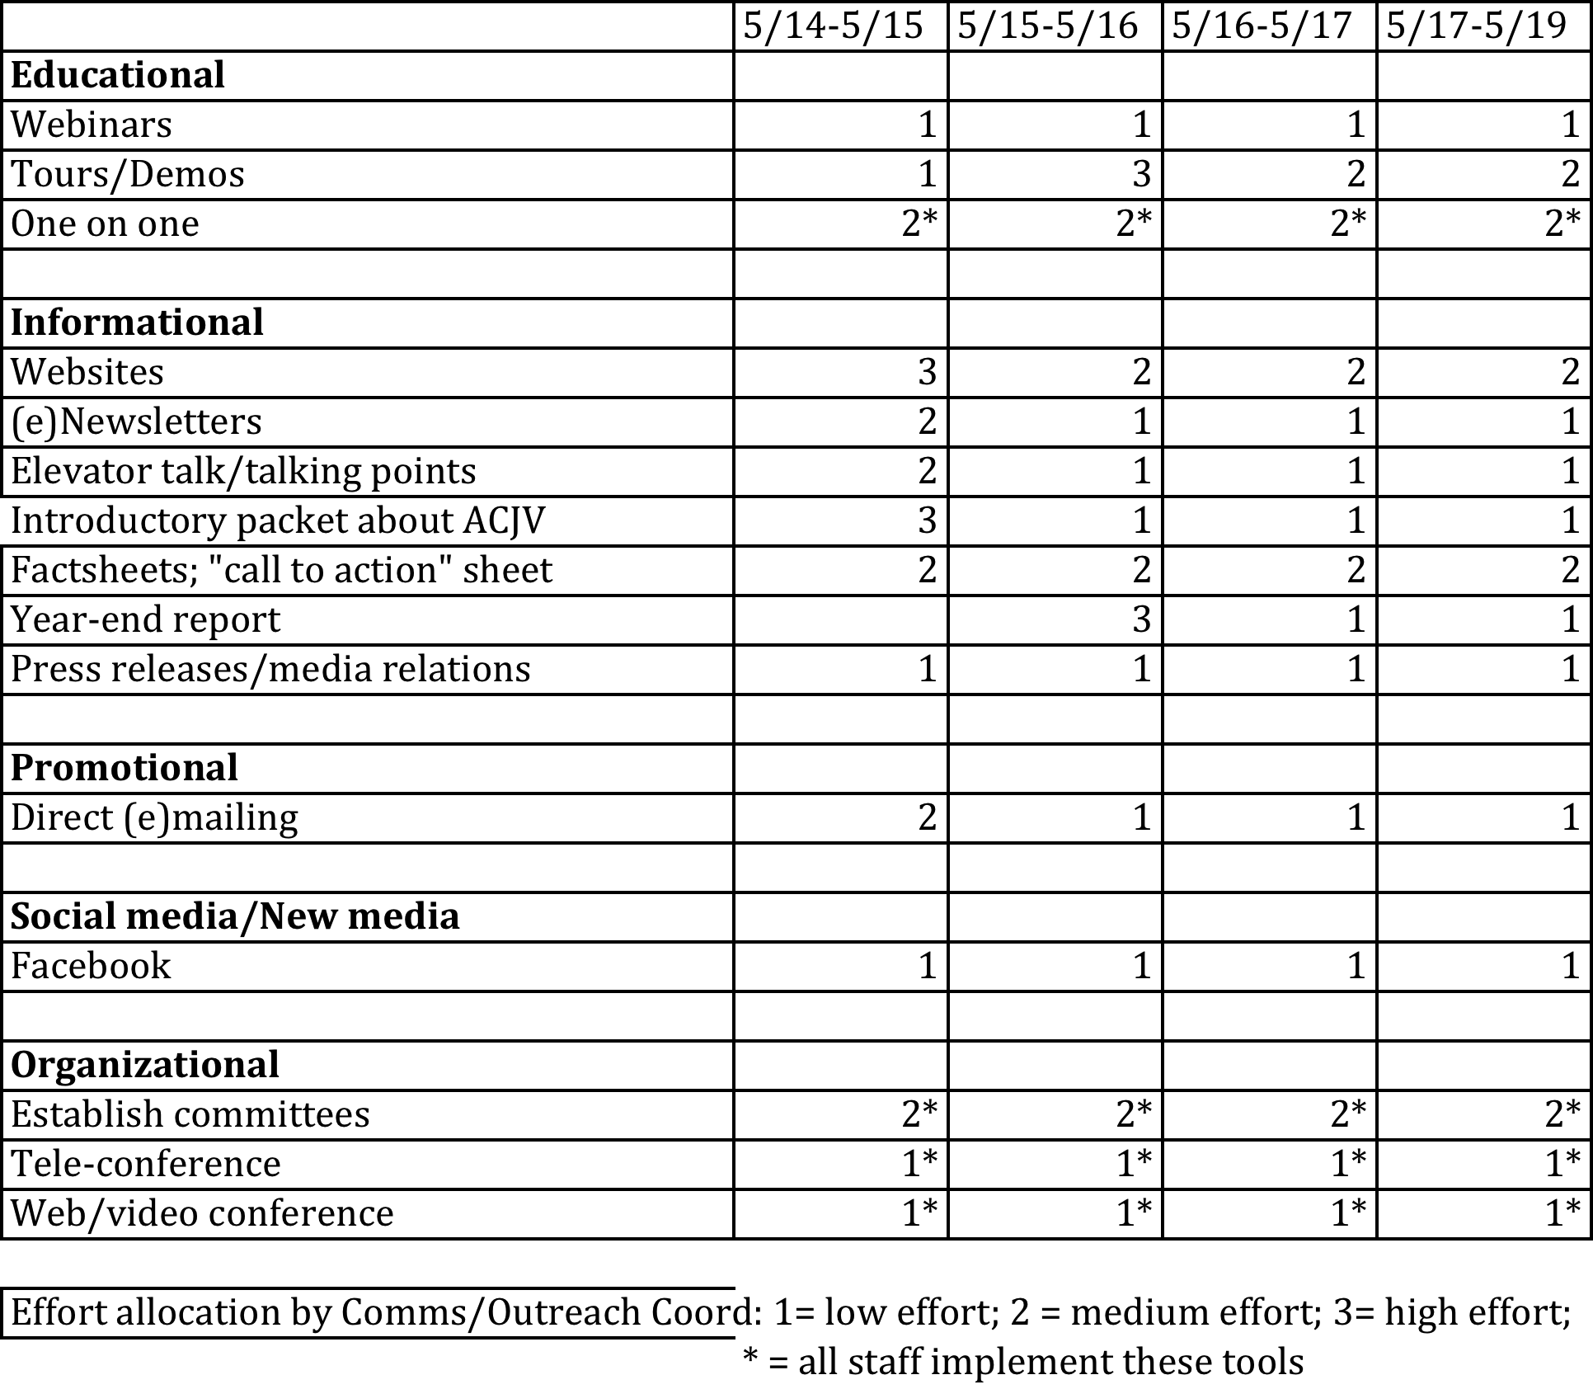

Evaluation
Evaluation is a process of critical examination. Information about a communications tactic or tools, its characteristics and its outcomes, and/or the audience it is intended to reach is collected and analyzed. Then well-informed judgments about the communications tactic or tool can be made.
Evaluation need not only be conducted at the end of a program or activity. Instead, it should be conducted before, during, and after development. Audience assessments are often a part of a needs assessment for communications, such as conducted to inform this Communications Plan. Needs assessments for specific tactics and tools or one of the communication campaigns may provide more information on how to undertake the communications efforts. As another step of formative evaluation, before implementation of an extensive campaign or investing a lot in a communications product, it should be pilot tested with the audience.
Each tactic and tool should also be evaluated to assess its effectiveness, leading to improvement of the tactic and tool or to guide the development of new products. The evaluation should include proximate (e.g., how many audiences reached, how many news articles published, how many web site hits, etc.) as well as ultimate (e.g., change in attitudes/behavior, increase in knowledge, decrease in bird disturbance in nesting area) measures. Evaluation may include formal and informal surveys, focus groups, interviews, and observations before, during and after the communications campaign.
Figure 3. MEERA’s schematic for the phases of evaluation aligned with the phases of program development.
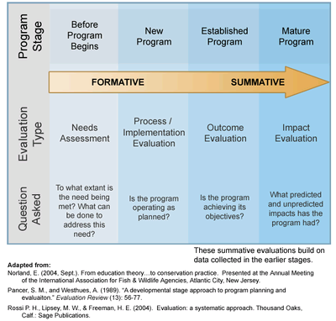
An evaluation plan is necessary before undertaking communications efforts. Evaluations specific to the communications objectives can be conducted as well as communications tied to the tactics and tools. The objectives table in this plan can guide evaluations with given audiences, and Table 8 below can guide evaluations of key tactics and tools that will address multiple goals.
It is recommended that the JV work with a professional evaluator on their evaluation activities. Quality evaluations require social science training and skills. The evaluator may be able to develop evaluation tools for ACJV to implement on their own, monitoring the progress of JV communications.

Table 8. Suggested proximate and ultimate evaluation measures and associated tools for some of the primary communications tools.
Tools | Proximate | Ultimate | Evaluation Tools
Website | - Number of website visitors increases each month.  - Amount of time website visitors spend at website increases each month.  -Number of pages website visitors view increases each month. | - x% website users report finding information they are looking for.  - x% website users believe website to be easy to use.  - x% website users report increased knowledge about ACJV and its activities after visiting website. | - Google Analytics (proximate).  - Online survey on website (ultimate).
E-newsletter | - More than 30% (JV average) of e-newsletter recipients open e-newsletter.  - More than 40% of e-newsletter readers click on 1 article to read in full.  - Number of e-newsletter readers increases each month.  - Requests to be added to e-newsletter distribution list increase. | - x% e-newsletter readers report finding interesting information and well-written articles.  - x% e-newsletter readers sign up for other activities listed in the e-newsletter and report reading about it there.  - x% e-newsletter readers report increased knowledge about ACJV and its activities after reading newsletters. | - E-newsletter program tracking function or Google Analytics (proximate).  -Online survey of e-newsletter email list (ultimate).
Year-End Report | - More than 40% of report distribution list opens report within two weeks of emailing report link.  - Staff, Board members, and Technical Committee members each distribute more than 10 reports/year.  - 75% of partner organizations respond to solicitation for content in annual report. | - x% report readers report finding information useful to their work.  - x% report readers indicate report is easy to read. | - Google Analytics to track who receives and opens email with report, who clicks on link to read it (proximate).  - Online survey of email distribution list that received report (ultimate).
Elevator Talk | - 75 % Staff, Board members, and Technical Committee members learn the elevator talk and deliver it regularly. | - x% staff and Board report that those who hear the elevator talk seem interested and ask follow up questions. | - Observation of Staff, Board members, and Technical Committee members (proximate).  - Informal focus group of staff and Board members (ultimate).

Resources

Bird Education Alliance for Conservation. www.birdedalliance.org
Bogart, R.E., Duberstein, J.N., & Slobe, D.F. (2009). Strategic communications and its critical role in bird habitat conservation: Understanding the social ecological landscape. In Rich, T.D., C. Arizmendi, D. Demarest and C. Thompson [eds.]. Tundra to Tropics: Connecting Birds, Habitats and People. Proceedings of the 4th International Partners in Flight Conference, 13-16 February 2008. McAllen, TX. University of Texas-Pan American Press. Edinburg, TX. [online: http://www.pwrc.usgs.gov/pif/pubs/McAllenProc/articles/PIF09_Education_Communication/Bogart_PIF09.pdf]
Jacobson, S.K. (1999). Communications skills for conservation professionals. Washington, D.C.: Island Press.
Jurin, R.R., Roush, D., & Danter, J. (2010). Environmental communication: Skills and principles for natural resource managers, scientists, and engineers. New York: Springer Science+Business Media.
My Environmental Education Evaluation Resource Assistant (MEERA). http://meera.snre.umich.edu/

Appendix A. ACJV’s Status on the Desired Characteristics of JV Matrix for Communications, Education, and Outreach.

Joint Ventures’ competencies are outlined in the “Desired Characteristics Matrix.” A section of that matrix defines the “minimal content” expected of a Joint Venture in their communications, education, and outreach activities, as well as the “comprehensive content” of a highly functioning Joint Venture. During the Discovery Phase of communications planning (in July 2013), we assessed the status of the ACJV communications, education, and outreach efforts (as shown below). The communications plan has been designed to aid the ACJV increasing the areas where it is achieving “comprehensive content.”

Sub-Element or Product | Minimal Content | Comprehensive Content | Status as of July 2013
Coordination/Partnerships | Appropriate joint venture partners or staff represents the Joint Venture mission to the local, regional, national, and international conservation community. | The JV has identified optimal roles for the Management Board, JV office, and the JV partners in furthering its biological objectives through communications, education, and outreach activities and products. As deemed appropriate, the JV has identified gaps in capabilities and fortified those gaps to raise awareness, change attitudes, and change behaviors to support bird habitat conservation. | Comprehensive
Priority Audiences and Objectives | Joint venture partners have evaluated the efficacy and applicability of communications, education and outreach activities in achieving Joint Venture conservation objectives. Joint Venture Management Board has identified priority internal and external audiences and key messages. | A JV Communications Plan, guided by information from biological planning, conservation design, habitat delivery, monitoring and research, is developed to set communication, education, and outreach objectives and target activities and products geographically, programmatically and to the highest priority conservation needs. The JV has identified and prioritized all relevant audiences and correlates audience objectives with bird habitat conservation goals and objectives to determine how much and where increases in audience awareness and what changes in attitudes/behaviors are necessary to reach bird conservation objectives. The JV has established appropriate means of engaging priority audiences. | Underway to achieving comprehensive
Tactics and Products | Mechanisms exist to facilitate communication between Management Board, joint venture office, and the joint venture partners. The Joint Venture maintains an up-to-date website. | Each tactic and/or product (Examples include, but are not limited to: partner newsletters, public website, news releases, project tours, meetings, presentations and workshops) is evaluated to assess effectiveness and guide development of future communications products and activities. | Beginning comprehensive
Audience Assessment | Joint venture partners conduct informal assessment of priority audiences to determine their baseline level of awareness, attitudes, and behaviors affecting bird conservation in the Joint Venture region. | JV conducts regular, formal assessments of priority audiences to measure change in awareness, attitudes and behaviors over time. Assessments may be in the form of focus groups, surveys, interviews or other systematic means of gathering audience data. The results are used to improve future JV activities in support of bird conservation objectives. | Minimal

