Peninsular Florida Bird Conservation Region (BCR 31) Plan

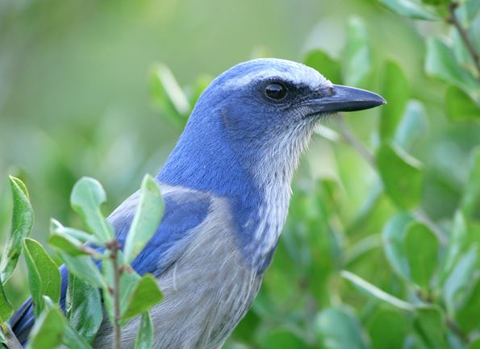 | 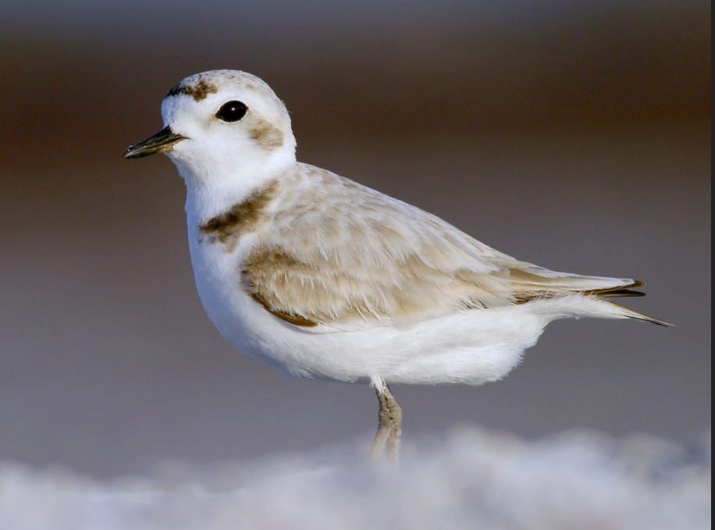
 | 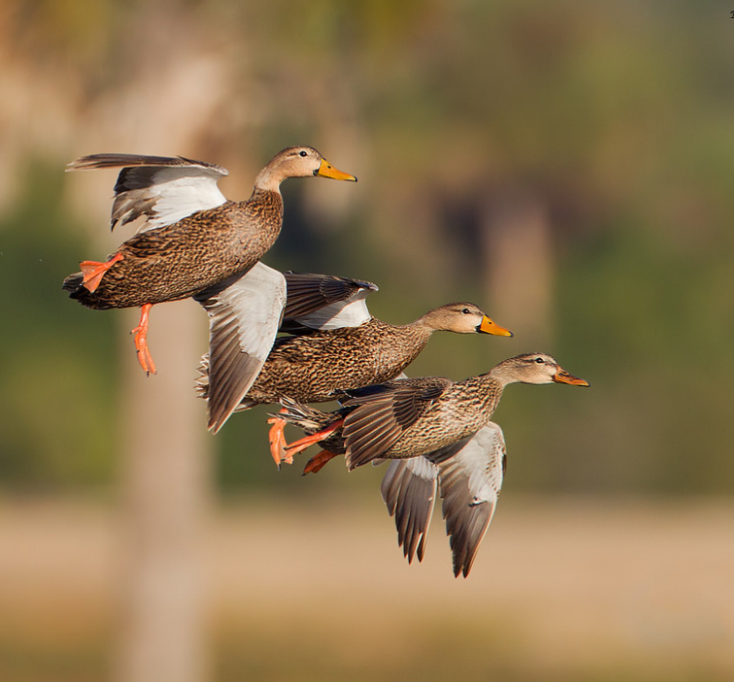

October 2017

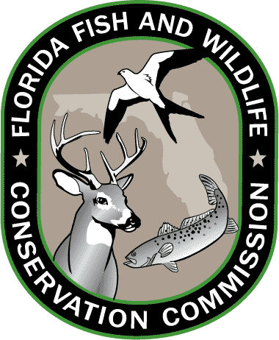 | 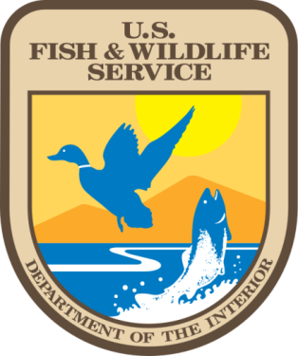
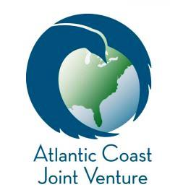

Version 1.0, October 2017

Written and Compiled by:

Adam M. Kent  Senior Scientist  Normandeau Associates, Inc.  4581 NW 6th Street, Ste. A  Gainesville, FL 32609  akent@normandeau.com | Craig Faulhaber  Avian Conservation Coordinator  Florida Fish and Wildlife Conservation Commission  1239 SW 10th Street  Ocala, FL 34471  craig.faulhaber@myfwc.com | Craig Watson  South Atlantic Coordinator  Atlantic Coast Joint Venture  U.S. Fish & Wildlife Service  Division of Migratory Birds  176 Croghan Spur Rd., Ste. 200  Charleston, SC 29407  craig_watson@fws.gov

Suggested citation: Kent, A. M., C. Faulhaber, and C. Watson. 2017. Peninsular Florida Bird Conservation Region (BCR 31) Plan. Prepared by Normandeau Associates, Inc. for the Florida Fish and Wildlife Conservation Commission and U.S. Fish and Wildlife Service.

Cover photo credits: Florida Scrub-Jay and Snowy Plover by Alex Kropp. Reddish Egret by Craig Watson. Mottled Ducks by FWC.

Contents
Contents iii
List of Tables v
List of Figures vi
Acronyms and Abbreviations vii
Acknowledgements viii
Signature Page x
Executive Summary xi
1 Introduction 1
1.1 Background 1
1.2 Atlantic Coast Joint Venture (ACJV) 2
1.3 BCR 31 Plan Purpose and Goals 2
2 Description of the Peninsular Florida Bird Conservation Region 2
2.1 Physical Description 4
2.2 Threats 5
2.2.1 Alterations of the Physical Environment 5
2.2.2 Degradation of Water Resources 5
2.2.3 Incompatible Fire Management 6
2.2.4 Introduced Plants and Animals 6
2.2.5 Climate Change 6
2.2.6 Disturbance to Nesting and Roosting Birds 6
3 Priority Species and Habitats 6
3.1 Species 6
3.1.1 Species Groups 6
3.1.2 Species Rankings 7
3.2 Habitat Types 11
3.3 Priority Species and Habitat Suites 15
3.3.1 1100 Hardwood Forested Uplands 16
3.3.2 1200 High Pine and Scrub 17
3.3.3 1300 Pine Flatwoods and Dry Prairie 18
3.3.4 1400 Mixed Hardwood Coniferous 19
3.3.5 1500 Shrub and Brushland 20
3.3.6 1600 Coastal Uplands 21
3.3.7 1800 Cultural Terrestrial 22
3.3.8 2100 Freshwater Nonforested Wetlands 24
3.3.9 2200 Freshwater Forested Wetlands 25
3.3.10 2400 Cultural Palustrine 26
3.3.11 5200 Intertidal 27
4 Priority Species Population and Habitat Objectives 28
4.1 Population Objectives 29
4.2 Habitat Objectives 37
5 Focus Areas 40
5.1 Waterfowl Focus Areas 40
5.2 Waterbird and Seabird Focus Areas 41
5.2.1 Waterbird Focus Areas 41
5.2.2 Seabird Focus Areas 44
5.3 Shorebird Focus Areas 45
5.4 Landbird Focus Areas 47
5.4.1 Landbird Migration Hotspot Areas 48
6 Conservation Strategies and Tools 52
6.1 Habitat Protection 52
6.1.1 Habitat Restoration 53
6.1.2 Habitat Enhancement and Management 53
6.1.3 Landowner Outreach, Education, and Incentives 54
6.1.4 Habitat Assessment 55
6.1.5 Audubon Important Bird Areas 56
6.2 Species-specific Actions 56
7 Conservation Resources and Funding 56
7.1 Conservation Resources 56
7.1.1 Federal Resources 57
7.1.2 FWC 57
7.1.3 Florida Department of Environmental Protection (FDEP) 57
7.1.4 Water Management Districts 57
7.1.5 Nonprofit Organizations 57
7.1.6 Multiple Partners/Other 58
7.2 Conservation Funding 59
8 Literature Cited 66
9 Appendices 70
Appendix A. BCR 31 Workshop Agenda and Attendees 70
Appendix B. Birds Potentially Affected by the Deepwater Horizon Oil Spill 72
Birds potentially Affected by the Deepwater Horizon (DWH) Oil Spill and Associated Habitats 72
Bird Conservation Strategies to Ameliorate Impacts and Examples of Actions 75
State and Federal Properties Potentially Affected by the DWH Oil Spill 77
Appendix C. Red-cockaded Woodpecker Clusters in Florida and USFWS Recovery Goals 82

List of Tables
Table 1. Sources of Data Used to Rank Priority Species in BCR 31 8
Table 2. Criteria for Ranking Florida Priority Bird Species (adapted from Watson 2014) 9
Table 3. Priority Bird Species in the Peninsular Florida Bird Conservation Region (BCR 31). Italicized species are FWC State Threatened. Bolded species are federally Threatened or Endangered. 10
Table 4. Class 2 Communities in BCR 31 12
Table 5. Priority Species in Hardwood Forested Uplands 16
Table 6. Priority Species in High Pine and Scrub 17
Table 7. Priority Species in Flatwoods and Dry Prairie 18
Table 8. Priority Species in Mixed Hardwood Coniferous 19
Table 9. Priority Species in Shrub and Brushland 20
Table 10. Priority Species in Coastal Uplands 21
Table 11. Priority Species in Cultural Terrestrial 23
Table 12. Priority Species in Freshwater Nonforested Wetlands 24
Table 13. Priority Species in Freshwater Forested Wetlands 25
Table 14. Priority Species in Cultural Palustrine 26
Table 15. Priority Species in Intertidal 27
Table 16. FWC Statewide Population Estimates and Objectives 30
Table 17. Southeast U.S. Waterbird Conservation Plan¹ BCR 31 Population Estimates and Objectives² 32
Table 18. Southeast U.S. Waterbird Conservation Plan addendum¹ BCR 31 Breeding Pair Estimates and Objectives 35
Table 19. USFWS Florida Population Estimates and Objectives 36
Table 20. FWC Florida Habitat Descriptions and Objectives 37
Table 21. ACJV Interim Habitat Objectives for Florida Based on Waterfowl Technical Committee Representatives' Expert Opinion and Professional Knowledge of Local Wetland and Waterfowl Conditions 40
Table 22. Potential Funding Sources in BCR 31 59

List of Figures
Figure 1. Boundaries of Peninsular Florida Bird Conservation Region (BCR 31). 3
Figure 2. Species richness for most commonly recorded species in Florida’s first Breeding Bird Atlas 4
Figure 3. Florida Cooperative Land Cover class 2 communities. 14
Figure 4. Waterfowl focus areas. 41
Figure 5. Waterbird focus areas. 42
Figure 6. FWC wading bird habitat mapped to 5- and 10-km (3.1 and 6.2-mile) aggregations. 43
Figure 7. Wood Stork and wading bird colony buffers. 44
Figure 8. Seabird focus areas. 45
Figure 9. Shorebird focus areas. 47
Figure 10. Landbird focus areas. 48
Figure 11. High bird stopover density in BCR 31 during fall migration. 50
Figure 12. High bird stopover density in BCR 31 during spring migration 51
Figure 13. Mean flight direction of migrants during spring (a) and fall migration (b) 52

Acronyms and Abbreviations
ACJV | Atlantic Coast Joint Venture
AFWA | Association of Fish and Wildlife Agencies
BCR | Bird Conservation Region
BSR | Biological Status Review
CLIP | Critical Lands and Waters Identification Project
CREP | Conservation Reserve Enhancement Program
CRP | Conservation Reserve Program
DOD | Department of Defense
DPS | Distinct population segments
ECOS | Environmental Conservation Online System (USFWS)
EQIP | Environmental Quality Incentives Program
ESA | Endangered Species Act
FDEP | Florida Department of Environmental Protection
FHWA | Federal Highway Administration
FLEP | Forestland Enhancement Programs
FLP | Forest Legacy Program
FNAI | Florida Natural Areas Inventory
FSP | Forest Stewardship Program
FWC | Florida Fish and Wildlife Conservation Commission
GEBF | Gulf Environmental Benefit Fund
HCP | Habitat Conservation Planning
ISMP | Imperiled Species Management Plan
NABCI | North American Bird Conservation Initiative
NAWCA | North American Wetlands Conservation Act
NAWMP | North American Waterfowl Management Plan
NFWF | National Fish and Wildlife Foundation
NGO | Nongovernmental Organization
NMBCA | Neotropical Migratory Bird Conservation Act
NPS | U.S. National Park Service
NRCS | Natural Resource Conservation Service
NYSDEC | New York State Department of Environmental Conservation
PFLCC | Peninsular Florida Landscape Conservation Cooperative
PIF | Partners in Flight
PRISM | Program for Regional and International Shorebird Monitoring
PT | Population Trend
SAV | Submerged aquatic vegetation
SRF | Species Recovery Fund
SWAP | State Wildlife Action Plan
SWCD | Soil and Water Conservation District
TB | Threats to Breeding
TN | Threats to Nonbreeding
TNC | The Nature Conservancy
USFWS | U.S. Fish and Wildlife Service
WRP | Wetlands Reserve Program

Acknowledgements
We thank the Florida Fish and Wildlife Conservation Commission (FWC) and the U.S. Fish and Wildlife Service’s (USFWS) Atlantic Coast Joint Venture (ACJV) for this opportunity to further bird conservation efforts in the Florida peninsula. Without the support of many FWC and ACJV staff this effort would not have been possible. In particular, we would like to thank Chuck Hunter of the USFWS for his guidance and support throughout the plan writing process. We also wish to recognize Amanda Kubes and Eva Salinas of the FWC for their help in creating maps and habitat tables. We especially would like to thank Dan O’Malley of FWC for his reviews of drafts as well as the habitat-species-association tables. We also thank Tim Jones of the ACJV for his help with the priority bird species list. Finally, we thank the following people for their input and contributions:

Mark | Asleson | Florida Fish and Wildlife Conservation Commission
Mark | Barrett | Florida Fish and Wildlife Conservation Commission
Reed | Bowman | Archbold Biological Station
Billy | Brooks | U.S. Fish and Wildlife Service
Janell | Brush | Florida Fish and Wildlife Conservation Commission
Brian | Camposano | Florida Forest Service
Jenny | Carter | Normandeau Associates, Inc.
Mark | Cook | South Florida Water Management District
Jane | Cooke | U.S. Fish and Wildlife Service
Andrew | Cox | Florida Fish and Wildlife Conservation Commission
Jim | Cox | Tall Timbers Research Station
Nancy | Douglass | Florida Fish and Wildlife Conservation Commission
Janice | Duquesnel | Florida Department of Environmental Protection
Diane | Eggeman | Florida Fish and Wildlife Conservation Commission
Andrew | Fanning | Florida Fish and Wildlife Conservation Commission
James | Farquhar | New York State Department of Environmental Conservation
Jamie | Feddersen | Tennessee Wildlife Resources Agency
Cindy | Fury | U.S. Fish and Wildlife Service
Jeff | Gainey | U.S. Forest Service
Whitney | Haskell | Florida Fish and Wildlife Conservation Commission
Karen | Hill | Normandeau Associates, Inc.
Dale | James | Ducks Unlimited
Tim | Jones | Atlantic Coast Joint Venture
Kevin | Kalasz | U.S. Fish and Wildlife Service
Greg | Kaufman | Florida Department of Environmental Protection
Patricia | Kelly | U.S. Fish and Wildlife Service
Marianne | Korosy | Audubon Florida
Amanda | Kubes | Florida Fish and Wildlife Conservation Commission
Felicia | Lee | Normandeau Associates, Inc.
Kirsten | Luke | U.S. Fish and Wildlife Service
Will | McDearman | U.S. Fish and Wildlife Service
Todd | Mecklenborg | U.S. Fish and Wildlife Service
Ken | Meyer | Avian Research & Conservation Institute
Erin | Meyers | U.S. Fish and Wildlife Service
Karl | Miller | Florida Fish and Wildlife Conservation Commission
Katy | NeSmith | Florida Natural Areas Inventory
Lori | Oberhofer | National Park Service
Brie | Ochoa | Florida Fish and Wildlife Conservation Commission
Dan | O’Malley | Florida Fish and Wildlife Conservation Commission
Joseph | Prenger | U.S. Fish and Wildlife Service
Jamie | Rader | Ducks Unlimited
Amy | Raker | Florida Fish and Wildlife Conservation Commission
Kacy | Ray | American Bird Conservancy
Jennylyn | Redner | Florida Fish and Wildlife Conservation Commission
Steve | Rockwood | Florida Fish and Wildlife Conservation Commission
Eva | Salinas | Florida Fish and Wildlife Conservation Commission
Amy | Schwarzer | Florida Fish and Wildlife Conservation Commission
Beth | Stys | Peninsular Florida LCC
Dan | Sullivan | Florida Fish and Wildlife Conservation Commission
Will | VanGelder | Southwest Florida Water Management District
Michelle | Vukovich | Normandeau Associates, Inc.
EJ | Williams | American Bird Conservancy
Graham | Williams | St. Johns River Water Management District
Julie | Wraithmell | Audubon Florida
Ricardo | Zambrano | Florida Fish and Wildlife Conservation Commission

Signature Page
The Peninsular Florida Bird Conservation Region (BCR 31) Plan is fully endorsed and supported by the Management Board of the Atlantic Coast Joint Venture. This plan represents one of many efforts in North America to integrate the objectives of existing and emerging bird conservation plans under the North American Bird Conservation Initiative into a single plan that land managers, biologists, administrators, and private landowners can use to achieve common goals and objectives for bird conservation across a regional landscape.

Chair: Rick Jacobsen, Director, Wildlife Division, Connecticut Department of Energy and Environmental Protection

Vice-Chair: Craig LeSchack, Director of Conservation Programs, Ducks Unlimited, Southern Region

BCR 31 Liaison: Diane R. Eggeman, Director, Division of Hunting and Game Management, Florida Fish & Wildlife Conservation Commission

Executive Summary
The Peninsular Florida Bird Conservation Region (BCR 31) Plan presents a coordinated approach to achieving bird conservation goals in the Florida peninsula. This plan compiles information from various sources, provides analyses of data on birds and habitats, and highlights priorities from bird conservation partners on where and how to implement bird conservation strategies. By identifying priority species, focus areas, and conservation actions, this plan will aid granting agencies in setting funding priorities.

As in most other BCRs, major threats to bird populations in Peninsular Florida are impacts to habitat, including anthropogenic habitat conversion and habitat degradation (e.g., from invasive species and oil spills). On top of these habitat-related threats, bird populations face additional human-caused threats such as disturbances to nesting areas, predation by outdoor cats, and window collisions. To most efficiently address these threats and manage bird populations in Peninsular Florida, this document recommends a variety of conservation strategies including funding land acquisition, conservation easements, and land management programs; implementing best management practices; coordinating with private landowners; and eliminating or minimizing existing threats. Conservation resources listed in this plan will help those involved in bird conservation achieve their goals.

The Florida Fish and Wildlife Conservation Commission, Atlantic Coast Joint Venture Partnership, select USFWS staff, and BCR 31 partners developed a list of 130 priority bird species divided into three tiers: Highest, High, and Moderate Concern. Unlike some other BCRs with more clearly defined priority habitat-species associations, many BCR 31 priority bird species are broadly distributed among a variety of habitats including uplands, wetlands, and coasts. Compared with most other BCRs, birds in BCR 31 have a more complex assortment of distributions, with many species represented by breeding, transient, and wintering populations.

This plan presents population estimates and objectives for Peninsular Florida priority species when available. Lack of a population estimate should not prevent implementation of conservation activities for priority species and habitats.

This plan also delineates focus areas for five groups of birds; waterfowl, waterbirds, seabirds, shorebirds, and landbirds. Existing sources such as ACJV planning documents, an in-person partner meeting, and partner feedback helped inform the boundaries of these focus areas.

Finally, this plan includes two appendices, a summary of the in-person bird conservation meetings held in Gainesville, Florida on 2 June 2016, and a section detailing birds potentially affected by the 20 April 2010 Deepwater Horizon Oil Spill in the Gulf of Mexico. This appendix contains a list of birds potentially affected by the spill and habitats they are most likely to use; a list of bird conservation strategies to ameliorate impacts of the spill; and a list of state and federal properties potentially affected by the spill.

Introduction
The Peninsular Florida Bird Conservation Region (BCR 31) is topographically limited, but biologically rich, with the highest number of bird species in the eastern United States. This species richness results partially from the peninsula’s position at the intersection of tropical Caribbean and temperate North American avifaunas, partially from its humid and productive climate, and to a lesser extent from its prehistorical connections with the western United States. The peninsula faces intense population pressure from humans, with extensive land use conversion. As a result of these anthropogenic habitat conversion pressures as well as its geographic context, BCR 31 contains an extraordinarily large number of priority bird species compared to other BCRs and a relatively larger list of federally listed bird species than any other BCR.

Within the United States, Florida has a unique avifauna, including the endemic Florida Scrub-Jay and many endemic subspecies such as the Florida Grasshopper Sparrow, Cape Sable Seaside Sparrow, and the Florida Burrowing Owl. Florida also has breeding populations of birds otherwise only found outside the United States, primarily in the Caribbean and beyond (e.g., Short-tailed Hawk, Snail Kite, Mangrove Cuckoo, White-crowned Pigeon, Antillean Nighthawk, and Black-whiskered Vireo). Some species (e.g., Crested Caracara, White-tailed Kite, and Burrowing Owl) are more common in the western United States and to the south.

A mix of approaches will optimize conservation of these species that are so widely varied in terms of biology and habitat. This plan outlines these species, their habitats, and approaches to conserving them.

Background
There is a wide variety of bird and habitat-related plans for Florida. These include Florida’s State Wildlife Action Plan and other plans such as those for shorebirds, waterbirds, and landbirds (see Section 7.1). This BCR 31 Plan combines a wide variety of information for all species in the area.

Bird conservation partners provided input to assist in the preparation of the BCR 31 Plan at an in-person meeting held in Gainesville on 2 June 2016 (see Appendix A). A webinar was held on 26 September 2016 to understand the purpose of the BCR 31 Priority Species List, understand the scoring system and sources of data used for developing the list, discuss data gaps, and agree on next steps for revising the list.

The process for compiling a list of priority bird species was complex because of the many sources of data and different ways of scoring the various conservation-related factors. In addition, subspecies and distinct population segments are not always scored consistently or at all among the sources. Evaluation of bird taxa in Peninsular Florida is more complex than in other BCRs due to the large number of endemic subspecies and species with distinct population segments in the BCR.

Atlantic Coast Joint Venture (ACJV)
The ACJV is a partnership of 16 states and one commonwealth, key federal and regional habitat conservation agencies, and organizations focused on conservation of native bird habitat spanning 7 BCRs within the Atlantic Flyway of the United States from Maine south to Puerto Rico. It utilizes principles of a strong biological foundation, a landscape approach to conservation, and a strong and diverse partnership to facilitate habitat conservation. The ACJV was originally formed as a regional partnership focused on the conservation of waterfowl and wetlands under the NAWMP in 1988, but has since broadened its focus to the conservation of habitats for all birds, consistent with major national and continental bird conservation plans and North American Bird Conservation Initiative (NABCI). The partners associated with these plans and with NABCI have looked to joint ventures as a major way to deliver habitat conservation outlined under the plans. The ACJV provides a structure and process that attracts partners, leverages and generates funding, and implements projects that support broad goals and objectives within the region. The ACJV also strives to integrate planning and implementation more efficiently and effectively throughout the JV and across BCRs to meet habitat needs that are consistent with major continental, national, and state bird conservation initiatives. Most recently, the ACJV has initiated a “coastal marsh” focus to protect, restore, and enhance coastal marshes and populations of birds that depend on them with three flagship species to represent these habitats: American Black Duck, Black Rail, and Saltmarsh Sparrow.

BCR 31 Plan Purpose and Goals
The purpose of the BCR 31 Plan is to synthesize information from regional and species-based plans into a concise format that is easily accessible to the many stakeholders for coordinating and implementing bird conservation activities. Primary stakeholders include federal and state agencies, nongovernmental organizations (NGOs), and other bird conservation interests.

The goals of the BCR 31 Plan are to:
- Help bird conservation and bird habitat projects secure funding and provide easy access to information about funding activities
- Bring both public and private bird conservation partners together at the federal, state, regional, and local levels
- Maintain information relevant to other bird-related plans in Peninsular Florida in one place

Description of the Peninsular Florida Bird Conservation Region
BCR 31 and the Peninsular Florida Landscape Conservation Cooperative (PFLCC) share the same boundaries (Figure 1). The northern boundary of the BCR 31 region is a transitional zone from Peninsular Florida where scrub communities and tropical plant communities such as black mangrove become less prominent. While BCR 19 (Southeast U.S. Continental Shelf) and BCR 20 (Gulf of Mexico) include waters off BCR 31, they are not included as part of this plan because they are covered in separate BCR plans. To the north of BCR 31 lies BCR 27, the Southeastern Coastal Plain Bird Conservation Region. A map of all bird conservation regions can be found here: http://nabci-us.org/resources/bird-conservation-regions-map/.

Within BCR 31, breeding bird species diversity decreases as one travels south. During the state’s first breeding bird atlas (FWC 2003), this peninsula effect of declining diversity was evident, becoming especially apparent in southwest Florida and the Florida Keys (Figure 2).
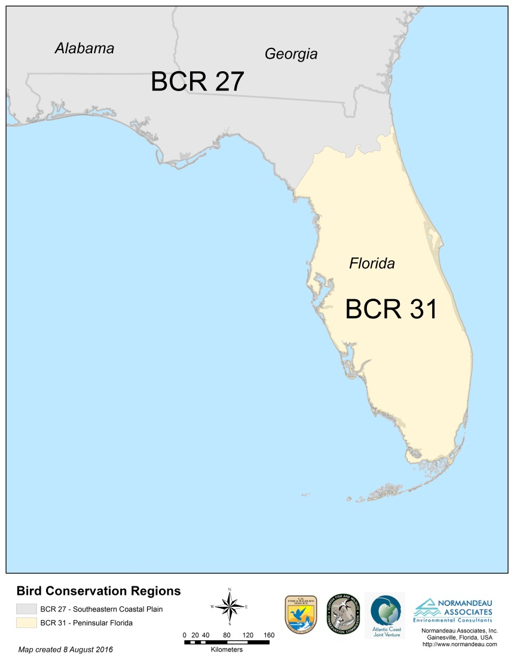
Figure 1. Boundaries of Peninsular Florida Bird Conservation Region (BCR 31).

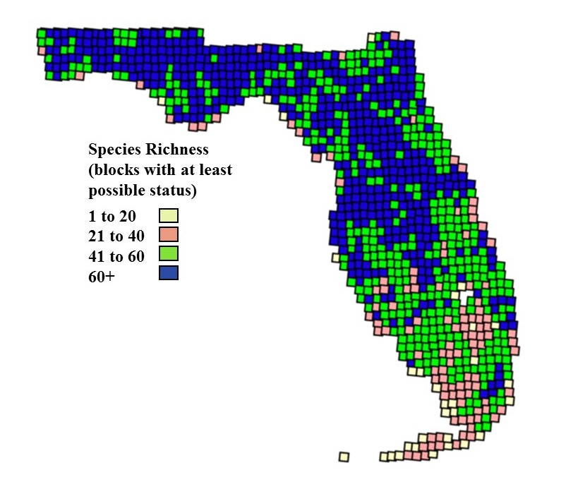
Figure 2. Species richness for most commonly recorded species in Florida’s first Breeding Bird Atlas (status possible, probable, or confirmed)
Source: FWC 2003

Physical Description
The Peninsular Florida BCR is a transition zone between the Southeastern Coastal Plain and the subtropics of south Florida. Though its highest points are lower than 100 m (328 ft), the peninsula contains a diverse variety of fresh water, saltwater, and terrestrial bird habitats (see Section 3.2). Excellent descriptions of these natural communities and processes that helped give the state its present character can be found in the following resources: State Wildlife Action Plan (SWAP; FWC 2012), Ecosystems of Florida (Myers and Ewel 1990), and Redner and Srinivasan (2014).

Numerous and diverse interior and coastal wetlands provide habitat for waterbirds and the highest diversity of wading birds in the United States. Priority bird species in BCR 31 typically considered landbirds (e.g., Snail Kite, Mangrove Cuckoo) also use aquatic habitats. Coastal beaches and mudflats hold diverse breeding shorebirds and larids such as terns and Black Skimmers. In the winter and during migration, these coastal habitats are used by a much larger diversity of shorebirds. Many of the peninsula’s wetlands are managed by local, state, or federal governments, affording them more protection from habitat conversion pressures than uplands. Still, many wetlands face altered hydrologic regimes from canals, and unnatural inputs from agriculture and urban runoff often degrade water quality. Coastal areas have high human use pressure and can even be affected by red tides.

The peninsula’s uplands have also faced an abundance of human threats including habitat conversion and fire suppression. Almost half of the peninsula’s land cover is categorized at Cultural Terrestrial, and only two natural communities contain more than 10% coverage: freshwater forested and nonforested wetlands (see Section 3.2). Sandhill, scrub, and dry prairie are particularly subject to conversion to housing and agriculture. Because of high levels of habitat fragmentation, fires can no longer spread across the landscape as they did in the past. Now wildfires are quickly controlled and smoldering embers that would have helped fires spread are swiftly extinguished. The majority of Florida’s uplands and many of its wetlands depend on fires as frequent as every few years to maintain the habitat structure needed for priority bird species such as Bachman’s Sparrows and Northern Bobwhite. Now land managers implement prescribed fires for the safety of humans and the benefit of wildlife, but there are many barriers to implementing these fires including weather, proximity to urban areas, and funding. Many once-burned areas have become overgrown and unsuitable for the bird species they once harbored.

Threats
Florida’s SWAP (FWC 2012) lists statewide threats to wildlife. More information about the majority of these threats can be found in the SWAP. The statewide threats that are most applicable to BCR 31 birds are briefly presented here.

Alterations of the Physical Environment
Habitat conversion, including habitat loss and fragmentation, affects most bird habitats statewide and is the most serious threats to the majority of Florida’s wildlife. These alterations of the physical environment are directly related to human activities such as construction of housing developments, commercial areas, and roads. Alteration of surface water flows through these activities as well as from canals has also changed the state’s landscape. As the state’s human population increases, more alterations of the physical environment can be expected to occur, with the highest pressure occurring on coastal and upland habitats.

Degradation of Water Resources
This widespread threat includes factors that alter hydrology and water quality, such as groundwater and surface water withdrawal, drainage or channelization of wetlands, diversion of rainfall from impervious cover, and various types of nonpoint source pollution including contamination from industrial and agricultural operations, inadequate stormwater treatment, and improper sewage management. Degradation of water resources is expected to continue in the near future as inputs increase and limits on groundwater withdrawals are reached.

Incompatible Fire Management
The majority of Florida’s birds are adapted to live in habitats shaped by fire. As increased human population and habitat fragmentation make the practice of prescribed burning more difficult, these fire-maintained habitats become degraded. Increased awareness of the value of prescribed fire for wildlife as well as human safety is currently leading to improvements in habitat management in parts of the state, but lack of burning is still a problem, especially in fragmented or otherwise difficult to safely burn habitats.

Introduced Plants and Animals
Invasive species, especially plants, can change community structure and composition and can alter hydrologic and fire regimes, soil sedimentation and erosion processes, and habitat values for birds. Invasive animals can also pose direct threats to birds, primarily through predation.

Climate Change
Much of the Florida peninsula will be impacted by only a small rise in sea level. Other effects of climate change could include shifts in rainfall patterns or fire regimes, both of which are difficult to accurately predict, but would almost certainly have dramatic impacts on birds. Finally, the human impact of climate change is also very difficult to predict, but such human actions as population shifts, major road-building projects, and coastal armoring could have dramatic impacts Florida’s birds.

Disturbance to Nesting and Roosting Birds
Disturbances to nesting and roosting areas can negatively impact birds. Some disturbances may cause long-term effects that might not be immediately apparent at the time of the disturbance. Other disturbances, such as a dog running through a colony of nesting terns, can cause an immediate, pronounced negative effect locally. Programs such as the Florida Shorebird Alliance and an increase in education and awareness about the negative effects of disturbance may reduce this threat in the future, though increased population pressure and a transient public make education a constant need.

Priority Species and Habitats
We classified priority bird species, identified priority habitats used by birds, and described priority species and habitat suites within the BCR, with the goal of providing guidance to partners when identifying and choosing among conservation actions.

Species
Bird species specifically mentioned in this plan are typically considered higher priority for conservation, but it is anticipated that many species not specifically mentioned in this plan will also benefit from the actions suggested to benefit priority bird species.

Species composition of groups of birds occurring in BCR 31 is outlined below.

Species Groups

Waterfowl
Priority Waterfowl include members of the order Anseriformes (waterfowl).

Waterbirds and Seabirds
For BCR 31, this group includes members of the families Gaviidae (loons), Podicipedidae (grebes), Phalacrocoracidae (cormorants), Anhingidae (Anhinga), Rallidae (rails, gallinules, and American Coot), Aramidae (Limpkin), and Gruidae (cranes). This group includes members of a group of birds often referred to as wading birds, including members of the families Ardeidae (herons, egrets, and bitterns), Ciconiidae (Wood Stork), and Threskiornithidae (ibises and Roseate Spoonbill). This group also includes seabirds, specifically members of the families Laridae (gulls, terns, and Black Skimmer), Pelecanidae (pelicans), Fregatidae (Magnificent Frigatebird), and Sulidae (boobies and Northern Gannet).

Members of the order Procellariiformes (tubenoses) are usually considered waterbirds, but are not covered in this plan because they are truly pelagic and do not nest in Florida. They therefore fall in BCRs 19 and 20, the Southeast U.S. Continental Shelf and the Gulf of Mexico respectively. Other pelagic seabirds such as Roseate Terns that nest in BCR 31 are associated with their nesting habitat in this plan (see Section 3.2).

Shorebirds
Priority Shorebirds include members of the families Haematopodidae (oystercatchers), Recurvirostridae (stilts and avocets), Charadriidae (plovers), and Scolopacidae (sandpipers and allies).

Landbirds
Priority landbirds comprise the order Passeriformes (perching birds/songbirds) and the following groups: Accipitridae (hawks, eagles, and kites), Apodidae (Chimney Swift), Caprimulgidae (nightjars), Columbidae (pigeons and doves), Cuculidae (cuckoos), Falconidae (falcons and Crested Caracara), Odontophoridae (New World quail), Phasianidae (Wild Turkey), Picidae (woodpeckers), and Strigidae (typical owls).

Species Rankings
The scoring rubric was derived from rules developed for the Atlantic Northern Forest (BCR 14) planning process (Dettmers 2006) and followed in the Piedmont (BCR 29) Implementation Plan (Table 2). The scoring rubric is based on three factors: continental concern, BCR responsibility (i.e., the importance of the BCR to a species’ global or continental distribution), and BCR concern (Table 2). A variety of data sources was used to derive scores for each of these three factors (Table 1), and discussions with Florida bird conservation partners also informed these scores. More information about the components (see footnotes in Table 2) used to score each of these factors can be found in the PIF Species Assessment Handbook (Panjabi et al. 2012). Subspecies and distinct population segments of concern in Florida were scored separately following a similar process, and continental concern was evaluated at the distinct population segment or subspecies level for those species. Federally and state-listed species were automatically listed as highest priority except for the Whooping Crane, which is a Nonessential Experimental Population.

Scores for identifying priority species were derived from the most recent available information in continental and regional plans including the State of the Birds report (North American Bird Conservation Initiative [NABCI] 2016), the 2012 Partners in Flight (PIF) Species Status Assessment (PIF Science Committee 2012), the 2016 PIF Landbird Conservation Plan (Rosenberg et al. 2016), the Southeast United States Regional Waterbird Conservation Plan (Hunter et al. 2006), and the North American Waterfowl Management Plan (North American Waterfowl Management Plan, Plan Committee 2004). Scoring for BCR Concern was based on BCR 31-specific information when possible (Table 1). When BCR-level scores were not available, continental scores were used, with some alterations to the scoring based on expert opinion of BCR-level threats. Continental Concern and BCR Concern scores were not always available from the same source. BCR Responsibility was determined using these same plans and databases, with more specific input from partners knowledgeable about those species occurring in BCR 31. The most up-to-date available scores and data were used.

Table 1. Sources of Data Used to Rank Priority Species in BCR 31
ACJV Ranking Process | Continental Concern | BCR Concern*
Waterfowl | Updated continental scores  (NAWMP 2016) | Derived from North American Waterfowl Management Plan
Waterbirds (breeding) | Updated continental scores  (NABCI 2016) | SE US Regional Waterbird Conservation Plan (Hunter et al. 2006) BCR 31 scores  (using TBx2+PT)
Waterbirds (nonbreeding/transient) | Updated continental scores  (NABCI 2016) | SE US Regional Waterbird Conservation Plan (Hunter et al. 2006) BCR 31 scores  (using TNx2+PT)
Shorebirds (breeding) | Updated continental scores  (NABCI 2016) | Updated continental scores  (NABCI 2016, using TBx2+PT)
Shorebirds (nonbreeding/transient) | Updated continental scores  (NABCI 2016) | Updated continental scores  (NABCI 2016, using TNx2+PT)
Landbirds (breeding) | Updated continental scores (Rosenberg et al. 2016) | PIF Species Status Assessment (PIF Science Committee 2012) BCR 31 scores (2012 version, using TBx2+PT)
Landbirds (nonbreeding/transient) | Updated continental scores (NABCI 2016) | PIF Species Status Assessment (PIF Science Committee 2012) continental scores
 |  | (NABCI 2016, using TNx2+PT)
*In some cases values were changed based on updated data.

This plan recognizes 130 bird species and subspecies as priority birds in BCR 31 (Table 3). Of these, approximately half have permanent resident populations in Peninsular Florida, almost 40 are nonbreeding visitors only, only about a dozen are present in the breeding season only, and about 15 visit the region only as transients. These species have been divided into a tiered framework ranked as Highest, High, and Moderate (Table 2).

The tiers are described as follows:
- Highest priority species are those requiring immediate action to recover, maintain, or improve existing populations levels or trends. These species are often given preference over lower ranked species when deciding where to focus efforts and allocate resources for management or other conservation actions.
- High priority species are those in need of immediate attention but from whom actions are not as time-sensitive as highest priority species because continental concerns or observed population declines are not as serious.
- Moderate priority species are those with populations that are more secure or subject to less serious threats at the continental or BCR level, and/or populations that have a smaller proportion of their continental distribution in the peninsula (e.g., species of conservation concern at the edge of their range and uncommon in the BCR). This group also includes several common species that are of moderate continental or BCR concern and for which the Florida peninsula supports a significant portion of the global population for the species.

Nuisance species are not addressed in this plan, but information on these species can be found on the FWC’s Nuisance Wildlife pages on their website.

Table 2. Criteria for Ranking Florida Priority Bird Species (adapted from Watson 2014)
Priority Tier | Criteria
 | Peninsular Florida Concern¹ | BCR Responsibility² | BCR Concern³ | Narrative
Highest | High | High or Moderate | High | Concern must be high, responsibility must be at least moderate
High | Moderate | High or Moderate | High | One or two criteria must be high, the others must be moderate, none are low
 | High | High or Moderate | Moderate
 | Moderate | High | Moderate
Moderate | High or Moderate | Low | High | Average must be at least moderate, one criterion may be low
 | Low | High or Moderate | High
 | High | Low | Moderate
 | Moderate | Moderate | Moderate
 | Low | High | Moderate
 | High | High or Moderate | Low
 | Moderate | High | Low
¹Peninsular Florida Concern is High if on PIF Watch List (CCS-max = 14 or 13 and PT-c = 5); Moderate if PIF Combined Continental Score of 12 or 13; otherwise Low
²BCR Responsibility is High if RD = 5 and %Pop > 5% or if RD = 4 and %Pop > 25%; Moderate
if RD > 3 and %Pop > 1%; Low if RD > 2, but where RD = 1 the species is only eligible for a Priority Tier if specifically designated as a priority by PIF regional partnership
- RD=Relative Density. Reflects the mean density of a species within a given BCR relative to density in the single BCR in which the species occurs in its highest density.
- %Pop=The proportion of the global population of a species that is contained within a BCR during the breeding season.
³BCR Concern is High if TB × 2 + PT > 10; Moderate if TB × 2 + PT > 7; otherwise Low
- TB=Threats to Breeding Populations. Indicates vulnerability due to the effects of current and probable future extrinsic conditions that threaten the ability of populations to survive and successfully reproduce in breeding areas within North America.
- PT=Population Trend. Indicates vulnerability due to the direction and magnitude of recent changes in population size.

Table 3. Priority Bird Species in the Peninsular Florida Bird Conservation Region (BCR 31). Italicized species are FWC State Threatened. Bolded species are federally Threatened or Endangered.
HIGHEST PRIORITY SPECIES
American Kestrel (Southeastern) | Least Tern | Seaside Sparrow (Cape Sable)
American Oystercatcher | Lesser Yellowlegs | Seaside Sparrow (migrant)
Bachman's Sparrow | Little Blue Heron | Seaside Sparrow (Scott's)
Black Rail | Mangrove Cuckoo | Short-tailed Hawk
Black Skimmer | Marsh Wren (Marian's) | Snail Kite
Burrowing Owl | Piping Plover | Snowy Plover
Cape May Warbler | Prairie Warbler (Florida) | Swallow-tailed Kite
Connecticut Warbler | Red Knot | Tricolored Heron
Crested Caracara | Red-cockaded Woodpecker | White-crowned Pigeon
Florida Scrub-Jay | Reddish Egret | Willet
Grasshopper Sparrow (Florida) | Roseate Spoonbill | Wilson's Plover
Great White Heron | Roseate Tern | Wood Stork
King Rail | Saltmarsh Sparrow | Yellow Rail
Kirtland's Warbler | Sandhill Crane (Florida) | -

HIGH PRIORITY SPECIES
American Avocet | Dunlin | Red-headed Woodpecker
American Bittern | Eastern Whip-poor-will | Ruddy Turnstone
American Woodcock | Horned Grebe | Sanderling
Anhinga | Least Bittern | Semipalmated Sandpiper
Bicknell's Thrush | Lesser Scaup | Short-billed Dowitcher
Black Tern | Marbled Godwit | Sooty Tern
Black-bellied Plover | Mottled Duck | Veery
Black-whiskered Vireo | Northern Bobwhite | Whimbrel
Bobolink | Painted Bunting | White Ibis
Clapper Rail (Mangrove) | Pectoral Sandpiper | -
Common Tern | Prairie Warbler (migrant) | -

MODERATE PRIORITY SPECIES
American Coot | Field Sparrow | Prothonotary Warbler
American Golden-Plover | Forster's Tern | Purple Gallinule
Black Scoter | Golden-winged Warbler | Purple Martin
Black-crowned Night-Heron | Grasshopper Sparrow (migrant) | Royal Tern
Blackpoll Warbler | Gray Kingbird | Rusty Blackbird
Bonaparte's Gull | Greater Yellowlegs | Short-eared Owl
Brown Booby | Green Heron | Snowy Egret
Brown Noddy | Gull-billed Tern | Sora
Brown Pelican | Henslow's Sparrow | Western Sandpiper
Brown-headed Nuthatch | Kentucky Warbler | White-rumped Sandpiper
Cerulean Warbler | Least Sandpiper | White-tailed Kite
Chimney Swift | Limpkin | Whooping Crane*
Chuck-will's-widow | Loggerhead Shrike | Wilson's Phalarope
Clapper Rail | Long-billed Curlew | Wood Thrush
Common Gallinule | Long-billed Dowitcher | Worm-eating Warbler
Common Ground-Dove | Magnificent Frigatebird | Yellow Warbler (Cuban)
Common Loon | Masked Booby | Yellow-billed Cuckoo
Common Nighthawk | Nelson's Sparrow | Yellow-crowned Night-Heron
Eastern Meadowlark | Northern Flicker | -
Eastern Towhee | Ovenbird | -
* Nonessential Experimental Population

Habitat Types
Habitat types were derived from the Florida Cooperative Land Cover Map (CLC; Redner and Srinivasan 2014), a partnership between the FWC and the Florida Natural Areas Inventory (FNAI). The CLC is updated regularly and uses a hierarchical scheme and numbering system that can be applied at different scales (Kawula 2009). Major classes include uplands (Class 1000), palustrine (Class 2000), riverine (Class 3000), lacustrine (Class 4000), estuarine (Class 5000), marine (Class 6000), exotics (Class 7000), open water (Class 8000), and other (Class 9000). For this plan, we chose to use one level down from these classes (hereafter referred to as “Class 2” natural communities; Table 4, Figure 3).

Twenty Class 2 natural community types have been identified as occurring in BCR 31, twenty of which are noted below along with one Class 1 community, Exotic Plants (Table 4, Figure 3). Some of these types have little to no acreage in the BCR (e.g., Surf Zone, Cultural Estuarine, Barren, and Outcrop Communities). We identified Class 2 natural communities that provide priority habitat for landbirds, waterbirds, shorebirds, and waterfowl.

Of these 20 natural communities, we selected several, including some aquatic communities, as priority landbird habitat in Peninsular Florida. Other natural communities either represent a smaller percentage of the BCR or are less important to priority landbirds. Cultural Terrestrial natural communities are not natural, but are included as priority habitat because they support many priority bird species (e.g., highest priority species Southeastern American Kestrel, Burrowing Owl, and Crested Caracara).

Extensive wetlands in Peninsular Florida’s interior and on its coast are excellent waterbird habitat. These wetlands include saltwater estuaries and lagoons, fresh and saltwater marshes and swamps, and lakes, rivers, and creeks as well as constructed water treatment areas and impoundments. Water levels in many of these constructed wetlands vary seasonally so that birds move from wetland to wetland depending on water level. Other than the Cultural Terrestrial community class that contains more than half the state’s acreage, two wetlands communities are the only other classes with more than 10% of the total natural community acreage in the state: Freshwater Nonforested Wetlands (16%) and Freshwater Forested Wetlands (11%). All of the state’s wetland communities are of some degree of importance to priority bird species. Because some coastal communities such as Surf Zone are very narrow and constricted by water and land on either side, they have very small acreages but are proportionally very important to foraging birds such as several species of priority shorebirds.

Open water (pelagic) habitats and their associated species (e.g., Black-capped Petrel, Audubon’s Shearwater) are not included as part of the BCR 31 plan because they are covered in other BCRs, specifically BCR 19 for the Atlantic and BCR 20 for the Gulf of Mexico. However, pelagic seabirds such as Roseate Terns that nest in BCR 31 are included in this plan.

More information about bird habitats in BCR 31 can be found in Florida’s SWAP (FWC 2012) and in Redner and Srinivasan (2014).

Table 4. Class 2 Communities in BCR 31
Category* | Land Cover Name | BCR 31 Hectares | BCR 31 Acres | % of BCR 31
1100 | Hardwood Forested Uplands | 86,542 | 213,850 | 0.88%
1200 | High Pine and Scrub | 293,774 | 725,931 | 2.97%
1300 | Pine Flatwoods and Dry Prairie | 571,685 | 1,412,664 | 5.79%
1400 | Mixed Hardwood Coniferous | 241,403 | 596,519 | 2.44%
1500 | Shrub and Brushland | 78,744 | 194,580 | 0.80%
1600 | Coastal Uplands | 19,727 | 48,746 | 0.20%
1700 | Barren and Outcrop Communities | 159 | 394 | 0.00%
1800 | Cultural Terrestrial | 4,500,391 | 11,120,699 | 45.57%
2100 | Freshwater Nonforested Wetlands | 1,557,529 | 3,848,734 | 15.77%
2200 | Freshwater Forested Wetlands | 1,097,398 | 2,711,726 | 11.11%
2300 | Nonvegetated Wetland | 729 | 1,802 | 0.01%
2400 | Cultural Palustrine | 23,751 | 58,691 | 0.24%
3100 | Natural Lakes and Ponds | 355,101 | 877,474 | 3.60%
3200 | Cultural Lacustrine | 142,290 | 351,606 | 1.44%
4100 | Natural Rivers and Streams | 44,547 | 110,079 | 0.45%
4200 | Cultural Riverine | 31,589 | 78,058 | 0.32%
5000 | Estuarine | 454,531 | 1,123,169 | 4.60%
5200 | Intertidal | 347,720 | 859,233 | 3.52%
5300 | Cultural Estuarine | 2,172 | 5,366 | 0.02%
6100 | Surf Zone | 18 | 45 | 0.00%
7000 | Exotic Plants | 26,745 | 66,089 | 0.27%
 | Total: | 9,876,546 | 24,405,454 | 100.00%
Source: A. Kubes and J. Redner, FWC, pers. comm.
*Classification accuracy varies among data sources that contribute to the map and metadata related to accuracy were not available for all sources. Some data sources were field verified. Most data were created through classification and interpretation of satellite imagery and other ancillary information. Classes that are ephemeral, dynamic, or transitional in nature (i.e., Surf Zone; Intertidal; and Natural Rivers and Streams; and associated subclasses) are underrepresented in this dataset. Objects less than the minimal mapping unit (0.5 acres) are not represented in this dataset.

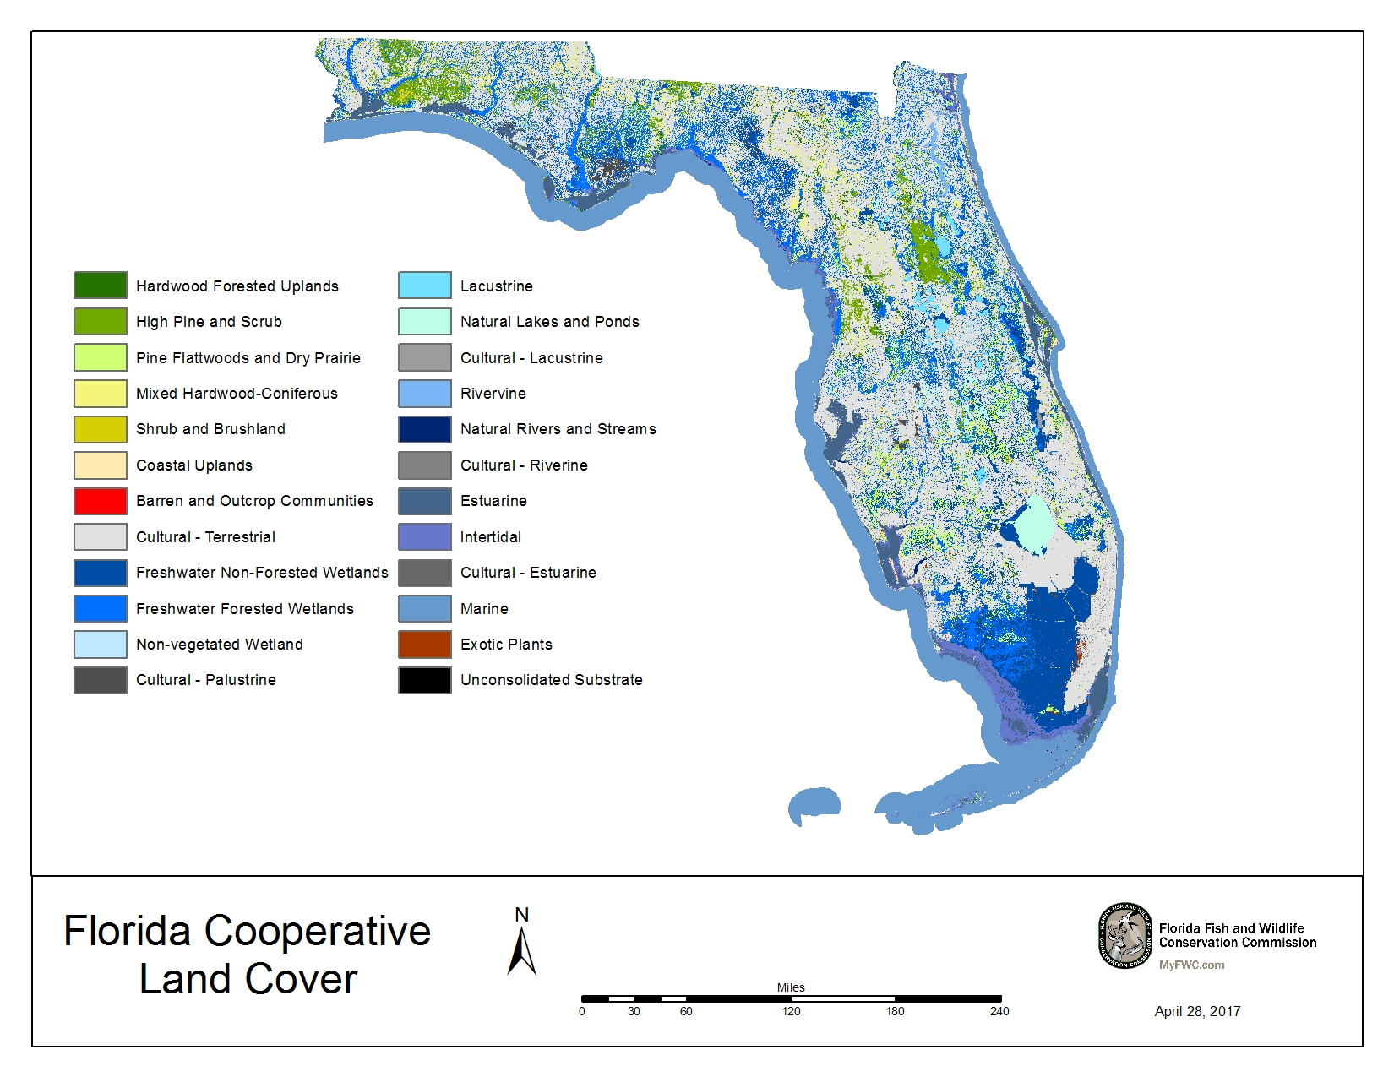
Figure 3. Florida Cooperative Land Cover class 2 communities.
Source: A. Kubes and E. Salinas, FWC, pers. comm.

Priority Species and Habitat Suites
During the bird conservation partner meeting in Gainesville on 1 June 2016, a suite of priority bird habitats was chosen based on partner input:
Uplands:
1100 Hardwood Forested Uplands
1200 High Pine and Scrub
1300 Pine Flatwoods and Dry Prairie
1400 Mixed Hardwood Coniferous
1500 Shrub and Brushland
1600 Coastal Uplands
1800 Cultural Terrestrial
Wetlands:
2100 Freshwater Nonforested Wetlands
2200 Freshwater Forested Wetlands
2400 Cultural Palustrine
5200 Intertidal

These habitats were chosen as the most valuable for native bird species, though other land covers also support some priority bird species.

Descriptions of these vegetation classes (in italics) are from Redner and Srinivasan (2014). This resource was chosen as the guide for this plan because it contains current habitat descriptions, has been adopted by both FWC and FNAI, and cross-walks to other classification systems used in the state. The bird associations listed in the tables for each vegetation class indicate species primarily found in these habitats that may also use different habitats during certain life stages, especially during migration. Personal communication from Chuck Hunter as well as expert opinion were used to inform the priority species lists for each habitat. In the tables below, bolded class codes at the top of each table are broad Class 2 categories, while vegetation classes listed below in italics are subclasses. The number of hectares in BCR 31 and percentage of BCR 31 for each natural community are from FWC.

1100 Hardwood Forested Uplands
Mesic or xeric forest dominated mainly by hardwood trees.
- 86,542 hectares (213,850 acres) in BCR 31
- 0.88% of BCR 31

Table 5. Priority Species in Hardwood Forested Uplands
Class Code | Habitat/Subclass | Species
 |  | Highest Priority | High Priority | Moderate Priority
1100  1110  1120  1130  1140  1150 | Hardwood Forested Uplands  Upland Hardwood Forest  Mesic Hammock  Rockland Hammock  Slope Forest  Xeric Hammock | Cape May Warbler  Connecticut Warbler  Kirtland's Warbler  Mangrove Cuckoo  Prairie Warbler (Florida)  Short-tailed Hawk  Swallow-tailed Kite  White-crowned Pigeon | American Woodcock  Black-whiskered Vireo  Eastern Whip-poor-will  Painted Bunting  Prairie Warbler (migrant)  Red-headed Woodpecker  Veery | Blackpoll Warbler  Cerulean Warbler  Chimney Swift  Chuck-will’s-widow  Eastern Towhee  Golden-winged Warbler  Kentucky Warbler  Northern Flicker  Ovenbird  Prothonotary Warbler  Wood Thrush  Worm-eating Warbler  Yellow-billed Cuckoo

Hardwood Forested Uplands are also known as Upland Hardwood Forest or Upland Mixed Forest in older classifications (FNAI 1990). These natural communities contain a variety of hardwood hammocks (Redner and Srinivasan 2014). These communities are a small percentage of the state, usually in fire shadows, but are important for migratory birds, such as many warblers, and resident landbirds, such as Red-headed Woodpecker, Northern Flicker, and Chuck-will’s-widow.

Subclasses within BCR 31 include1110 Upland Hardwood Forest, 1120 Mesic Hammock, 1130 Rockland Hammock, and 1150 Xeric Hammock.

1200 High Pine and Scrub
Hills with mesic or xeric woodlands or shrublands; canopy, if present, open and consisting of pine or a mixture of pine and deciduous hardwoods.
- 293,774 hectares (725,931 acres) in BCR 31
- 2.97% of BCR 31

Table 6. Priority Species in High Pine and Scrub
Class Code | Habitat/Subclass | Species
 |  | Highest Priority | High Priority | Moderate Priority
1200  1210  1220  1230  1240 | High Pine and Scrub  Scrub (Oak, Rosemary, Sand Pine, and Coastal Scrub)  Upland Mixed Woodland  Upland Coniferous  Sandhill | American Kestrel (Southeastern)  Bachman's Sparrow  Florida Scrub-Jay  Red-cockaded Woodpecker | Northern Bobwhite  Red-headed Woodpecker | Brown-headed Nuthatch  Chuck-will's-widow  Common Ground-Dove  Common Nighthawk  Eastern Towhee  Field Sparrow  Loggerhead Shrike  Northern Flicker

High Pine and Scrub contain two of the most important bird habitats in BCR 31, Sandhill and Scrub, but also other well-drained upland pinelands. These uplands are important habitat for many priority landbirds including the federally listed Florida Scrub-Jay and Red-cockaded Woodpecker as well as Bachman's Sparrow. High Pine has many species in common with Pine Flatwoods.

Subclasses within BCR 31 include 1210 Scrub (Oak, Rosemary, Sand Pine, and Coastal Scrub), 1220 Upland Mixed Woodland, 1230 Upland Coniferous, and 1240 Sandhill.

1300 Pine Flatwoods and Dry Prairie
Mesic pine woodland or mesic shrubland on flat sandy or limestone substrates, often with a hard pan that impedes drainage.
- 571,685 hectares (1,412,664 acres) in BCR 31
- 5.79% of BCR 31

Table 7. Priority Species in Flatwoods and Dry Prairie
Class Code | Habitat/Subclass | Species
 |  | Highest Priority | High Priority | Moderate Priority
1300  1310  1320  1330  1340 | Flatwoods and Dry Prairie  Dry Flatwoods (both Mesic and Scrubby Flatwoods)  Pine Rockland  Dry Prairie  Palmetto Prairie | Bachman's Sparrow  Burrowing Owl  Crested Caracara  Florida Scrub-Jay  Grasshopper Sparrow (Florida)  Red-cockaded Woodpecker  Sandhill Crane (Florida)  Swallow-tailed Kite  Yellow Rail | Mottled Duck  Northern Bobwhite  Red-headed Woodpecker | Brown-headed Nuthatch  Chuck-will's-widow  Common Ground-Dove  Common Nighthawk  Eastern Meadowlark  Eastern Towhee  Field Sparrow  Henslow's Sparrow  Loggerhead Shrike  Northern Flicker

Pine Flatwoods and Dry Prairie include forested flatwoods and open prairie. Pine Flatwoods has species in common with High Pine, including Red-cockaded Woodpecker and Bachman's and Henslow's sparrows. The treeless dry prairies of central Florida are important habitat for many priority landbirds including the federally listed Florida Grasshopper Sparrow, Crested Caracara, and the state-listed Florida Burrowing Owl.

Subclasses within BCR 31 include 1310 Dry Flatwoods (both Mesic and Scrubby Flatwoods), 1320 Pine Rockland, 1330 Dry Prairie, and 1340 Palmetto Prairie.

1400 Mixed Hardwood Coniferous
Mix of hardwood and coniferous trees where neither is dominant.
- 241,403 hectares (596,519 acres) in BCR 31
- 2.44% of BCR 31

Table 8. Priority Species in Mixed Hardwood Coniferous
Class Code | Habitat/Subclass | Species
 |  | Highest Priority | High Priority | Moderate Priority
1400  1410 | Mixed Hardwood Coniferous  Successional Hardwood Forest | Cape May Warbler  Connecticut Warbler  Kirtland's Warbler  Short-tailed Hawk  Swallow-tailed Kite | American Woodcock  Black-whiskered Vireo  Eastern Whip-poor-will  Painted Bunting  Prairie Warbler (migrant)  Red-headed Woodpecker | Blackpoll Warbler  Chimney Swift  Chuck-will’s-widow  Eastern Towhee  Kentucky Warbler  Northern Flicker  Ovenbird  Wood Thrush  Worm-eating Warbler  Yellow-billed Cuckoo

Mixed Hardwood Coniferous forests contain a similar species composition as Hardwood Forested Uplands, although they make up a larger percentage of the state and are usually more frequently burned. They are also important for migratory birds.

The subclass 1410 Successional Hardwood Forest in included within BCR 31.

1500 Shrub and Brushland
An early condition of old-field succession, dominated by various shrubs, tree saplings, and lesser amounts of grasses and herbs. Includes a variety of land covers where natural upland community types have been recently disturbed through clear-cutting commercial pinelands, land clearing, or fire, and are recovering through natural successional processes.
- 78,744 hectares (194,580 acres) in BCR 31
- 0.80% of BCR 31

Table 9. Priority Species in Shrub and Brushland
Class Code | Habitat/Subclass | Species
 |  | Highest Priority | High Priority | Moderate Priority
1500  1510 | Shrub and Brushland  Other Shrubs and Brush | Kirtland's Warbler  Prairie Warbler (Florida) | Eastern Whip-poor-will  Northern Bobwhite  Painted Bunting  Prairie Warbler (migrant) | Common Ground-Dove  Common Nighthawk  Eastern Towhee  Kentucky Warbler

Shrub and Brushland habitats have many species in common with Scrub habitat (in the High Pine and Scrub category) as well as Dry Prairie (in the Pine Flatwoods and Dry Prairie category) and are important for several declining species such as Northern Bobwhite, Eastern Whip-poor-will, and Common Nighthawk.

The subclass 1510 Other Shrubs and Brush is included within BCR 31.

1600 Coastal Uplands
Mesic or xeric communities restricted to barrier islands and near shore; woody or herbaceous vegetation; other communities may also occur in coastal environments.
- 19,727 hectares (48,746 acres) in BCR 31
- 0.20% of BCR 31

Table 10. Priority Species in Coastal Uplands
Class Code | Habitat/Subclass | Species
 |  | Highest Priority | High Priority | Moderate Priority
1600  1610  1620  1630  1640  1650  1660  1670 | Coastal Uplands  Beach Dune  Coastal Berm  Coastal Grassland  Coastal Strand  Maritime Hammock  Shell Mound  Sand Beach (Dry) | American Oystercatcher  Black Rail  Black Skimmer  Cape May Warbler  Connecticut Warbler  Kirtland's Warbler  Least Tern  Mangrove Cuckoo  Piping Plover  Red Knot  Roseate Tern  Snowy Plover  Willet  Wilson's Plover | Bicknell's Thrush  Black-bellied Plover  Black-whiskered Vireo  Black Tern  Bobolink  Common Tern  Dunlin  Eastern Whip-poor-will  Marbled Godwit  Mottled Duck  Painted Bunting  Prairie Warbler (migrant)  Red-headed Woodpecker  Ruddy Turnstone  Sanderling  Semipalmated Sandpiper  Short-billed Dowitcher  Veery  Whimbrel | Blackpoll Warbler  Bonaparte's Gull  Cerulean Warbler  Chuck-will's-widow  Common Ground-Dove  Common Nighthawk  Eastern Meadowlark  Eastern Towhee  Forster's Tern  Golden-winged Warbler  Gray Kingbird  Gull-billed Tern  Kentucky Warbler  Least Sandpiper  Loggerhead Shrike  Long-billed Curlew  Masked Booby  Northern Flicker  Ovenbird  Prothonotary Warbler  Royal Tern  Snowy Egret  Western Sandpiper  White-rumped Sandpiper  Wood Thrush  Worm-eating Warbler  Yellow-billed Cuckoo

Costal Uplands are similar to other communities such as Hardwood Forested Uplands, Shrub and Brushland, and Dry Prairie. These communities often have a large oak or shrub component and in some cases may merge into another community with little noticeable transition. These uplands are important habitat for priority landbirds including Painted Buntings and migrant warblers. Because this community includes Sand Beach, beach-nesting birds such as Snowy Plovers and Black Skimmers are also included here.

Subclasses within BCR 31 include1610 Beach Dune, 1620 Coastal Berm, 1630 Coastal Grassland, 1640 Coastal Strand, 1650 Maritime Hammock, 1660 Shell Mound, and 1670 Sand Beach (Dry).

1800 Cultural Terrestrial
Includes communities that are both created and maintained by human activities or are modified by human influence to such a degree that the physical conformation of the substrate, or the biological composition of the resident community, is substantially different from the character of the substrate or community as it existed prior to human influence.
- 4,500,391 hectares (11,120,699 acres) in BCR 31
- 45.57% of BCR 31

Table 11. Priority Species in Cultural Terrestrial
Class Code | Habitat/  Subclass | Species
 |  | Highest Priority | High Priority | Moderate Priority
1800  1810  1820  1830  1840  1850  1860  1870  1880 | Cultural Terrestrial  Mowed Grass  Urban (including Urban Open Pine, Golf Courses, Cemeteries, Commercial and Residential, etc.)  Rural (including Agriculture, Pasture, and Tree Plantations)  Transportation  Communication  Utilities  Extractive (including Strip Mines, Reclaimed Lands, and Spoil Areas)  Bare Soil/Clear Cut | American Kestrel (Southeastern)  Bachman's Sparrow  Burrowing Owl  Crested Caracara  Sandhill Crane (Florida)  Short-tailed Hawk  Swallow-tailed Kite | American Woodcock  Bicknell's Thrush  Black-bellied Plover  Bobolink  Eastern Whip-poor-will  Northern Bobwhite  Painted Bunting  Pectoral Sandpiper  Prairie Warbler (migrant)  Red-headed Woodpecker  Veery | American Golden-Plover  Blackpoll Warbler  Brown-headed Nuthatch  Cerulean Warbler  Chimney Swift  Chuck-will's-widow  Common Ground-Dove  Common Nighthawk  Eastern Meadowlark  Eastern Towhee  Field Sparrow  Golden-winged Warbler  Grasshopper Sparrow (migrant)  Gray Kingbird  Henslow's Sparrow  Kentucky Warbler  Least Sandpiper  Loggerhead Shrike  Northern Flicker  Ovenbird  Purple Martin  Short-eared Owl  Snowy Egret  Sora  White-tailed Kite  Whooping Crane  Wood Thrush  Worm-eating Warbler  Yellow-billed Cuckoo
Cultural Terrestrial includes a variety of human-influenced communities from Industrial, Transportation, and High Intensity Urban to Agriculture and Unimproved/Woodland Pasture. Due to extensive loss of dry prairie and sandhill, pastures and similar open habitats provide important habitat for state-listed species such as the Florida Sandhill Crane, Southeastern American Kestrel, and Burrowing Owl, as well as the Federally-listed Crested Caracara. While Cultural-Terrestrial habitat is important for these and other priority birds (shorebirds, waterfowl, and waterbirds), other natural communities are also important for these species.

Subclasses within BCR 31 include 1810 Mowed Grass, 1820 Urban (including Urban Open Pine, Golf Courses, Cemeteries, and more heavily built up categories such as Commercial and Residential), 1830 Rural (including Agriculture, Pasture, and Tree Plantations), and 1870 Extractive (including Strip Mines, Reclaimed Lands, and Spoil Areas).

2100 Freshwater Nonforested Wetlands
Herbaceous or shrubby palustrine communities in floodplains or depressions; canopy trees, if present, are very sparse and often stunted.
- 1,557,529 hectares (3,848,734 acres) in BCR 31
- 15.77% of BCR 31

Table 12. Priority Species in Freshwater Nonforested Wetlands
Class Code | Habitat/Subclass | Species
 |  | Highest Priority | High Priority | Moderate Priority
2100  2110  2120,2130  2140  2150 | Freshwater Nonforested Wetlands  Prairies and Bogs  Marshes  Floating/Emergent Aquatic Vegetation  Submergent Aquatic Vegetation | Black Rail  King Rail  Lesser Yellowlegs  Little Blue Heron  Roseate Spoonbill  Sandhill Crane (Florida)  Seaside Sparrow (Cape Sable)  Snail Kite  Tricolored Heron  Wood Stork  Yellow Rail | American Bittern  American Golden-Plover  Anhinga  Black Tern  Bobolink  Least Bittern  Mottled Duck  Pectoral Sandpiper  Semipalmated Sandpiper  White Ibis | American Coot  Black-crowned Night-Heron  Common Gallinule  Eastern Meadowlark  Greater Yellowlegs  Green Heron  Gull-billed Tern  Least Sandpiper  Limpkin  Long-billed Dowitcher  Purple Gallinule  Snowy Egret  Sora  White-rumped Sandpiper  Whooping Crane  Yellow-crowned Night Heron

Freshwater Nonforested Wetlands make up the second largest percentage of BCR 31 and are the largest natural community in the area. These open wetlands are important habitat for many priority waterbirds including most species of waders, rails, shorebirds, and waterfowl. They are also important habitat for some landbirds such as Snail Kite and Eastern Meadowlark.

Subclasses within BCR 31 include 2110 Prairies and Bogs, 2120 and 2130 Marshes, 2140 Floating/Emergent Aquatic Vegetation, and 2150 Submergent Aquatic Vegetation.

2200 Freshwater Forested Wetlands
Floodplain or depression wetlands dominated by hydrophytic trees.
- 1,097,398 hectares (2,711,726 acres) in BCR 31
- 11.11% of BCR 31

Table 13. Priority Species in Freshwater Forested Wetlands
Class Code | Habitat/Subclass | Species
 |  | Highest Priority | High Priority | Moderate Priority
2200  2210  2220  2230 | Freshwater Forested Wetlands  Cypress/Tupelo  Other Coniferous Wetlands (e.g., Wet Flatwoods)  Other Hardwood Wetlands (e.g., Hydric Hammock) | Little Blue Heron  Red-cockaded Woodpecker  Roseate Spoonbill  Short-tailed Hawk  Swallow-tailed Kite  Tricolored Heron  Wood Stork | American Woodcock  Anhinga  Red-headed Woodpecker  White Ibis | Black-crowned Night-Heron  Brown-headed Nuthatch  Chimney Swift  Chuck-will's-widow  Eastern Towhee  Green Heron  Limpkin  Loggerhead Shrike  Northern Flicker  Prothonotary Warbler  Rusty Blackbird  Yellow-crowned Night Heron

Freshwater Forested Wetlands make up the third largest percentage of BCR 31 and are the second largest natural community in the area. These wetlands with variable height tree canopy are important habitat for many species of waders including the Wood Stork. They are also important habitat for many landbirds including Red-headed Woodpecker, Prothonotary Warbler, Short-tailed Hawk, and Swallow-tailed Kite.

Subclasses within BCR 31 include 2210 Cypress/Tupelo, 2220 Other Coniferous Wetlands (e.g., Wet Flatwoods), and 2230 Other Hardwood Wetlands (e.g., Hydric Hammock).

2400 Cultural Palustrine
Communities that are created and maintained by human activities or are modified by human influence to such a degree that the physical conformation of the substrate, the hydrology, or the biological composition of the resident community is substantially different from the character of the substrate, hydrology, or community as it existed prior to human influence.
- 23,751 hectares (58,691 acres) in BCR 31
- 0.24% of BCR 31

Table 14. Priority Species in Cultural Palustrine
Class Code | Habitat/Subclass | Species
 |  | Highest Priority | High Priority | Moderate Priority
2400  2410  2420  2430  2440  2450 | Cultural Palustrine  Impounded Marsh  Impounded Swamp  Grazed Wetlands  Clearcut Wetland  Wet Coniferous Plantation | American Golden-Plover  Black Rail  King Rail  Lesser Yellowlegs  Little Blue Heron  Roseate Spoonbill  Sandhill Crane (Florida)  Short-tailed Hawk  Snail Kite  Swallow-tailed Kite  Tricolored Heron  Wood Stork  Yellow Rail | American Bittern  American Woodcock  Anhinga  Black Tern  Least Bittern  Mottled Duck  Pectoral Sandpiper  Red-headed Woodpecker  Semipalmated Sandpiper  White Ibis | American Coot  Black-crowned Night-Heron  Bobolink  Chuck-will's-widow  Common Gallinule  Eastern Towhee  Eastern Meadowlark  Greater Yellowlegs  Green Heron  Gull-billed Tern  Least Sandpiper  Limpkin  Long-billed Dowitcher  Northern Flicker  Prothonotary Warbler  Purple Gallinule  Snowy Egret  Sora  White-rumped Sandpiper  White-tailed Kite  Whooping Crane  Yellow-crowned Night Heron

Bird species composition for Cultural Palustrine wetlands is similar to that of other freshwater wetlands depending on whether or not trees and shrubs are present and their density. In some areas, Impounded Marshes are very important for wintering waterfowl as well as Snail Kites. Impounded Swamps can be important for Red-headed Woodpeckers and Prothonotary Warbler, depending on their hydroperiod and availability of snags.

Subclasses within BCR 31 include 2410 Impounded Marsh, 2420 Impounded Swamp, 2430 Grazed Wetlands, 2440 Clearcut Wetland, and 2450 Wet Coniferous Plantation.

5200 Intertidal
Includes the area between the highest tide level and the lowest tide level; the substrate is periodically exposed and flooded by semidiurnal tides (two high tides and two low tides per tidal day.
- 347,720 hectares (859,233 acres) in BCR 31
- 3.52% of BCR 31

Table 15. Priority Species in Intertidal
Class Code | Habitat/Subclass | Species
 |  | Highest Priority | High Priority | Moderate Priority
5200  5210  5220  5230  5240  5250 | Intertidal  Exposed Limestone  Tidal Flat  Oyster Bar  Salt Marsh  Mangrove Swamp | American Oystercatcher  Black Rail  Black Skimmer  Cape May Warbler  Great White Heron  Kirtland's Warbler  Least Tern  Lesser Yellowlegs  Little Blue Heron  Mangrove Cuckoo  Marsh Wren (Marian's)  Piping Plover  Prairie Warbler (Florida)  Reddish Egret  Red Knot  Roseate Spoonbill  Roseate Tern  Saltmarsh Sparrow  Seaside Sparrow (migrant)  Seaside Sparrow (Scott's)  Snowy Plover  Tricolored Heron  White-crowned Pigeon  Willet  Wilson's Plover  Wood Stork  Yellow Rail | American Avocet  American Bittern  Anhinga  Black Tern  Black-bellied Plover  Black-whiskered Vireo  Clapper Rail (Mangrove)  Common Tern  Dunlin  Green Heron  Least Bittern  Marbled Godwit  Mottled Duck  Prairie Warbler (migrant)  Ruddy Turnstone  Sanderling  Semipalmated Sandpiper  Short-billed Dowitcher  Sooty Tern  Whimbrel  White Ibis | American Coot  American Golden-Plover  Black-crowned Night-Heron  Blackpoll Warbler  Bonaparte's Gull  Brown Noddy  Brown Pelican  Cerulean Warbler  Clapper Rail  Forster's Tern  Golden-winged Warbler  Gray Kingbird  Greater Yellowlegs  Gull-billed Tern  Kentucky Warbler  Least Sandpiper  Long-billed Curlew  Magnificent Frigatebird  Nelson's Sparrow  Ovenbird  Western Sandpiper  White-rumped Sandpiper  Wilson's Phalarope  Wood Thrush  Worm-eating Warbler  Yellow Warbler (Cuban)  Yellow-billed Cuckoo  Yellow-crowned Night Heron

Intertidal includes such diverse communities as Tidal Flat, Salt Marsh, and Mangrove Swamp. These are important habitat for many priority landbirds including the federally listed Wood Stork, Piping Plover, and Red Knot and state-listed Snowy Plover, Least Tern, American Oystercatcher, and White-crowned Pigeon.

Subclasses within BCR 31 include 5210 Exposed Limestone, 5220 Tidal Flat, 5230 Oyster Bar, 5240 Salt Marsh, and 5250 Mangrove Swamp.

Priority Species Population and Habitat Objectives
Population and habitat objectives are lacking for most priority bird species in BCR 31, especially at the BCR level. Most of the information on these objectives is from either national or statewide plans. More is known about the habitat needs of breeding birds, while fewer studies have been done on the habitat needs of birds that are strictly migratory in Florida, especially as far as minimum patch size and specific habitat components. Within BCR 31, critical habitat has been designated by the USFWS for Cape Sable Seaside Sparrow, Piping Plover, and Snail Kite. More information about this critical habitat is available from the USFWS Environmental Conservation Online System (ECOS) webpages (USFWS 2017).

The following qualitative objectives are available for different taxa groups:

Waterbirds (Hunter et al. 2006):
Overarching conservation goals for the region include the following:
- Recover declining and otherwise vulnerable high priority species and subspecies (especially listed taxa) to healthy population levels region-wide.
- Maintain healthy populations of other species.
- Restore and protect habitats essential for conservation.
- Develop and implement science-based approaches to resolving issues related to human interactions with waterbirds, including depredation, fishing gear entanglement, and collision with structures, including the establishment of maximum acceptable population reduction objectives if justified.

Specific objectives for Florida:
- Protect populations and habitats in areas essential for conservation of high-priority brush- and tree-nesting species (i.e. the Everglades, Florida Bay).
- Protect and restore nesting beaches for beach nesting waterbirds.
- Protect and manage marsh, wet prairie, savanna, and grassland habitat for marshbirds.
- Resolve factors that may be causing high mortality for open water and pelagic species.
- Increase populations for additional regionally important species such as Little Blue Heron, Magnificent Frigatebird, and Interior Least Tern.

Shorebirds (Hunter 2002):
Three general habitat goals for BCR 31 are the following:
- Provide optimal breeding habitat to maintain and increase populations of priority species.
- Provide high-quality managed habitat to support requirements of species migrating through or spending winter in the region.
- Restrain human disturbance to tolerable levels for shorebirds throughout the year.
Regional population goals:
- Maintain breeding populations and ensure high reproductive success to ensure sustainable populations of each of the highest-priority species in the region.
- During the next 50 years, double the breeding population size for each of the highest-priority species in the region, and/or determine population levels needed to ensure long-term viability through population viability analyses.

Habitat and management goals:
- Provide optimal breeding habitat to maintain and increase priority species populations in the planning region.
- Provide high-quality managed habitat to support successful migration through and over wintering within the planning region.
- Maintain disturbance frequencies at breeding, foraging, and roost sites to below the tolerance levels for successful reproduction or for maintaining fat stores needed for long-distance migration.
- Work closely with beach managers and communities (including sea turtle monitoring crews) and educate them on ways to minimize plover nest disturbance and to avoid running over plover chicks where use of vehicles is allowed on beaches.
- Provide specific guidance for both private and public land managers to closely match peak shorebird habitat needs in their respective areas (e.g., to slow the timing of spring draw-downs and build in habitat recommendations involving teal considerations in autumn).
- Provide cooperating private landowners with proper incentives to delay planting for about a month.
- Assess individual managers’ current contributions as well as their capacities to help achieve habitat objectives outlined in this report, including the potential to close beaches where excessive public use is shown to be detrimental to important nesting habitat.
- When beach renourishment projects are necessary, work with communities, state, and federal agencies on the timing and design of the project to minimize disturbance and impacts on shorebird food base.
- Maintain washovers, sandflats, and mudflats, especially on barrier islands created by hurricanes; that is, do not immediately attempt “repairs” to hurricane-created habitat.
- Work with appropriate fishery councils and organizations to reduce, or if necessary eliminate, fisheries harvesting horseshoe crabs either directly or through bycatch.
- Work with all interested parties to improve both flows and quality of freshwater inputs into estuarine systems.

Population Objectives
While statewide population objectives for some species can be found in FWC’s Species Action Plans (FWC 2013i), only a few of these species occur solely within BCR 31, so population objectives are assessed at a statewide scale (Table 16). Most priority bird species do not have a population objective at the BCR level. However, population objectives at the BCR level were set for waterbirds in the Southeast United States Regional Waterbird Conservation Plan (Hunter et al. 2006; Table 17Table 17) and for three species of state-listed shorebirds (Hunter 2002; Table 18). The USFWS represents population objectives for many species as various scales, so the scales that were most similar to BCR 31 were used to calculate population objectives (Table 19). Dates and regions for which population estimates and objectives were set vary in the following tables and numbers are not always congruent. For example, for Reddish Egret, FWC’s 2013 statewide population estimate (Table 16) was 600 to 800 mature individuals, while the Southeast U.S. Waterbird Conservation Plan (Table 17) estimated 250 pairs in BCR 31 in 2006.

The Bachman's Warbler, Ivory-billed Woodpecker, and the Eskimo Curlew are all listed by the USFWS as endangered, but are not covered in this plan because none of these species have been documented in Florida in many years and no active conservation programs exist for them.

Table 16. FWC Statewide Population Estimates and Objectives
Bird Species | Florida Population in 2013 | Objective for Florida Population
American Oystercatcher | <500 breeding adults | 500 pairs
Black Skimmer | Estimated 3,672 breeding adults | 4,000 pairs
Brown Pelican | Average of 9,028 breeding Brown Pelicans during 1968 to 2001 | Maintain or increase the population of Brown Pelicans in Florida.
Florida Burrowing Owl | <10,000 mature individuals | Maintain a stable or increasing population trend for the Florida Burrowing Owl within 10 years.
Florida Mottled Duck (FWC 2011) | 53,328 (SE = 12,058) in spring 2008 | Maintain the most recent 5-year average estimate of breeding population density at or above 2.4 birds per km2 of mottled duck habitat (42,000 birds) within the currently surveyed area.
Florida Sandhill Crane | Just under 4,600 individuals | Increase the statewide estimate by 10% over the next 10 years.
Least Tern | Estimated at a mean of 12,562 breeding pairs | 13,000 pairs
Limpkin | Hunter et al. (2006) estimated the Florida population of Limpkins to be between 4,000 and 6,000 pairs. | Maintain or increase the population size of the Limpkin.
Little Blue Heron | N/A | Reverse the decline of little blue heron in Florida.
Marian's Marsh Wren | No information available on population size or trend within the past 10 years. Based on surveys conducted in 1979, there were an estimated 2,000 to 3,000 breeding pairs. | Maintain or increase current population within the next 10 years
Northern Bobwhite (FWC 2007) | An estimated density for Peninsular Florida of 0.024 bird per improvable acre in 1999 | An estimated density for Peninsular Florida of 0.106 birds per improvable acre to match the 1980 fall population estimate
Osprey (Monroe County) | Likely 3,500 to 4,000 pairs statewide; Monroe County population conservatively estimated at <250 pairs (S.Bass, USFWS, unpublished data; T. Wilmers, USFWS, pers. comm, L. Oberhofer, NPS, unpublished data). | Maintain a stable or increasing population trend for the nonmigratory Ospreys in Monroe, Lee, Collier, and Miami-Dade counties over the next 20 years.
Reddish Egret | 600 to 800 mature individuals (Note: 2017 estimate of 480 nesting pairs [95%CI: 375 – 606; FWC unpublished data]). | Increase the population size of the Reddish Egret in Florida.
Roseate Spoonbill | N/A | Increase the population size of the Roseate Spoonbill in Florida
Scott's Seaside Sparrow | No information available on population size or trend within the past 10 years. The population in 1979 was estimated at 2,500 to 3,500 pairs. | Maintain or increase current population within the next 10 years.
Snowy Plover | Estimated at least 444 breeding adults | 500 pairs
Southeastern American Kestrel | <10,000 mature individuals | Maintain a stable or increasing population trend in Florida within the next 10 years. Increase one or more subpopulations to greater than 1,000 mature individuals.
Tricolored Heron | N/A | Reverse the decline of Tricolored Heron in Florida.
Wakulla Seaside Sparrow | N/A | Maintain or increase current population within the next 10 years.
White-crowned Pigeon | N/A | Maintain a stable or increasing population of the White-crowned Pigeon in Florida over the next 10 years.
Worthington's Marsh Wren | No information was available on population size or trend within the past 10 years. Based on surveys from 1975 to 2001, there were an estimated 1,000 to 2,000 pairs. | Maintain or increase current population within the next 10 years.
Source: Unless otherwise noted, FWC Species Action Plans (FWC 2013i; see literature cited for species-specific references)

Table 17. Southeast U.S. Waterbird Conservation Plan¹ BCR 31 Population Estimates and Objectives²
Common Name | BCR 31 Population in 2006 | BCR 31 Population Objective
American Bittern (nonbreeding) | N/A (Global population est. 830,000 individuals) | Support (regardless of actual population sizes) 20% of nonbreeding individuals
American Coot | 3,000 pairs | 7,500 pairs
Anhinga | ~4,000 pairs | 3,700–18,500 pairs
Black Rail | ~4,000 pairs (Note: statewide population estimated at 200-500 pairs in 2016 (Watts 2016) | 8,750 pairs (Note: 2017 ACJV goal is 2,500 pairs throughout the Atlantic Flyway by 2056).
Black Skimmer | ~1,000 pairs | 2,500 pairs
Brown Noddy | ~2,000 pairs (Subtropical Florida) | 4,500 pairs (Subtropical Florida)
Brown Pelican | 500: <300 pairs in Florida Bay and Upper Keys; <200 pairs on Lower Keys (Cottrell and Marquesas keys) | 800: ~500 pairs in Florida Bay and Upper Keys; ~300 pairs on Lower Keys (<200 pairs today on Cottrell and Marquesas keys)
Cattle Egret | ~30,000 pairs | 15,000 pairs
Clapper Rail | ~3,000 pairs | 5,000 pairs
Double-crested Cormorant | 7,000–8,000 pairs | <10,000 pairs
Great Blue Heron, Great Egret, Little Blue Heron, Tricolored Heron, Green Heron, Yellow-crowned Night-Heron, Glossy Ibis | Experiencing nesting declines in Peninsular Florida | Determine causes of the trend and reverse for all colonially nesting wading birds in Peninsular Florida.
Great White Heron | <1,400 pairs | Average of ~2,500 pairs
Greater Flamingo | N/A | Increase monitoring attention for individuals occurring in Florida Bay, focus on documenting origins, determining local habitat use, and detecting any breeding behavior
Green Heron, Black-crowned Night-Heron, Yellow-crowned Night-Heron | N/A | Determine means to test use of Breeding Bird Survey data or establish alternative approach to estimate regional populations within 10 years. Develop means to evaluate changes in population numbers, trends, and habitat use.
Gull-billed Tern | <50 pairs in FL | ~850 pairs in SE Coastal Plain
King Rail | 600 pairs | 5,500 pairs
Laughing Gull | N/A | ~1,000 pairs in Florida
Least Bittern | ~30,000 pairs | 63,000 pairs
Least Tern | ~4,000 pairs | ~5,000 pairs
Limpkin | >4,000 pairs | 12,000 pairs
Little Blue Heron | <4,000 pairs | ~5,000 pairs
Magnificent Frigatebird | 50–100 pairs | Support a long-term average of ~150 pairs with existing 70–100 pairs at Long Key (Dry Tortugas) and reestablish colony at Marquesas Keys of 50–80 pairs.
Pied-billed Grebe | ~4,000 pairs | 10,000 pairs
Purple Gallinule | ~1,000 pairs | 1,800 pairs
Reddish Egret | ~250 pairs (<100–125 pairs Florida Bay, <50 pairs Lower Keys, ~50 pairs Tampa Bay, ~50 pairs Merritt Island). (Note: 2017 estimate of 480 nesting pairs [95%CI: 375 – 606; FWC unpublished data]) | ~775 pairs (~500 pairs Subtropical Florida, ~275 pairs for Peninsular Florida)
Roseate Spoonbill | <600 pairs today (2006), all in Florida Bay and Upper Keys | ~1,000 pairs in Florida Bay and Upper Keys
Roseate Tern | ~200 pairs | 500 pairs in the Lower Florida Keys by providing additional nesting habitat, mostly artificial dredge spoil islands or other artificial structures that are reasonably protected from disturbance and predators.
Royal Tern | ~2,500 pairs | ~5,000 pairs
Sandhill Crane | 2,720 pairs | 4,000 pairs
Sandwich Tern | ~500 pairs | 1,000 pairs
Sooty Tern | 30,000 pairs (Subtropical Florida) | 45,000 pairs (Subtropical Florida)
Tricolored Heron | <1,000 pairs in Florida | 1,000 pairs in Florida
White Ibis | ~40,000 pairs | 55,000 pairs
Whooping Crane (Nonessential Experimental migrant pop.) | ~40 adults and ~20 young | >100 individuals (including >25 productive pairs by 2010)
Whooping Crane (Nonessential Experimental resident pop.) | 1–20 pairs (Note: 14 individuals in 2017; B. Brooks, USFWS Wildlife Biologist, pers. comm.) | 25 productive pairs and 100 individuals by 2010
Wood Stork | ~6,300 pairs | ~20,000 pairs
Yellow Rail (nonbreeding) | N/A (Global population estimate of 215,000 individuals) | Support (regardless of actual population sizes) 20% of nonbreeding individuals
¹Hunter et al. 2006
²Note that some numbers are for areas other than BCR 31

Table 18. Southeast U.S. Waterbird Conservation Plan addendum¹ BCR 31 Breeding Pair Estimates and Objectives
Common Name | BCR 31 Breeding Pairs | BCR 31 Objective
American Oystercatcher | 291 (Atlantic 15, Gulf 276) | - Increase number of breeding pairs within 50 years to what is considered needed to ensure viability commensurate with what is practicable (to be determined).  - Achieve an adult (>3 year-old) survivorship of 88% (use this number until additional data indicate otherwise).  - Maintain average annual nest success of 48% among all pairs and an average of at least 1 fledged young per successful pair. It seems the nest success, in particular, could then directly relate to evaluation of management actions to control predators and restrict beach use (without sea-level rise issues).
Snowy Plover | 61 (Tampa Bay 4, Bradenton to Bonita Beach 39, Marco Island south 8) | - Increase number of breeding pairs within 50 years to what is considered needed to ensure viability commensurate with what is practicable (to be determined).  - Achieve an adult (>3 yr-old) survivorship of 88% (use this number until additional data indicate otherwise).  - Maintain average annual nest success of 48% among all pairs and an average of at least 2 fledged young per successful pair. It seems the nest success, in particular, could then directly relate to evaluation of management actions to control predators and restrict beach use (without sea-level rise issues).
Wilson’s Plover | <500 (Atlantic <100?, Gulf + Keys <400?) | - Increase number of breeding pairs within 50 years to what is considered needed to ensure viability commensurate with what is practicable (to be determined).  - Achieve an adult (>3 yr-old) survivorship of 88% (use this number until additional data indicate otherwise)  - Maintain average annual nest success of 48% among all pairs and an average of at least 2 fledged young per successful pair. It seems the nest success, in particular, could then directly relate to evaluation of management actions to control predators and restrict beach use (without sea-level rise issues).
¹Hunter 2002

Table 19. USFWS Florida Population Estimates and Objectives
Common Name | Florida Population | Florida Population Objective
Audubon's Crested Caracara (USFWS 1999) | 400–500 individuals in 1999 | 300 Territories
Cape Sable Seaside Sparrow (USFWS 2010a) | 2,998 over the last 10 years | 6,600 birds
Everglade Snail Kite | 2,056 in 2016 (Fletcher et al. 2017) | 10-year average with a coefficient of variation <20% for total population is estimated as >650 to reclassify as Threatened from Endangered (USFWS 2007)
Florida Grasshopper Sparrow | 43 singing males; unknown number of females (unpublished data, Florida Grasshopper Sparrow Working Group, 2017). | Interim goal: further loss, fragmentation, and degradation of habitat in Kissimmee River basin prevented; >10 protected and managed sites contain stable, self-sustaining populations of 50-100 breeding pairs within their historic range; when each of these sites exhibit a rate of increase >0.0, sustained as a 2-year average over >6 years. (USFWS 1999)
Florida Scrub-Jay | Assuming a 50-70% decline on private lands since the 1992-1993 survey, estimated 3,100-3,750 Florida Scrub-Jay groups range-wide (Faulhaber and Miller in litt. 2012) | See 1990 Recovery Plan, current plan is being updated with new recovery objectives
Kirtland's Warbler | Occurs as a migrant | N/A
Piping Plover | 306 wintering individuals counted in 2011; approximately 70% of the known breeding population was found in the winter survey. (Elliott-Smith et al. 2015) | N/A
Red-cockaded Woodpecker | See Appendix C | See Appendix C
Red Knot (rufa subspecies) | N/A | N/A
Roseate Tern | 261 nests per year, average 2000 to 2005) (USFWS 2010b) | Populations in the Caribbean remain stable or increasing for >5 consecutive years. (USFWS 1993)
Whooping Crane; Nonessential Experimental Population program discontinued in Florida (B. Brooks, USFWS Wildlife Biologist, pers. comm.) | 14 | N/A; the Service and partners propose translocating remaining birds to assist the Louisiana non-migratory flock.
Wood Stork (B. Brooks, USFWS Wildlife Biologist, pers. comm.) | From 2014 through 2016, average of 5,146 nesting pairs in Florida; average of 10,645 nesting pairs in Southeast US | 5-year average of 10,000 nesting pairs is delisting goal for Southeast US; population expanding north; assess if South FL is acting as a sink.

Habitat Objectives
FWC’s Species Action Plans (FWC 2013i) set statewide habitat objectives for several species (Table 20), though some of these species occur solely within BCR 31.

Table 20. FWC Florida Habitat Descriptions and Objectives
Bird Species | Florida Habitat | Florida Habitat Objective
American Oystercatcher | Sandy beaches, inlets, and estuaries. Breeding habitat includes sparsely vegetated beaches, spoil islands (especially for the American Oystercatcher), and gravel rooftops. Foraging habitats include sandy beach shorelines, estuaries, lagoons, impoundments, mollusk beds, shell rakes, and other tidal areas. | Preserve and protect ground breeding sites in the state; and manage sufficient habitat, natural and manmade, to accommodate population growth.
Black Skimmer | Sandy beaches, inlets, estuaries, freshwater lakes and manmade water bodies. Breeding habitat: sparsely vegetated beaches, spoil islands, and gravel rooftops. Forage in shallow waters immediately offshore and within estuaries, lagoons, impoundments; and occasionally fresh water. | Preserve and protect ground breeding sites in the state; and manage sufficient habitat, natural and manmade, to accommodate population growth.
Brown Pelican | Coastal islands and beaches, including mangrove islands, dredge material (spoil) islands, and other areas that provide suitable roosts near foraging grounds. | Protect and maintain existing colony locations and provide additional protected breeding habitat where possible.
Florida Burrowing Owl | Open habitats q short groundcover. Native dry prairies, pastures, agricultural fields, golf courses, airports, schools, and vacant lots. | Protect and manage burrowing owl habitat to ensure long-term population viability.
Florida Mottled Duck (FWC 2011) | Prairie/pasture wetlands; floodplain marshes; coastal impoundments and marshes; manmade stormwater treatment wetlands; urban/suburban ponds, ditches, and canals; and other wetlands | Maintain habitat quantity and quality to ensure adequate nesting, brood-rearing, molting, and wintering habitat for Florida Mottled Ducks.
Florida Sandhill Crane | Shallow marshes for roosting and nesting; open upland and wetland habitats for foraging (Wood and Nesbitt 2001). Most vegetation < 50 cm (20 in) high (Stys 1997). | Maintain or increase the statewide area of habitat suitable for cranes at or above 31,200 km² (19,400 mi²) over the next 10 years.
Least Tern | Sandy beaches, inlets, estuaries, freshwater lakes and manmade bodies of water. Breeding habitat includes sparsely vegetated beaches, spoil islands, and gravel rooftops. Forage in shallow waters immediately offshore and within estuaries, lagoons, and impoundments; they will also forage in bodies of fresh water. | Preserve and protect ground breeding sites in the state; and manage sufficient habitat, natural and manmade, to accommodate population growth.
Limpkin | Freshwater sloughs and marshes, wooded swamps, springs and spring runs, edges of rivers and ponds, low-salinity estuarine wetlands, and human-created impoundments and canals (Palmer 1962, Hipes et al. 2000, Bryan 2002, FWC 2011) containing apple snails. | Maintain or increase the population size of the limpkin through management and protection of foraging and nesting habitat.
Little Blue Heron | Healthy wetlands, mangrove and other islands, and vegetated areas suitable for resting and breeding. Forage in shallow marine, brackish, or freshwater sites, including tidal ponds and sloughs, mudflats, mangrove-dominated pools, freshwater sloughs and marshes, and human-created impoundments. Rely on freshwater forage sites to raise young until they become more salt tolerant (Frederick 1996, Rodgers 1996). | Improve the quality and amount of habitat and to provide winter habitat for migratory populations.
Marian's Marsh Wren | Unaltered salt marshes. | Maintain or increase current area of occupancy within the next 10 years.
Northern Bobwhite (FWC 2007) | Row crop agriculture and private non-industrial timberlands; native range (largely dry-prairie and palmetto flatwoods); public and industrial timberlands | Identify areas in Florida where large, landscape-scale habitat restoration is feasible and implement strategies to achieve sustainable and huntable bobwhite populations on those landscapes.
Osprey | Manmade impoundment, canals, ponds, lakes, and bays, usually with clear, shallow waters (0.5 to 2 m [1.6 to 6.6 ft] deep) for hunting that are within 10 to 20 km (6.2 to 12.4 mi) of nest sites. (Bierregaard et al. 2016) | In Monroe County, improve potential habitat and prioritize habitat-based management if research determines that this population is genetically distinct.
Reddish Egret | Healthy wetlands, mangrove and other islands, and vegetated areas suitable for resting and breeding. Restricted to coastal areas and forage in mostly shallow marine environments such as sandbars and sandy shorelines that are devoid of grass. | Improve the quality and amount of wading bird habitat and to provide winter habitat for migratory populations; Increase the number of locations.
Roseate Spoonbill | Healthy wetlands, mangrove and other islands, and vegetated areas suitable for resting and breeding. | Improve quality and amount of wading bird habitat and to provide winter habitat for migratory populations; increase the number of locations
Scott's Seaside Sparrow | Usually confined to extensive stands of salt marsh. | Maintain or increase current area of occupancy within the next 10 years.
Snowy Plover | Sandy beaches, inlets, and estuaries. Breeding habitat includes sparsely vegetated beaches, and spoil islands. Forage in a variety of coastal habitats including washovers; mudflats; sandflats; wrack lines; sparsely vegetated dunes; and shorelines of coastal ponds, lagoons, and salt marshes. | Preserve and protect ground breeding sites in the state; and manage sufficient habitat, natural and manmade, to accommodate population growth.
Southeastern American Kestrel | Southeastern sandhill ecosystem typically consisting of a widely spaced canopy of longleaf pine (Pinus palustris) or slash pine (P. elliottii var. densa) with wiregrass (Aristida stricta) and forb dominated groundcover. Also, scrub, scrubby flatwoods, and dry prairie, pastures, parks, golf courses, and orange groves (Stys 1993). Secondary cavity nesters. Most natural nest cavities are in dead longleaf pine, sand pine (P. clausa), or various oak (Quercus spp.) trees. Nesting also can occur in live pines (Gault et al. 2004). | Increase known area of occupancy on public and private lands to greater than 3,000 km².
Tricolored Heron | Healthy wetlands, mangrove and other islands, and vegetated areas suitable for resting and breeding. forage in shallow marine, brackish, or freshwater sites, including tidal ponds and sloughs, mudflats, mangrove-dominated pools, freshwater sloughs and marshes, and human-created impoundment. | Improve the quality and amount of wading bird habitat and to provide winter habitat for migratory populations.
Wakulla Seaside Sparrow | Usually confined to extensive stands of salt marsh. | Maintain or increase current area of occupancy within the next 10 years.
White-crowned Pigeon | Mangrove islands for breeding and tropical hardwood hammock for foraging. | Maintain or increase current known area of occupancy (≥400 km² [≥ 154.4 mi²]) in Florida over the next 10 years
Worthington's Marsh Wren | Dependent on unaltered salt marshes. | Maintain or increase current area of occupancy within the next 10 years
Source: Unless otherwise noted, 2013 FWC Species Action Plans
Table 21. ACJV Interim Habitat Objectives for Florida Based on Waterfowl Technical Committee Representatives' Expert Opinion and Professional Knowledge of Local Wetland and Waterfowl Conditions
Focus Area | Protect |  | Enhance |  | Restore |  | Total
 | Hectare | Acres | Hectares | Acres | Hectares | Acres | Hectares | Acres
Gulf Coast | 15,351 | 37,934 | N/A | N/A | N/A | N/A | 15,351 | 37,934
Orange Creek/Ocklawaha Basin | 1,147 | 2,835 | 5,736 | 14,175 | 3,442 | 8,505 | 10,325 | 25,515
Upper Everglades Basin | 7,387 | 18,254 | 36,935 | 91,267 | 22,161 | 54,761 | 66,483 | 164,282
Upper St. Johns and Adjacent Coast | 3,347 | 8,271 | 16,736 | 41,355 | 10,041 | 24,813 | 30,124 | 74,439
Subtotal | 27,232 | 67,294 | 59,407 | 146,797 | 35,644 | 88,079 | 122,283 | 302,170
Source: USFWS 2005

Focus Areas
The purpose of the focus areas in this plan is to inform landscape-level conservation. BCR 31 focus areas were derived from a variety of sources including the in-person partner meeting and partner feedback. They were chosen to represent priorities for bird conservation in the region. Focus areas are not the only areas within a BCR that provide basic habitat needs for priority species, but they are geographic areas that have been identified by the bird conservation community as areas with high conservation potential because of their biological attributes at the landscape scale. Small habitat patches can also be important for birds at different stages of their life cycle. In some cases, such as where critical habitat exists for shorebirds only in very small areas, these areas have been included, but in most cases small patches are excluded from focus areas.

Waterfowl Focus Areas
Waterfowl focus areas are based on those established by the ACJV Technical Committee. They include wetlands on the Gulf coast north of Tampa Bay, the Central Florida Chain of Lakes from Lake Okeechobee north though the central part of the state, and marshes of the Upper St. John’s River, as well as areas around Tampa Bay and the bays from Charlotte Harbor south to Sanibel Island (J. Feddersen, FWC Waterfowl Biologist, pers. comm.)
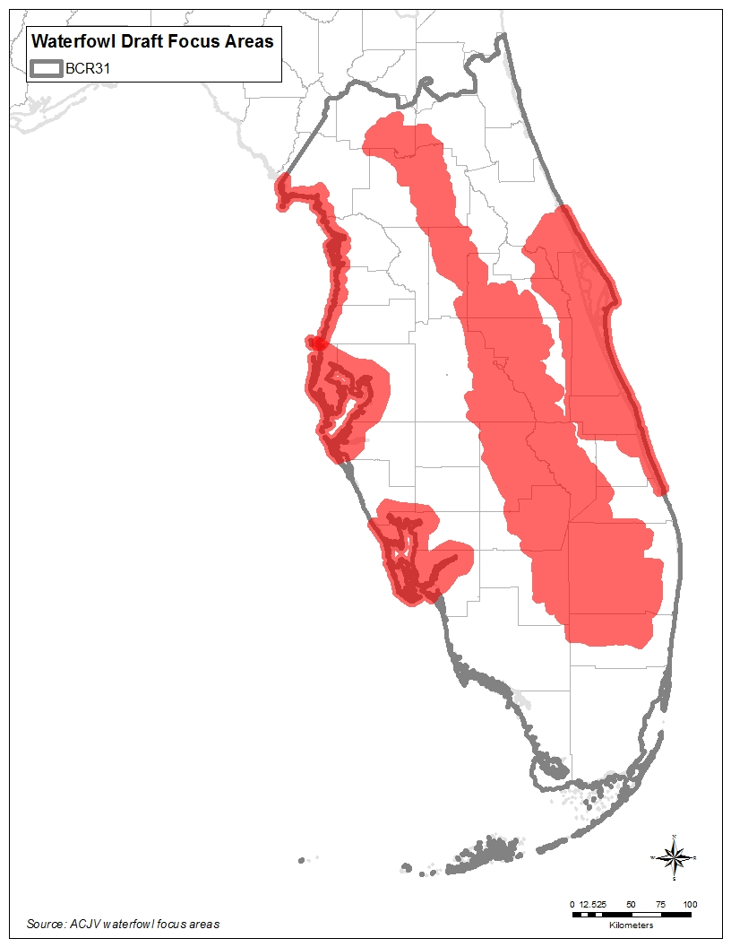
Figure 4. Waterfowl focus areas.
Source: ACJV Waterfowl Focus Areas (ACJV 2017)

Waterbird and Seabird Focus Areas
For BCR 31, the waterbird category includes all waterbirds not covered in shorebirds and waterfowl categories.

Waterbird Focus Areas
Due to the importance of the entire Florida peninsula for waterbirds, the entire BCR 31 is considered a focus area (Figure 5). While the point of having a focus area is to focus resources instead of spreading them out across a large area, this proved very difficult with waterbirds due to the distribution of waterbird habitat in BCR 31.

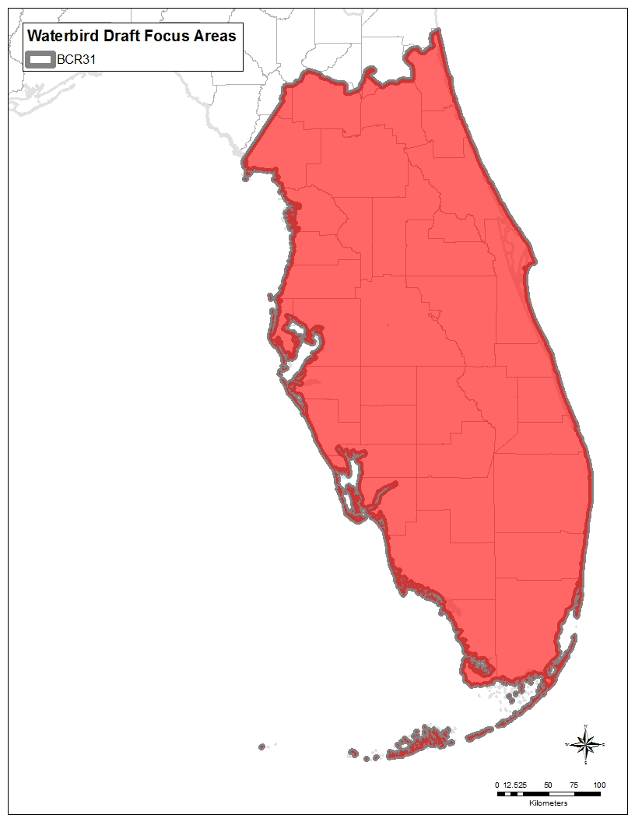
Figure 5. Waterbird focus areas.

After many attempts to narrow down waterbird habitat in the state to the most important areas for waterbirds, it become apparent that no single approach resulted in a satisfactory configuration of focus areas. Focus Areas were first created based on FWC’s wading bird foraging habitat model because it was assumed that wading bird habitat would also be important for other waterbirds. Starting with the wading bird foraging habitat map, 5- and 10-km (3.1 and 6.2-mile) aggregations were used to form larger polygons (Figure 6). The resulting map showed all but a small area of the peninsula (e.g., southeastern Florida, the Brooksville Ridge area) as important to wading birds. Next, a map using buffers around wading bird and Wood Stork nesting colonies was created. This map showed an even smaller percent of the state not covered by priority habitat (Figure 7). For Wood Stork colonies, a buffer of 24.1 km (15 miles) was used. Fifteen miles is an average buffer size between the USFWS 20.9-, 24.1-, and 29.9-km (13-, 15-, and 18.6-mile) buffers recommended for different parts of the state (USFWS 2016). For wading birds, a 12.9-km (8-mile) radius was used. Eight miles is in between the 11.3- to 14.5-km (7- to 9-mile) radius suggested as a foraging habitat area in FWC’s wading bird action plan (FWC 2013c).
As can be seen from Figures 6 and 7, only a very small percentage of the BCR (mostly the center of Lake Okeechobee) would be left off a map using a combination of these two methods to identify focus areas. For this reason, the entire BCR is considered a focus area for waterbirds.

5-km aggregation | 10-km aggregation
Figure 6. FWC wading bird habitat mapped to 5- and 10-km (3.1 and 6.2-mile) aggregations.
Source: FWC 2013c; maps by Amanda Kubes, FWC

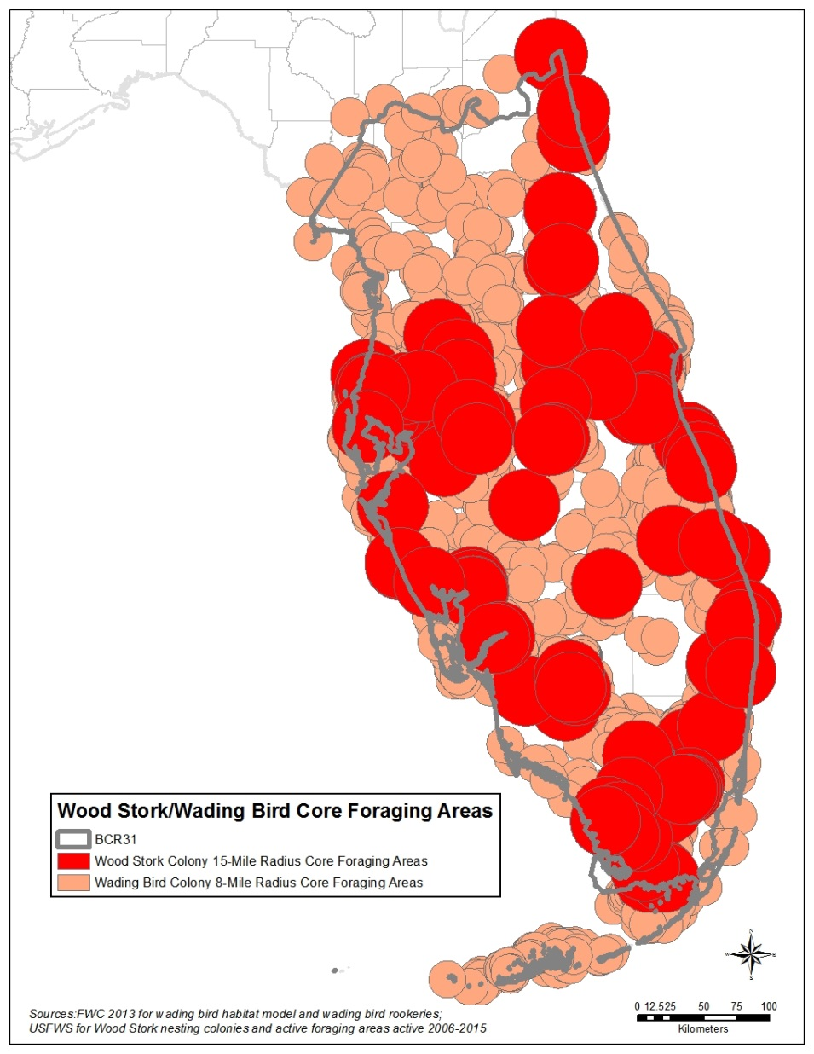
Figure 7. Wood Stork and wading bird colony buffers.
Source: FWC 2013c; USFWS 2016

Seabird Focus Areas
Seabird focus areas are based on Least Tern and Black Skimmer habitat models in FWC’s beach-nesting bird action plan (FWC 2013a) because these two species encompass the needs of a majority of focal seabirds. These areas cover the majority of the peninsular Florida coast with the exception of southwest Florida, much of which is dominated by mangroves. While at any one point in time this entire area is not important to seabirds, nesting areas frequently shift with changing habitat conditions, and this broad coverage allows potential new nesting areas to be captured. A broad belt across the interior of the peninsula has been used by nesting Least Terns and could be important depending on local variable conditions. Other sources for seabird focal areas include the following:
- Dry Tortugas due to the particular importance of these islands for seabirds with otherwise very limited breeding ranges in the United States (e.g., Magnificent Frigatebird, Masked and Brown Booby, Brown Noddy, and Sooty Tern).
- The area around Cedar Key for nesting Least Terns and for nonbreeding Black Skimmers with flocks of hundreds regularly wintering in the area (J. Brush, FWC Wildlife Biologist, pers. comm.; eBird 2016).

A seabirds focus areas map was created separate from the waterbirds map because of the importance of Florida for seabirds and the differences in habitat between seabirds and other waterbirds.

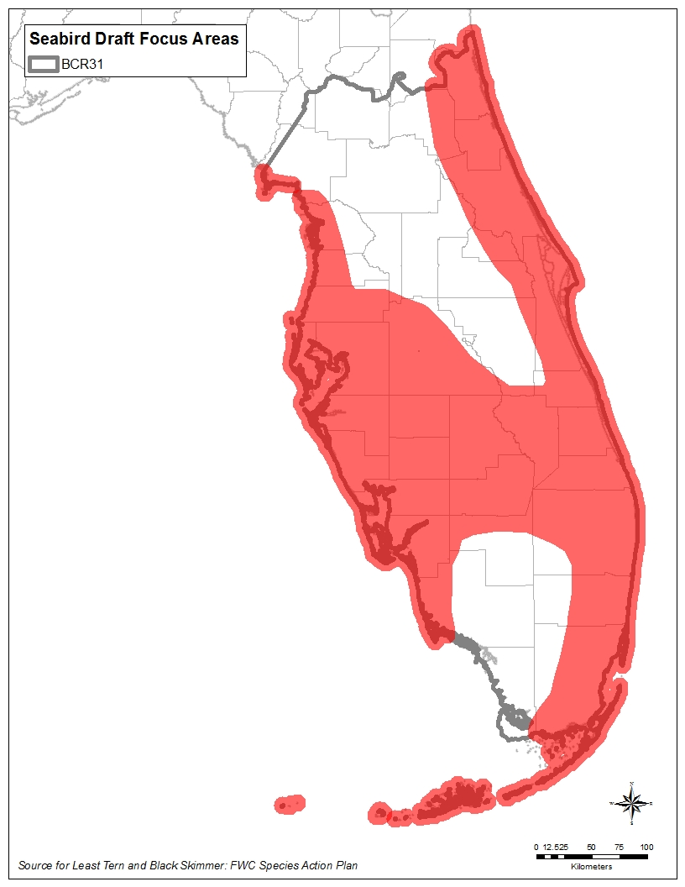
Figure 8. Seabird focus areas.
Source: FWC 2013a

Shorebird Focus Areas
Shorebird focus areas are based on Snowy Plover and American Oystercatcher maps in FWC’s beach-nesting bird action plan (FWC 2013a) because these two species encompass the needs of a majority of focal shorebirds. This focus area covers the majority of both coasts because of the uncertainty in the location of shorebird nesting and foraging areas. Other sources for shorebird focal areas include the following:
- Piping Plover Critical Habitat (USFWS 2001)
- Bahia Honda and Long Key in the Florida Keys (J. Duquesnel, FDEP and Keys Shorebird Partnership Coordinator, pers. comm.)
- Crandon Park for value for wintering Piping Plovers (although not critical habitat, these beaches regularly attract 30 nonbreeding Piping Plovers [eBird 2016])
- Coast between and including Lake Ingraham and Snake Bight and nearby lagoons due to the importance for wintering shorebirds (N. Douglass, FWC Wildlife Biologist, pers. comm.)
- Lake Okeechobee and agricultural areas to the southeast for their importance for migrant shorebirds (N. Douglass and R. Zambrano, FWC Wildlife Biologists, pers. comm.; eBird 2016).

While many interior parts of the state are important for migrating and wintering shorebirds (e.g., agricultural areas), this plan has chosen to focus primarily on coastal shorebird habitat, with the exception of the Everglades Agricultural Area and the Lake Okeechobee shoreline, a part of the state with very high concentrations of shorebirds in migration.

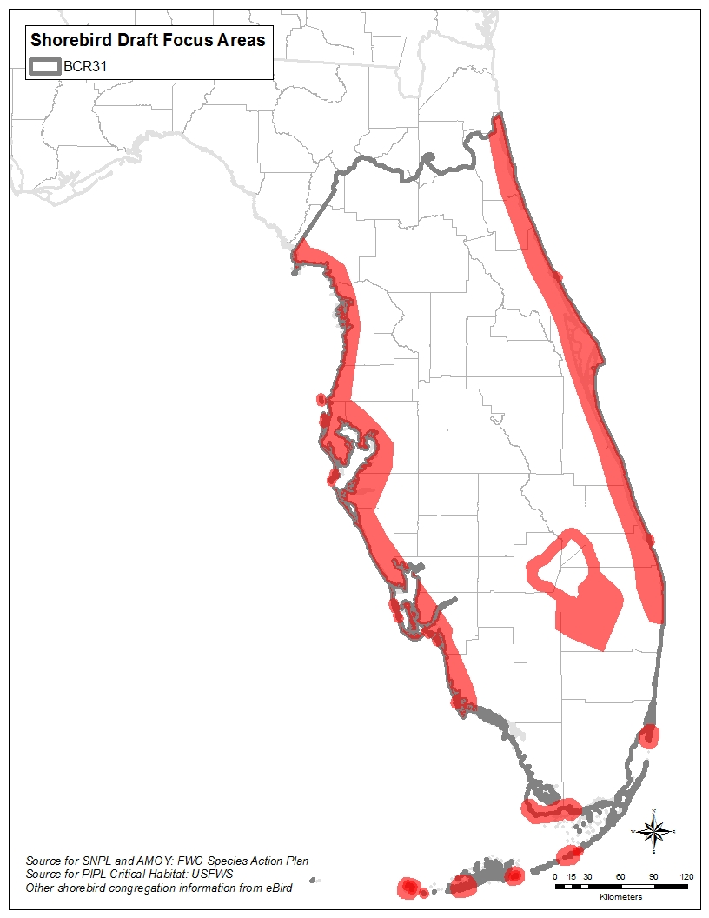
Figure 9. Shorebird focus areas.
Source: FWC 2013a; USFWS 2001, eBird 2016

Landbird Focus Areas
With a wide variety of priority species of landbirds, including many that also use aquatic habitats, a landbird focus area that includes only uplands would not meet all species’ needs. Landbird needs are better met by using Critical Lands and Waters Identification Project (CLIP) Biodiversity Resource Priorities 1 and 2 (Oetting, Hoctor, and Volk 2014) because these areas take into account the state’s most important areas for Strategic Habitat Conservation, Vertebrate Potential Habitat Richness, Rare Species Habitat Conservation, and Priority Natural Communities. The CLIP priorities map (Figure 10) was simplified by tracing the outlines of the major aggregations of CLIP Priority 1 and 2 lands to form larger polygons so that it is useful at the scale of an standard US letter size (8.5 by 11-inch [21.6 by 27.9-cm]) page.

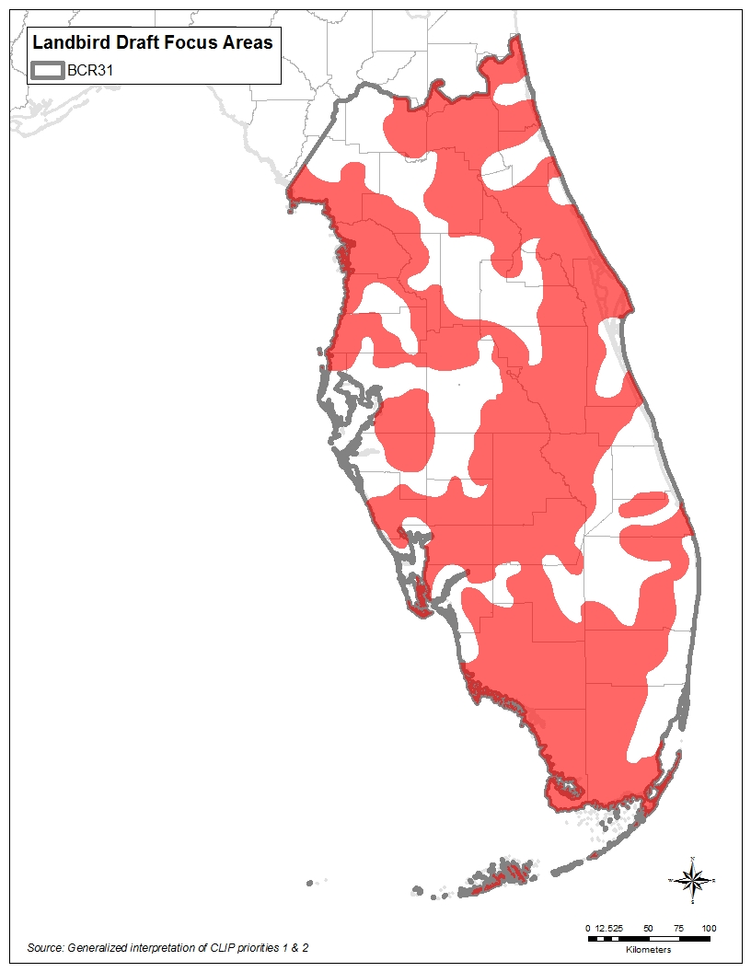
Figure 10. Landbird focus areas.
Adapted from: Oetting, Hoctor, and Volk 2014

Landbird Migration Hotspot Areas
During migration, birds require stopover habitat that provides energy resources and safety from predators. Because stopover use of land birds during migration can vary dramatically from day to day and locally in space, comprehensive and long-term monitoring of stopover use is necessary to identify areas that are consistently used by migrant birds in high densities.

BCR 31 serves as the wintering grounds and point of departure for many Neotropical migrants heading south in the fall. Additionally, the Florida coastline is the first landmass many birds encounter after hours or even days of migrating from the Yucatan Peninsula of Mexico or the various islands in the Caribbean during the spring.

BCR 31 provides critical stopover habitat for Neotropical migrants en route to and from their wintering areas. Species of conservation concern that regularly pass through this region during migration include the federally endangered Kirtland’s Warbler (Setophaga kirtlandii), as well as Bicknell’s Thrush (Catharus bicknelli), Wood Thrush (Hylocichla mustelina), Golden-winged Warbler (Vermivora chrysoptera), Blue-winged (Vermivora cyanoptera), Prothonotary Warbler (Protonotaria citrea), Swainson’s Warbler (Limnothlypis swainsonii), Kentucky Warbler (Geothlypis formosa), Cerulean Warbler (Setophaga cerulea), Bay-breasted Warbler (Setophaga castanea), Prairie Warbler (Setophaga discolor), Canada Warbler (Cardellina canadensis), Henslow’s Sparrow (Ammodramus henslowii), and Painted Bunting (Passerina ciris) (Watson et al. 2005).

The identification of exit and entry points (Figure 11, Figure 12) and flight direction (Figure 13), and the identification of important stopover habitat sites provide guidance for conservation efforts that will provide energy resources for migrating landbirds.

For a copy of the full report, methodologies, and other detailed information relative to these migration products, please see the links below:

http://acjv.org/radar_study/FinalReport_La_Puma&Buler_2013.pdf

http://acjv.org/radar_study/LaPuma_SE_Radar_Project_Presentation.pdf

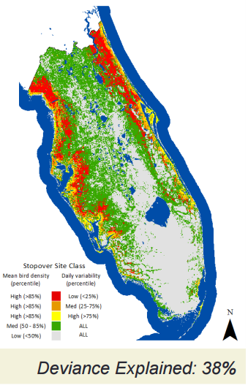
Figure 11. High bird stopover density in BCR 31 during fall migration.
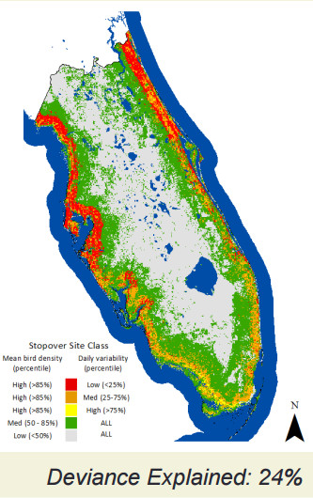
Figure 12. High bird stopover density in BCR 31 during spring migration

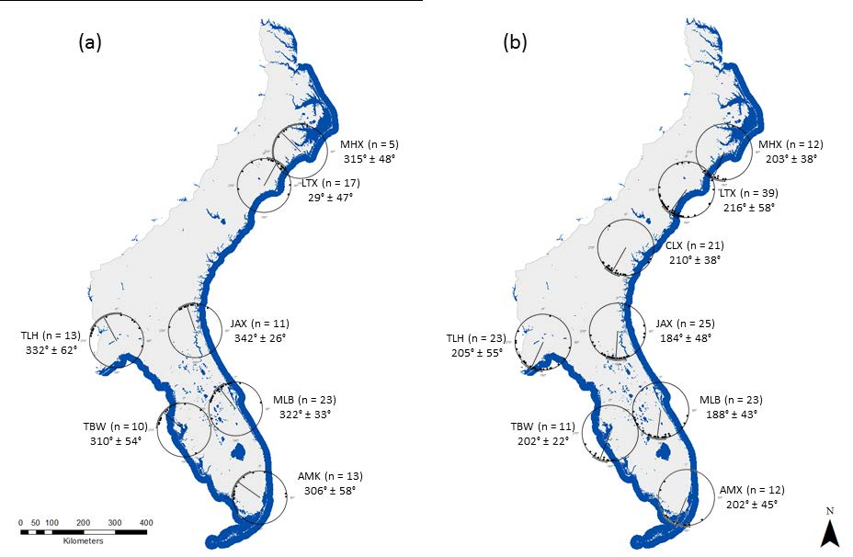
Figure 13. Mean flight direction of migrants during spring (a) and fall migration (b)

Conservation Strategies and Tools
The following conservation strategies and tools can be used to assist managers and conservation planners in evaluating potential conservation actions for birds in BCR 31. In most cases, these strategies and tools apply to more than one habitat or priority bird species. Relative priority for each of the following strategies and tools will depend on a variety of factors.

Habitat Protection
- Increase Fee Title Acquisitions: Direct acquisition of lands to be owned by a conservation agency or organization and managed for wildlife conservation in perpetuity. Priority acquisitions include BCR focus areas and areas where acquisition builds upon networks of contiguous existing protected lands. Major partners include FWC, Florida Department of Environmental Protection, water management districts, counties, national wildlife refuges, national forests, The Nature Conservancy (TNC), land trusts, and state Audubon chapters.
- Increase Conservation Easements
- Establish Critical Wildlife Areas in accordance with Rule 68A-19.005 Florida Administrative Code.
- Increase Cooperative Agreements: Development of collaborative projects with corporations, government agencies, private landowners, and other organizations that protect important bird habitats and/or integrate land use practices that benefit bird habitats
- Increase Leases: Establishment of long-term property leases with private landowners, corporations, and other private entities where habitat protection and management activities can be implemented
- Increase Financial Incentives: Development of state and local legislation that provides financial benefits to individual landowners for protecting and conserving valuable habitats on their land
- Increase Urban/Suburban Habitat Protection Initiatives: Provide urban and suburban residents with outreach and training (through Audubon chapters, green space committees, green building committees, etc.) to implement habitat and bird protection initiatives such as Audubon Bird Friendly Community, Audubon at Home programs, Florida-Friendly Landscaping, and National Wildlife Federation’s Garden for Wildlife and Certified Wildlife Habitat programs.
- Reduce habitat loss and fragmentation due to habitat conversion.
- Encourage cooperation among various groups engaged in conservation work.

Habitat Restoration
- Restore priority habitats.
- Target priority, unprotected areas around existing wetlands for easements and/or acquisition with the goal to restore or maintain high freshwater quality.
- Restore drained and ditched wetlands by eliminating drains and ditches to restore hydrology and planting/seeding native wetland plants.
- Restore the natural flow of streams and floodplain wetlands.
- Restore and maintain the natural hydrology of existing wetlands.
- Restore pyrogenic natural communities that have become overgrown in the absence of fire.
- Restore tree islands for priority waterbirds.

Habitat Enhancement and Management
- Improve water level management on managed wetlands.
- Use prescribed fire to restore and maintain natural fire-dependent ecological communities such as Scrub and Longleaf Pine Flatwoods.
- Provide high-quality managed shorebird habitat (e.g., contaminant-free foraging resources and roosting areas) to support migrating and overwintering shorebirds.
- Flood agricultural fields where appropriate for shorebird and waterfowl use.
- Where feasible, use dikes and water control structures to create fall/winter wetland habitat for waterfowl, shorebirds, and other species
- Identify and implement best management practices that benefit priority bird species.
- Promote habitat management on private lands.
- Control exotic and invasive vegetation: Eliminate and suppress the spread of invasive and exotic plants in wetlands and uplands using physical, biological, and/or chemical control methods.
- Manage vegetation to maintain habitat for priority beach-nesting birds.
- Use prescribed grazing, prescribed fire, or mowing to maintain pastures for priority bird species.
- Maintain or increase extent of field borders and other fallow habitats.
- Increase and improve active management to improve habitat quality within existing and future focus areas.
- Develop cooperative programs among agencies, NGOs, and local governments to improve habitat quality or benefit priority bird species.
- Continue to explore and utilize the Forest Legacy Program (FLP) and the ForestStewardship Program of the U.S. Forest Service (USFS), USDA Natural Resource Conservation Service (NRCS), and USFWS to fund projects on private forest lands that will improve forest conditions for priority bird species.
- Use the NRCS Wetlands Reserve Easements (WRE) designed to restore degraded wetlands by restoring the hydrology on a site to pre-agricultural conditions, to the extent practical. .
- Initiate dialogue with managers of public lakes and reservoirs regarding costs/benefits of Hydrilla management, and/or promote establishment of native submerged aquatic vegetation (SAV) where Hydrilla removal is taking place.
- Create treatment wetlands to mediate water runoff in/near human developments for priority bird species habitat.
- Encourage the retention of blocks of native vegetation in urban development.
- Encourage retention or creation of habitat corridors to link habitat patches among urban/suburban areas.
- Leave snags where possible for cavity nesting birds, and use nest boxes or artificial cavities where appropriate (e.g., for Red-cockaded Woodpeckers, Southeastern American Kestrels).
- Manage spoil islands when possible for priority bird species.
- Support mobile resource management teams that can increase the ability of land managers to apply prescribed fire and other management treatments.

Landowner Outreach, Education, and Incentives
- Coordinate implementation of federal, state, and local assistance programs with priorities and needs of BCR 31 focus areas. Biologists that have a role in implementing Farm Bill programs (e.g., NRCS Wetlands Reserve Program) should strive to initiate these projects in designated BCR 31 focus areas that benefit priority bird species and associated habitats.
- Establish community-based habitat protection programs
- Ensure ACJV coordination with NRCS on BCR 31 priorities
- Implement the NRCS Farm Bill and encourage participation in USFS habitat programs
- Enhance habitat on federal lands: Work with federal agencies such as the USFWS, USFS, and the Department of Defense (DOD) to develop and help implement programs to better manage and enhance bird and other wildlife habitats on federal lands.
- Work with federal and state regulatory agencies to ensure that mitigation measures conserve bird habitat. Mitigation actions resulting from development projects and policies driving those actions should be coordinated with BCR 31 conservation priorities to ensure that bird habitat benefits through protection and management.
- Develop outreach materials for the general public such as informational and educational leaflets and brochures, audiovisual programs, and others to increase awareness and support for BCR 31 priority birds.
- Promote bird habitat land conservation programs to landowners, e.g., work with developers, consultants, engineering firms, local governments, etc. to incorporate more wildlife/habitat friendly developments through efforts such as those of FWC’s Office of Conservation Planning Services.
- Participate in watershed protection and management planning efforts to benefit birds. Help develop and provide input on watershed management and estuary plans/guidelines aimed at preventing degradation of wetland health and productivity from municipal waste, agricultural runoff, sedimentation, and industrial contaminants. Work with all interested stakeholders to improve freshwater quality.
- Predator management: Take steps to control predators where intervention is necessary to protect high priority species and ensure and sustain the viability of the population.
- Provide outreach to landowners on the impact of feral cat populations on bird predation and conservation.
- Work with agencies and private groups to eliminate deliberate releases of domestic game species such as Mallard and Wild Turkey.
- Improve outreach and education to landowners on priority habitats or in focus areas.
- Promote Cat Indoors programs and discourage feral cat colonies.
- Promote Lights Out programs in large urban centers.
- Organize regional or statewide working groups to overcome challenges to managing for priority birds.
- Work with utility companies to develop Avian Protection Plans to reduce collisions and electrocutions.
- Encourage citizen science projects to support conservation of priority birds (e.g., beach-nesting bird stewarding and monitoring, kestrel nest box programs, Audubon’s Jay Watch).
- Work with landowners to manage gravel rooftops for priority birds (e.g., Least Tern, Black Skimmer, Common Nighthawk).
- Reduce entanglement issues and discourage feeding of waterbirds at fishing piers and similar locations.
- Address impacts of mechanical beach cleaning on beach-nesting birds.
- Work with stakeholders on adaptation strategies for climate change.
- Address wildlife-human conflicts.

Habitat Assessment
- Identify the largest and highest-quality habitat patches (e.g., old growth pine) for all focal species within BCR 31 as targets for coordinated conservation strategy (acquisition, easements, and management, etc.)
- Assess private lands to determine how existing private lands fill the needs for priority birds. Use the USFS Forest Stewardship Program (FSP) Spatial Analysis Project to identify potential private lands for conservation efforts.
- Work with local, state, and federal agencies to develop programs that incentivize landowners to contribute to habitat assessment efforts.
- Develop regional species-specific databases of critical demographic parameters that can be used in habitat suitability models.
- Identify important wintering sites for birds.
- Identify and conserve as many remaining wetlands as possible on private lands through federal assistance and incentive programs.

Audubon Important Bird Areas
- Important Bird Areas can be useful for helping identify sites to target for protection and/or habitat management. More information on Important Bird Area criteria and a map can be found at the hotlink.

Species-specific Actions
- Develop regional species-specific databases of critical demographic parameters that can be used in habitat suitability models.
- Gather demographic information to identify limiting factors, such as forest fragmentation, that are causing population declines in priority bird species.
- Identify important wintering sites for Rusty Blackbirds.
- Retain islands of woody vegetation in waterbodies for wading bird nesting.
- Improve outreach and education on Chimney Swift benefits and habitat needs for nesting.
- Posting, stewarding, and monitoring Critical Wildlife Areas and other important nesting areas for beach-nesting birds and colonial waterbirds (e.g., through Audubon Florida’s Project Colony Watch). Identify and implement monitoring for shorebirds and seabirds through the Florida Shorebird Alliance.
- Conduct translocations for certain priority species where translocation has been identified as a priority conservation action (e.g., Red-cockaded Woodpeckers, Florida Scrub-Jays).

Conservation Resources and Funding

Conservation Resources
A wide variety of resources are available to assist with bird conservation in Florida. Some of the broader reaching of these are the SWAP (FWC 2012), FWC’s Imperiled Species Management Plan (ISMP; FWC 2016a), FWC’s Regional Assessments, and Florida’s Cooperative Conservation Blueprint (FWC 2016b). For federally listed species, Recovery Plans are available.

The FWC has an internal process for prioritizing information and management needs on an annual basis and much information is contained in species action plans (SAPs). The USFWS has an internal system of prioritizing research and monitoring needs for federally listed species. For more information, refer to FWC SAPs or federal recovery plan for individual species or taxa suites. For information on the latest Florida priority bird species needs, contact FWC’s Avian Conservation Coordinator.

During the in-person meeting in Gainesville on 2 June 2016 (see Appendix A), partners identified Florida-specific resources (see Section 6) to achieve bird conservation. These resources formed the basis for the following list, which has been refined to add additional resources. For funding resources, see Section 7.2.

For the following resources, if the hot link provided for a resource does not work, the resource may be found using a Google search or by contacting Florida’s Avian Coordinator.

Federal Resources
- Recovery plans for federally listed species.
- Peninsular Florida Landscape Conservation Cooperative (PFLCC)
- Comprehensive Everglades Restoration Plan (CERP)
- Integrated Waterbird Management and Monitoring (IWMM)

FWC
- Imperiled Species Management Plan (ISMP) and associated Biological Status Reviews (BSRs) and Species Action Plans (FWC 2013i)
- Private Lands Partnerships
- Florida’s State Wildlife Action Plan (SWAP)
- Waterfowl Management Strategic Plan (2008) and plans for Florida Mottled Duck (2011) and Northern Bobwhite (2007)
- Cooperative Conservation Blueprint
- Florida Shorebird Business Plan (in progress) to guide Gulf Environmental Benefit Fund money for beach nesting birds

Florida Department of Environmental Protection (FDEP)
- Florida Forever
- Acquisition and Restoration Council (ARC)

Water Management Districts
- SWIM plans, especially for the Gulf Coast
  - Southwest Florida WMD (SWFWMD) SWIM Plan
  - St. Johns River WMD (SJRWMD) SWIM Plans
- St. John’s River WMD:
  - Lake Apopka
  - Upper St. John’s River Basin
  - Northern Coastal Basin
- South Florida WMD
  - Ecosystem Restoration
  - Land Management (Stewardship)
  - Water Reservations

Nonprofit Organizations
- Audubon Florida
  - Audubon Florida Jay Watch
  - Audubon Flyway Initiative (including nonbreeding)
    - Audubon Flyway article
    - Audubon Flyway Initiative article
    - Audubon Flyway Initiative webpage
  - Audubon Bird Friendly Community
  - Audubon at Home
- Fish & Wildlife Foundation of Florida
- Florida Ornithological Society
  - Breeding Bird Atlases: FWC 2003 and FOS 2016
- Gulf Environmental Benefit Fund and here (GEBF)
- National Bobwhite Conservation Initiative
- National Fish and Wildlife Foundation (NFWF)
- National Wildlife Federation
  - Garden for Wildlife
  - Certified Wildlife Habitat
- UF-IFAS Florida Yards and Neighborhoods
  - Homeowner Program
  - Builder and Developer Program
  - Florida-Friendly Landscaping

Multiple Partners/Other
- Florida Shorebird Alliance, which is mostly for breeding shorebirds and seabirds now but will include nonbreeding birds soon.
- Atlantic Flyway Shorebird Initiative, NFWF
- Critical Lands and Waters Identification Project (CLIP)
- Florida Natural Areas Inventory (FNAI) data sets
- Florida Forever Conservation Needs Assessment (FFCNA)
- Florida Ecological Greenways Network
- Climate Change Resilience Pilots, Federal Highway Administration (FHWA)
- Restore the Gulf, Gulf Ecosystem Restoration Council
- Gulf Spill Restoration, NOAA
- Southeast Region Conservation Planning Atlas
- Activities in Florida, Southeast Aquatic Resources Partnership
- MOTUS. The MOTUS wildlife tracking system is a collaborative research network that uses radio telemetry arrays to answer questions about movements, migration, and survival of birds. The USFWS, the FWC, and conservation partners are interested in expanding the network of MOTUS towers in Florida and have created a working group (“FLOTUS”) for this purpose

Conservation Funding
Table 22. Potential Funding Sources in BCR 31
Program | Description | Funding | Match (Grantee/ Grantor) | Applicant Eligibility
Florida Fish and Wildlife Conservation Commission (FWC)
State Wildlife Grants (SWG) | Matching grants program that provides financial support for projects addressing conservation needs identified in the State Wildlife Action Plan. Both planning and implementation of programs are permitted. | Varies | Nonfederal match must be at least 35% of total project costs in 2016 | Nonfederal public and private entities
National Fish and Wildlife Foundation (NFWF)
General Matching Grants Program | Matching grants are awarded to projects that address priority actions promoting fish and wildlife conservation and the habitats on which they depend, work proactively to involve other conservation and community interests, leverage available funding, and evaluate project outcomes. Does not include basic research. | $10,000 to $150,000 | Minimum 2:1 | Federal, tribal, state, and local governments, educational institutions, and nonprofit conservation organizations
National Wildlife Refuge Friends Group Grant Program | Includes start-up grants to provide formative and/or initial operational support, capacity building grants to strengthen the capacity of existing refuge Friends organizations to enable them to be more effective, and project specific grants, which may include developing outreach and conservation education programs for private landowners, habitat restoration projects, watchable wildlife programs, etc. | $1,500 to $5,000 | None required | Nonprofit organizations interested in assisting a National Wildlife Refuge or group of refuges
Acres for America | A partnership between Walmart Stores, Inc. and NFWF to provide funding for projects that conserve important habitat for fish, wildlife, and plants through acquisition of interest in real property. The goal of the program is to offset the footprint of Wal-Mart’s domestic facilities on at least an acre by acre basis through these acquisitions. Preference will be given to acquisitions that are part of published conservation plans (North American Waterfowl Management Plan, Partners in Flight, etc.), draft state conservation strategies, or Endangered Species Act (ESA) recovery plans. | About $3.1 million will be available annually for 10 years for conservation investments. | All grant awards require a minimum 1:1 match of cash or contributed goods and services. Federal funds may be considered as match. Higher ratios of matching funds will at times aid in making applications more competitive. | Not specified
National Forest Foundation
Grants | Several opportunities for action-oriented projects that directly enhance the health and well-being of America's National Forests and Grasslands and that engage the public in stewardship. | Varies | Minimum 1:1 | Varies but includes nongovernmental and nonprofit organizations, universities, and businesses. Applications cannot be accepted from federal agencies, regional, state, or local government entities.
National Wildlife Federation (NWF)
Species Recovery Fund (SRF) Grants | Created to spur habitat restorations, species reintroductions, private land conservation activities, and other creative endeavors that directly improve conditions for species listed under the federal ESA. | $3,000 to $7,000 | Not specified | Any organization, agency, tribe, university, or individual working to improve on-the-ground conditions for species listed under the federal ESA.
National Park Service (NPS)
Challenge Cost Share | This program supports local projects that promote conservation and recreation, environmental stewardship, education, and engaging youth in the outdoors. | $25,000 max award | 1:1 (nonfederal) | Educational institutions, private for-profit entities, or not-for-profit organizations
Natural Resource Conservation Service (NRCS)
Environmental Quality Incentives Program (EQIP) | Voluntary conservation program for farmers and ranchers that promotes agricultural production and environmental quality as compatible national goals. EQIP offers financial and technical help to eligible participants for installing or implementing structural and management practices on eligible agricultural land. Includes promotion of at-risk species habitat conservation. | Not specified | 1 to 10 year incentive payment and cost share (75% to 90%) contracts | Private landowners
Agricultural Conservation Easement  Program (ACEP) | Provides financial and technical assistance to help conserve agricultural lands and wetlands and their related benefits | Not specified | 1:1 | American Indian tribes, state and local governments and nongovernmental organizations
Working Lands for Wildlife Initiative (WLFW) | Voluntary program to primarily benefit high priority Gopher Tortoise habitat in BCR 31 but also other bird habitat in agricultural areas. Works with agricultural producers to create and improve Tortoise habitat with regulatory predictability from the U.S. Fish and Wildlife Service. | Not specified | Not specified | Private landowners
Longleaf Pine Initiative (LLPI) | Works with producers on private lands in nine states to improve the sustainability and profitability of longleaf pine forest ecosystems. | $10.6 million in 2016 | — | Private landowners
Regional Conservation Partnership Program (RCPP) | Delivers conservation assistance to producers and landowners; provides through partnership agreements and through program contracts or easement agreements. | Varies | — | Producers and landowners
USDA Farm Service Agency
Conservation Reserve Program (CRP) | Voluntary program to help agricultural producers safeguard environmentally sensitive land. Producers enrolled in CRP plant long-term, resource-conserving covers to improve water quality, control soil erosion, and enhance wildlife habitat. | Farmers receive an annual rental payment for the term of the multiyear contract. Cost sharing is provided. | 10–15 year rental programs with 1:1 cost share in establishing approved conservation practices. | Private landowners
Conservation Reserve Enhancement Program (CREP) | CREP aims to improve water quality and wildlife habitat by offering rental payments to farmers who voluntarily restore riparian buffers, filter strips, and wetlands using approved conservation practices. Another CREP goal is to establish 8,000 acres of perpetual conservation or open space easements statewide. State cost-share payments are administered through local Soil and Water Conservation District (SWCD) offices. May include permanent easements. | Not specified | 3:1 from state; 1:1 from farm service agency (expenses for implementing best management practices, such as fencing or alternative watering systems). | Private landowners
US Forest Service (USFS)
Forest Legacy Program (FLP) | Directly supports property acquisition and efforts to acquire donated conservation easements. | In FY 2017, $100 million for 34 projects | 1:3 (grantee match may come from private, state, or local sources) | Private forest landowners
Forest Stewardship Program (FSP) | Provides technical assistance through state forestry agency partners to nonindustrial private forest (NIPF) owners to encourage and enable active long-term forest management. A primary focus of the program is the development of comprehensive, multi-resource management plans that provide landowners with the information they need to manage their forests for a variety of products and services. | Not specified but works in conjunction with EQIP | — | Nonindustrial private forest landowners
U.S. Fish and Wildlife Service (USFWS)
Neotropical Migratory Bird Conservation Act (NMBCA) | The NMBCA program provides matching grants to Neotropical migratory bird conservation projects throughout the Western Hemisphere, with at least 75% of funding going to projects outside the US. | Yearly appropriation varies  https://www.fws.gov/birds/grants/neotropical-migratory-bird-conservation-act/how-to-apply.php | Minimum 3:1 | Any United States, Latin American, or Caribbean individual, corporation, government agency, trust, association, or other private entity
Partners for Fish and Wildlife (PFW)  CFDA 15.631 | Provides technical and financial assistance to private landowners and others who want to restore or improve habitat on their property through cooperative agreements. Does not fund planning and research. | Varies | 1:1 (including cash/in-kind match) | Private landowners, tribes, local governments
Coastal Program  CFDA 15.630 | Voluntary, incentive-based program that provides direct technical assistance and financial assistance in the form of cooperative agreements to coastal communities and landowners to restore and protect fish and wildlife habitat on public and private lands. Identify geographic focus areas and direct resources to conserve habitat for federal trust species within these areas. Work plans developed in coordination with partners and involvement from USFWS staff. Projects must advance USFWS mission, promote biological diversity, and be based upon sound scientific biological principles. | $5,000 to $50,000 | No match required | Native American tribal governments (federally recognized) and organizations, governments (city, township county, state, special district), institutions of higher education (public, private, and state-controlled), nonprofits with and without 501(c)(3) status, individuals, small businesses, for-profit organizations
North American Wetlands Conservation Act (NAWCA) Grants  CFDA 15.623 | All wetland conservation proposals that meet the requirements of the Act will be accepted. However, funding priority will be given to projects from new applicants (who have never received a NAWCA grant) with new partners, where the project ensures long-term conservation benefits. This does not preclude former NAWCA grant recipients from receiving small grants funding. | Varies | 1:1 | Available to private or public organizations or to individuals who have developed partnerships to carry out wetland conservation projects in the United States, Canada, and Mexico.
National Coastal Wetlands Grants (NCWG) | Provides funds for wetland conservation projects in North America for acquisition, restoration, enhancement, management, and preservation of coastal wetlands. | Varies | Usually 25% by applicant | States must be the applicant, however, funds can be provided to subgrantees (i.e., NGOs and federal agencies)
Endangered Species Grants—Habitat Conservation Planning (HCP) Assistance Grants  CFDA 15.615 | Provides financial assistance to states and territories to support the development of HCPs that provide for the conservation of imperiled species while allowing economic activities to proceed. Can include animal, plant, and habitat surveys; research; planning; monitoring; habitat protection, restoration, management, and acquisition; and public education. | Varies | 75% for single state or territory; 90% for two or more states or territories implementing a joint project | Restricted to those state fish and wildlife agencies with which the USFWS has a current cooperative agreement for the species involved
Endangered Species Conservation Recovery Implementation Funds  CFDA 15.657 | To develop a long-term objective of improving the effectiveness and efficiency of the federal ESA. | Varies by Region | No match required | Nonprofits that do not have 501(c)(3) status with the IRS, other than institutions of higher education
Endangered Species Grants Recovery Land Acquisition | Provides financial assistance to states and territories to acquire habitat for endangered and threatened species. Can include animal, plant, and habitat surveys; research; planning; monitoring; habitat protection, restoration, management, and acquisition; and public education. | Varies | 25% of estimated project cost; or 10% when two or more states or territories implement a joint project | Restricted to those state fish and wildlife agencies with which the USFWS has a current cooperative agreement for the species involved
Multistate Conservation Grants – Wildlife and Sport Fish Restoration Program (WSFR) | To support sport fish and wildlife restoration projects identified by the Association of Fish and Wildlife Agencies (AFWA). Funds may be used for sport fisheries and wildlife research projects, aquatic education, habitat improvements, and other projects. | $6 million annually | No match required | States, groups of states, USFWS, and nongovernmental organizations

Literature Cited
Atlantic Coast Joint Venture (ACJV). (2017). National priority areas for each taxa group. <http://acjv.org/our-science/gis-resources/>. Accessed on 9 January 2017.

Bierregaard, R. O., A. F. Poole, M. S. Martell, P. Pyle and M. A. Patten. 2016. Osprey (Pandion haliaetus), The Birds of North America (P. G. Rodewald, Ed.). Ithaca: Cornell Lab of Ornithology; Retrieved from the Birds of North America: https://birdsna-org.bnaproxy.birds.cornell.edu/Species-Account/bna/species/osprey

Deepwater Horizon Natural Resource Damage Assessment Trustees. 2016. Deepwater Horizon Oil Spill: Final Programmatic Damage Assessment and Restoration Plan (PDARP) and Final Programmatic Environmental Impact Statement (PEIS). <www.gulfspillrestoration.noaa.gov/restoration-planning/gulf-plan>

Dettmers, Randy. 2006. A Blueprint for the Design and Delivery of Bird Conservation in the Atlantic Northern Forest. U.S. Department of Interior, Fish and Wildlife Service. Northeast Regional Office, Hadley, MA. 346pp.

Elliott-Smith, E., M. Bidwell, A. E. Holland, and S. M. Haig. 2015. Data from the 2011 International Piping Plover Census: U.S. Geological Survey Data Series 922, 296 pp. <http://dx.doi.org/10.3133/ds922>

Federal Geographic Data Committee. 2013. Classification of Wetlands and Deepwater Habitats of the United States. Second Edition. FGDC–STD-004-201. Wetlands Subcommittee. <www.fws.gov/wetlands/documents/Classification-of-Wetlands-and-Deepwater-Habitats-of-the-United-States-2013.pdf >

Fletcher, R., C. Poli, E. Robertson, B. Jeffery, S. Dudek, and B. Reichert. 2017. Snail Kite demography, 2016 Annual Report. Prepared for U.S. Army Corps of Engineers Environmental Branch and The Florida Fish and Wildlife Conservation Commission. U. S. Geological Survey Florida Cooperative Fish and Wildlife Research Unit and University of Florida Department of Wildlife Ecology and Conservation. Gainesville, Florida.

Florida Fish and Wildlife Conservation Commission (FWC). 2003. Florida's breeding bird atlas: A collaborative study of Florida's birdlife. http://www.myfwc.com/bba/.

Florida Fish and Wildlife Conservation Commission (FWC). 2007. Strategic plan for Northern Bobwhite restoration in Florida. Tallahassee, Florida.

Florida Fish and Wildlife Conservation Commission (FWC). 2011. A Conservation Plan for the Florida Mottled Duck. Tallahassee, Florida.

Florida Fish and Wildlife Conservation Commission (FWC). 2012. Florida’s Wildlife Legacy Initiative: Florida’s State Wildlife Action Plan. Tallahassee, Florida.

Florida Fish and Wildlife Conservation Commission (FWC). 2013a. A species action plan for four imperiled species of beach nesting birds. Tallahassee, Florida.

Florida Fish and Wildlife Conservation Commission (FWC). 2013b. A species action plan for four saltmarsh songbirds. Tallahassee, Florida.

Florida Fish and Wildlife Conservation Commission (FWC). 2013c. A species action plan for six imperiled wading birds: Little Blue Heron, Reddish Egret, Roseate Spoonbill, Snowy Egret, Tricolored Heron, and White Ibis. Tallahassee, Florida.

Florida Fish and Wildlife Conservation Commission (FWC). 2013d. A species action plan for the Brown Pelican. Tallahassee, Florida.

Florida Fish and Wildlife Conservation Commission (FWC). 2013e. A species action plan for the Florida Burrowing Owl. Tallahassee, Florida.

Florida Fish and Wildlife Conservation Commission (FWC). 2013f. A species action plan for the Florida Sandhill Crane. Tallahassee, Florida.

Florida Fish and Wildlife Conservation Commission (FWC). 2013g. A species action plan for the Southeastern American kestrel. Tallahassee, Florida.

Florida Fish and Wildlife Conservation Commission (FWC). 2013h. A species action plan for the White-crowned Pigeon. Tallahassee, Florida.

Florida Fish and Wildlife Conservation Commission (FWC). 2013i. Species action plans. <http://myfwc.com/wildlifehabitats/imperiled/species-action-plans>

Florida Fish and Wildlife Conservation Commission (FWC). 2016a. Imperiled Species Management Plan: 2016–2026. Tallahassee, Florida. http://myfwc.com/imperiledspecies

Florida Fish and Wildlife Conservation Commission (FWC). 2016b. Florida’s Cooperative Conservation Blueprint. <http://myfwc.com/conservation/special-initiatives/blueprint>

Florida Natural Areas Inventory (FNAI) and Florida Department of Natural Resources. 1990. Guide to natural communities of Florida. Gainesville, Florida.

Florida Natural Areas Inventory (FNAI). 2017. Florida Conservation Lands. <http://fnai.org/gisdata.cfm>

Hunter, W.C. 2002. Southeastern Coastal Plains-Caribbean Region Report, U.S. Shorebird Conservation Plan, Region 4 USFWS, Atlanta, Georgia.

Hunter, W. C., W. Golder, S. Melvin, and J. Wheeler. 2006. Southeast United States Regional Waterbird Conservation Plan. Waterbird Conservation for the Americas, Washington, D.C.

Kawula, R. 2009. Florida Land Cover Classification System: Final Report. Florida Fish and Wildlife Conservation Commission, Tallahassee, Florida.

Myers, R. L., and J. J. Ewel, eds. 1990. Ecosystems of Florida. University Presses of Florida, Gainesville. 765 pp.

North American Bird Conservation Initiative (NABCI). 2016. The State of North American Birds 2016. Environmental and Climate Change Canada: Ottawa, Ontario. 8 pages. <www.stateofthebirds.org>

North American Waterfowl Management Plan (NAWMP), Plan Committee. 2004. North American Waterfowl Management Plan 2004. Implementation Framework: Strengthening the Biological Foundation. Canadian Wildlife Service, U.S. Fish and Wildlife Service, Secretaria de Medio Ambiente y Recursos Naturales, 106 pp.

Oetting, J., T. Hoctor, M. Volk. 2014. Critical Lands and Waters Identification Project (CLIP): Version 3.0 Technical Report – February 2014. Report to the U.S. Fish and Wildlife Service Peninsular Florida Landscape Conservation Cooperative, Tallahassee, FL.

Panjabi, A. O., P. J. Blancher, R. Dettmers, and K. V. Rosenberg, Version 2012. Partners in Flight Technical Series No. 3. Rocky Mountain Bird Observatory website: <http://www.rmbo.org/pubs/downloads/Handbook2012.pdf>

Partners in Flight (PIF) Science Committee. 2012. Species Assessment Database, version 2012. <http://rmbo.org/pifassessment>. Accessed on 10 December 2016.

Redner, J., and S. Srinivasan. 2014. Florida Vegetation and Land Cover 2014. Final report. June 30, 2014. FWRI Grant # 6207. Center for Spatial Analysis, Fish and Wildlife Research Institute, Florida Fish and Wildlife Conservation Commission, Tallahassee, Florida.

Rosenberg, K. V., J. A. Kennedy, R. Dettmers, R. P. Ford, D. Reynolds, J.D. Alexander, C. J. Beardmore, P. J. Blancher, R. E. Bogart, G. S. Butcher, A. F. Camfield, A. Couturier, D. W. Demarest, W. E. Easton, J.J. Giocomo, R.H. Keller, A. E. Mini, A. O. Panjabi, D. N. Pashley, T. D. Rich, J. M. Ruth, H. Stabins, J. Stanton, T. Will. 2016. Partners in Flight Landbird Conservation Plan: 2016 Revision for Canada and Continental United States. Partners in Flight Science Committee. 119 pp.

Schulte, S. A. 2016. Florida Beach-Nesting Bird Plan. Manomet, Massachusetts. 38 pp.

U.S. Fish and Wildlife Service (USFWS). 1993. Caribbean Roseate Tern recovery plan. September 24, 1993. Atlanta, Georgia. 40 pp.

U.S. Fish and Wildlife Service (USFWS). 1999. South Florida multispecies recovery plan. Atlanta, Georgia. 2172 pp.

U.S. Fish and Wildlife Service (USFWS). 2001. Endangered and threatened wildlife and plants; Final determinations of critical habitat for wintering Piping Plovers; Final Rule. 66 Federal Register 132, pp. 36038-36143.

U.S. Fish and Wildlife Service (USFWS). 2005. Atlantic Coast Joint Venture Waterfowl Implementation Plan, Revision, March 2005.

U.S. Fish and Wildlife Service (USFWS). 2007. Everglade Snail Kite (Rostrhamus sociabilis plumbeus) 5-Year Review: Summary and Evaluation. Vero Beach, Florida. 20 pp.

U.S. Fish and Wildlife Service (USFWS). 2010a. Cape Sable Seaside Sparrow (Ammodramus maritimus mirabilis) 5-Year Review: Summary and Evaluation. Vero Beach, Florida. 21 pp.

U.S. Fish and Wildlife Service (USFWS). 2010b. Caribbean Roseate Tern and North Atlantic Roseate Tern (Sterna dougallii dougallii) 5-year review: summary and evaluation. USFWS southeast region, Caribbean ecological services field office, Boquerón, Puerto Rico; and northeast region, New England field office, Concord, New Hampshire. https://ecos.fws.gov/docs/five_year_review/doc3588.pdf

U.S. Fish and Wildlife Service (USFWS). 2016. Wood Stork Nesting Colonies and Core Foraging Areas Active within 2006–2015 in Florida. Map. <www.fws.gov/northflorida/WoodStorks/WOST_Data/2016_FL_Nesting_Colonies_Core_Foraging_Areas_Active_2006-2015%20Map.pdf>

U.S. Fish and Wildlife Service (USFWS). 2017. Environmental Conservation Online System (ECOS). <http://ecos.fws.gov/ecp>. Accessed on 10 January 2017.

Watson, C., C. Hayes, J. McCauley, and A. Milliken. 2005. The South Atlantic Migratory Bird Initiative – an integrated approach to conservation of “all birds across all habitats." USDA Forest Service Gen. Tech. Rep. PSW-GTR-191.

Watson, J. K. 2014. The Piedmont Bird Conservation Region (BCR 29) implementation plan: Version 1.1. Southern Appalachian Bird Conservancy. Sevierville, Tennessee.

Watts, B. D. 2016. Status and distribution of the eastern black rail along the Atlantic and Gulf Coasts of North America. The Center for Conservation Biology Technical Report Series, CCBTR-16-09. College of William and Mary/Virginia Commonwealth University, Williamsburg, Virginia. 148 pp.

Appendices

Appendix A. BCR 31 Workshop Agenda and Attendees
The meeting was held on 2 June 2016 from 10:00 am to 3:45 pm at the U.S. Geological Survey Wetland and Aquatic Research Center (7920 NW 71st Street, Gainesville, FL 32653)

Start | End | Item | Process | Objective
10:00 AM | 10:10 AM | Introduction  Welcome (Adam, Craig F)  Housekeeping, agenda (Adam) | Brief presentations | Participants understand the objectives and agenda.  Participants sign up for lunch.
10:10 AM | 10:30 AM | Overview of NABCI & BCR 31 (Craig W) | Presentation | Participants understand BCR 31 & NABCI framework
10:30 AM | 11:00 AM | Present draft priority species list (Craig W)  Status of BCR 31 species list  Process for commenting on list | Presentation; discussion (all) | Participants understand function of priority species list and information needed to move a species' status
11:00 AM | 12:00 PM | Vet priority habitats  Background on habitats (Craig F); function for BCR (Craig W) | Presentation; discussion (all) | Participants understand the proposed priority habitat framework
12:00 PM | 1:00 PM | Lunch
1:00 PM | 2:00 PM | Population and Habitat Objectives (Craig W)  Present BCR process and solicit information from attendees. | Presentation; discussion (all) | Present BCR/JV process for determining objectives and solicit information from audience on information sources.
2:00 PM | 3:00 PM | Focus Areas  Importance of focus areas for BCRs (Craig W); making of draft focus area maps (Adam) | Presentation; review maps & discussion (all) | Participants understand focus area purpose; provide feedback on proposed focus areas and identify potential new areas.
3:00 PM | 3:30 PM | Strategies to achieve goals of the plan (Craig W)  Strategies to secure funding and assist partners | Presentation; discussion (all) | Participants understand draft strategies; suggest strategies to secure funding and assist bird conservation partnerships
3:30 PM | 3:45 PM | Final thoughts and next steps  Method of communication about BCR 31 plan (Adam) | Short presentation | Participants agree on next steps
 | 3:45 PM | Adjourn
 |  | Useful links: | Piedmont Bird Conservation Plan
 |  |  | South Atlantic Migratory Bird Initiative

Agency/Organization/Company | Representative
Audubon Florida | Marianne Korosy
Ducks Unlimited | Jamie Rader
Florida Department of Environmental Protection | Greg Kaufmann
Florida Natural Areas Inventory | Katy NeSmith
FWC-Hunting & Game Management (HGM) | Jamie Feddersen
FWC-Species Conservation Planning (SCP) | Craig Faulhaber
FWC-Wildlife & Habitat Management (WHM) | Dan Sullivan
Normandeau Associates, Inc. | Adam Kent
Peninsular Florida LCC | Beth Stys
South Florida Water Management District | Mark Cook
St. Johns River Water Management District | Graham Williams
USFWS-Atlantic Coast Joint Ventures | Craig Watson
USFWS-National Wildlife Refuges | Chuck Hunter

Appendix B. Birds Potentially Affected by the Deepwater Horizon Oil Spill
This appendix contains the following three lists: 1) birds potentially affected by the Deepwater Horizon (DWH) oil spill and habitats they are most likely to use, 2) bird conservation strategies to ameliorate impacts of the DWH oil spill and examples of actions for those strategies, 3) state and federal properties potentially affected by the DWH oil spill.

Birds potentially Affected by the Deepwater Horizon (DWH) Oil Spill and Associated Habitats
This bird list is from Chapter 4 of the Final Programmatic Damage Assessment and Restoration Plan (PDARP; Deepwater Horizon Natural Resource Damage Assessment Trustees 2016) for the DWH oil spill. The associated habitats¹ were generated based on Atlantic Coast Joint Ventures (ACJV) Priority Species habitat associations (X) with additional information from expert input; () indicates species–habitat associations not listed by ACJV.

Species | Guild | Marine subtidal | Marine Intertidal | Estuarine subtidal | Estuarine intertidal general | Estuarine intertidal Emergent | Estuarine intertidal Scrub-shrub | Estuarine intertidal Forested | Riverine tidal | Lacustrine limnetic | Lacustrine littoral | Palustrine unconsolidated bottom | Palustrine aquatic bed | Palustrine unconsolidated shore | Palustrine emergent | Palustrine scrub-shrub | Palustrine forested | Offshore
American White Pelican | Pelican | X |  |  |  |  |  |  |  |  |  |  |  |  | X
Brown Pelican | Pelican | X | X | X | X |  |  |  |  |  |  |  |  |  | X
Brown Booby | Seabird
Magnificent Frigatebird | Seabird
Masked Booby | Seabird
Northern Gannet | Seabird | X
Pomarine Jaeger | Seabird
Parasitic Jaeger | Seabird
American Coot | Rail | X |  |  |  |  | X | X | X | X | X | X | X | X | X
Clapper Rail | Rail |  | X |  | X | X | X | X | X | X | X | X | X | X | X
Common Gallinule | Rail
Purple Gallinule | Rail |  |  |  |  | X | X | X | X | X | X | X | X | X | X
Sora | Rail
Virginia Rail | Rail
Osprey | Raptor
Black-crowned Night-heron | Wader |  |  |  |  | X | X | X | X | X | X | X | X | X | X |  | X
Cattle Egret | Wader
Great Blue Heron | Wader
Glossy Ibis | Wader |  | X |  | X | X | X | X | X | X | X | X | X | X | X |  | X
Great Egret | Wader |  | X |  | X
Green Heron | Wader
Least Bittern | Wader |  |  |  | X | X | X | X | X | X | X | X | X | X | X
Little Blue Heron | Wader |  | X |  | X |  |  |  |  |  |  |  |  |  |  |  | X
Reddish Egret | Wader |  |  | X |  | X
Roseate Spoonbill | Wader | X |  |  |  |  |  |  |  |  |  |  |  |  | X
Snowy Egret | Wader |  | X |  | X
Tricolored Heron | Wader |  |  |  | X
White Ibis | Wader |  | X |  | X | X | X | X | X | X | X | X | X | X | X
Yellow-crowned Night-Heron | Wader |  |  |  |  | X | X | X | X | X | X | X | X | X | X |  | X
Black-Bellied Whistling-Duck | Waterfowl
Blue-winged Teal | Waterfowl |  |  |  |  |  |  |  |  | X | X | X | X |  | X
Bufflehead | Waterfowl
Canada Goose | Waterfowl | X |  |  |  |  |  |  |  |  |  |  |  |  | X
Fulvous Whistling-Duck | Waterfowl
Green-winged Teal | Waterfowl
Lesser Scaup | Waterfowl | X |  | X |  |  |  |  |  |  |  |  |  |  | X
Mallard | Waterfowl |  |  | X |  |  |  |  |  |  |  |  |  |  |  |  | X
Mottled Duck | Waterfowl
Red-Breasted Merganser | Waterfowl
Ruddy Duck | Waterfowl
Surf Scoter | Waterfowl
Double-crested Cormorant | Cormorant
Neotropic Cormorant | Cormorant
Belted Kingfisher | Land
Boat-tailed Grackle | Land
Red-winged Blackbird | Land
Seaside Sparrow | Land |  |  |  | X | X | X
Common Loon | Loons & grebes | X |  | X
Pied-billed Grebe | Loons & grebes |  |  |  |  | X | X | X | X | X | X | X | X | X | X
Source: Table 4.7-3 in Deepwater Horizon Natural Resource Damage Assessment Trustees (2016).
¹For habitat descriptions, see Federal Geographic Data Committee 2013

Bird Conservation Strategies to Ameliorate Impacts and Examples of Actions
The following actions are derived from FWC's Species Action Plans for saltmarsh songbirds (FWC 2013b), Brown Pelican (FWC 2013d), and wading birds (FWC 2013c). No shorebird or beach-nesting bird actions are included in this list because these are already included in other resources including Hunter (2002), the FWC’s Species Action Plan for imperiled beach-nesting birds (FWC 2013a), the Florida Beach-nesting Bird Plan (Schulte 2016), and the U.S. Shorebird Conservation Partnership.

Habitat Conservation and Management
- Restore appropriate areas of unoccupied habitat for each taxon.
- Maintain and restore habitat by preventing reduction of the total area of contiguous tracts of salt marsh and by removing artificial barriers (e.g., canals, causeways) that divide the marsh and reduce patch size.
- Promote and utilize shoreline stabilization activities in and around colonies. Methods that are beneficial to wildlife and habitat include planting emergent vegetation, removing exotic vegetation and replacement with native vegetation, placing turbidity curtains, creating oyster reefs and breaks (natural buffers), placing lime rock boulders into deep dredge holes (e.g., Biscayne Bay), and managing for mature mangroves.
- Restore, protect, improve, or create suitable breeding habitat on spoil islands and other sites.
- Eliminate nonnative plant species in and around colonies.
- Ensure continued water quality monitoring, estuary health assessments, etc., and assist and advise to improve conditions where water quality is poor.
- Encourage private landowners to manage for taxon and potentially acquire private lands where colonies are located if it is determined that further management and protection is necessary.
- Protect and/or construct shallow tidal flats for foraging reddish egrets.

Population Management
- Identify colonies/nesting areas where predation is a threat and manage predators according to established predator control recommendations for that area.

Rule and Permitting Intent
- Protect active nesting areas from disturbance.
- Protect taxon (mostly applies to wading birds and brown pelicans) from the threats associated with intentional feeding.

Law Enforcement
- Post “do not disturb” signs at colonies/nesting areas where feasible and appropriate.
- Continue posting signs, patrolling, and enforcing rules for designated Critical Wildlife Areas (CWAs).

Incentives and Influencing
- Acquire conservation easements as a means for protecting taxon.
- Protect and restore coastal wetlands from siltation and nonpoint source pollution by using existing Natural Resource Conservation Service (NRCS) Farm Bill programs (Wetlands Reserve Program [WRP], Wildlife Habitat Incentives Program, Environmental Quality Incentives Program) and their associated cost-share conservation practices to undertake conservation measures such as fencing livestock and providing bank stabilization through aquatic and bank vegetation plantings that will benefit the taxon’s habitat.
- Partner with NRCS, USFWS Coastal Program, and other partners to develop incentives to maintain buffer areas around privately owned riparian or coastal areas.
- Partner with the USFWS Coastal Program to focus funding on habitat enhancement projects that benefit birds.
- Increase natural water retention on private lands within watersheds by restoring stream connectivity to the floodplain as a means of increasing wetland protection and restoration (and restoring natural hydrology to streams) without the need for additional acquisition.
- Address waterbird feeding and fishing line entanglement with programs such as FWC’s “DON’T CUT THE LINE! Reel. Remove. Release” program. (http://myfwc.com/unhook)

Education and Outreach
- In areas with the potential for human disturbance of taxon, increase public awareness by providing educational information at boat ramps and other suitable locations about buffers and disturbance of breeding and foraging sites. Key messages for education and outreach efforts include:
  - Disturbance of birds at their nesting sites can prevent them from nesting successfully.
  - Florida’s populations of some species (e.g., reddish egrets and roseate spoonbills) are so small that every nest is important.
  - Recovery of Florida’s imperiled wading birds depends on appropriate management of important foraging habitat and nesting areas.
- Install “Don't Feed the [taxon]” signs that target small-scale (noncommercial) feeding.

State and Federal Properties Potentially Affected by the DWH Oil Spill
Properties listed were selected because they are coastal, state, or federally owned and were either 1) directly affected by the DWH oil spill and/or 2) contain species that were potentially affected by the DWH oil spill.

Name and Managing Agency | Acres | County | Manager City
U.S. Fish and Wildlife Service
Big Mullet Key Research Natural Area | 21.00 | MONR | Big Pine Key
Caloosahatchee National Wildlife Refuge | 40.00 | LEEX | Sanibel
Cedar Keys National Wildlife Refuge | 891.15 | LEVY | Chiefland
Chassahowitzka National Wildlife Refuge | 30,842.91 | CITR, HERN | Crystal River
Cottrell Key Research Natural Area | 50.00 | MONR | Big Pine Key
Crocodile Lake National Wildlife Refuge | 6,708.06 | MONR | Key Largo
Crystal River National Wildlife Refuge | 137.24 | CITR | Crystal River
Great White Heron National Wildlife Refuge | 117,722.53 | MONR | Big Pine Key
Island Bay National Wildlife Refuge | 20.24 | CHAR | Sanibel
J. N. Ding Darling National Wildlife Refuge | 6,474.49 | LEEX | Sanibel
Key West National Wildlife Refuge | 208,308.17 | MONR | Big Pine Key
Little Mullet Key Research Natural Area | 18.00 | MONR | Big Pine Key
Lower Suwannee National Wildlife Refuge | 52,472.01 | DIXI, LEVY | Chiefland
Matlacha Pass National Wildlife Refuge | 564.73 | LEEX | Sanibel
National Key Deer Refuge | 84,935.36 | MONR | Big Pine Key
Norberg Research Natural Area | 115.00 | LEEX | Sanibel
Passage Key National Wildlife Refuge | 63.87 | MANA | Crystal River
Pine Island National Wildlife Refuge | 608.48 | LEEX | Sanibel
St. Marks National Wildlife Refuge | 72,089.74 | JEFF, TAYL, WAKU | St. Marks
St. Vincent National Wildlife Refuge | 12,493.86 | FRAN, GULF | Apalachicola
Ten Thousand Islands National Wildlife Refuge | 35,049.00 | COLL | Naples
National Park Service
Big Cypress National Preserve | 720,564.01 | BROW, COLL, DADE, MONR | Ochopee
De Soto National Memorial | 30.00 | MANA | Bradenton
Dry Tortugas National Park | 64,701.22 | MONR | Homestead
Everglades National Park | 1,508,975.57 | COLL, DADE, MONR | Homestead
Gulf Islands National Seashore | 67,017.87 | ESCA, OKAL, SANT | Gulf Breeze
U.S. Air Force
Air Force Special Operations Command, Hurlburt Field | 6,634.00 | OKAL | Hurlburt Field
Eglin Air Force Base | 463,448.00 | ESCA, OKAL, SANT, WALT | Niceville
Eglin Air Force Base Cape San Blas Satellite Property | 750.00 | GULF | Niceville
MacDill Air Force Base | 5,600.00 | HILL | MacDill Air Force Base
Tyndall Air Force Base | 29,946.00 | BAYX | Tyndall Air Force Base
U.S. Navy
Blue Angel Recreation Park | 346.00 | ESCA | Pensacola
Naval Air Station Key West | 6,249.00 | MONR | Key West
Naval Air Station Pensacola | 6,800.00 | ESCA | Pensacola
Naval Coastal Systems Center | 647.00 | BAYX | Panama City
U.S. Forest Service
Choctawhatchee National Forest | 143.43 | OKAL, SANT | Tallahassee
Bureau of Land Management
Lathrop Bayou Tract | 209.75 | BAYX | Jackson
FDEP, Division of Recreation and Parks
Anclote Key Preserve State Park | 12,177.10 | PASC, PINE | Dunedin
Bahia Honda State Park | 491.25 | MONR | Big Pine Key
Bald Point State Park | 4,875.49 | FRAN | Alligator Point
Big Lagoon State Park | 704.93 | ESCA | Pensacola
Caladesi Island State Park | 2,420.04 | PINE | Dunedin
Camp Helen State Park | 230.51 | BAYX, WALT | Panama City Beach
Cayo Costa State Park | 2,460.56 | LEEX | Boca Grande
Cedar Key Museum State Park | 18.63 | LEVY | Cedar Key
Cedar Key Scrub State Reserve | 6,784.31 | LEVY | Cedar Key
Charlotte Harbor Preserve State Park | 45,385.20 | CHAR, LEEX | Punta Gorda
Cockroach Bay Preserve State Park | 615.00 | HILL | Ellenton
Collier-Seminole State Park | 7,271.80 | COLL | Naples
Crystal River Archaeological State Park | 61.55 | CITR | Crystal River
Crystal River Preserve State Park | 27,417.30 | CITR | Crystal River
Curry Hammock State Park | 1,112.50 | MONR | Marathon
Dagny Johnson Key Largo Hammock Botanical State Park | 2,805.20 | MONR | Key Largo
Deer Lake State Park | 2,009.09 | WALT | Santa Rosa Beach
Delnor-Wiggins Pass State Park | 201.06 | COLL | Naples
Don Pedro Island State Park | 245.12 | CHAR | Boca Grande
Dr. Julian G. Bruce St. George Island State Park | 2,023.47 | FRAN | St. George Island
Econfina River State Park | 5,031.37 | TAYL | Tallahassee
Eden Gardens State Park | 168.01 | WALT | Panama City Beach
Egmont Key | 272.43 | HILL | St. Petersburg
Ellie Schiller Homosassa Springs Wildlife State Park | 200.25 | CITR | Homosassa
Estero Bay Preserve State Park | 11,381.62 | LEEX | Estero
Fakahatchee Strand Preserve State Park | 77,853.56 | COLL | Copeland
Florida Keys Overseas Heritage State Trail | 188.93 | MONR | Key Largo
Fort Zachary Taylor Historic State Park | 56.71 | MONR | Key West
Fred Gannon Rocky Bayou State Park | 346.42 | OKAL | Niceville
Gasparilla Island State Park | 127.24 | LEEX | Boca Grande
Grayton Beach State Park | 2,187.44 | WALT | Santa Rosa Beach
Henderson Beach State Park | 243.94 | OKAL | Destin
Honeymoon Island State Park | 2,824.43 | PINE | Dunedin
Indian Key Historic State Park | 110.49 | MONR | Islamorada
John Pennekamp Coral Reef State Park | 63,839.67 | MONR | Key Largo
Lignumvitae Key Botanical State Park | 10,724.22 | MONR | Islamorada
Long Key State Park | 1,000.20 | MONR | Long Key
Madira Bickel Mound State Archaeological Site | 9.18 | MANA | Ellenton
Marjorie Harris Carr Cross Florida Greenway State Recreation and Conservation Area | 70,833.51 | CITR, LEVY, MARI, PUTN | Ocala
Mound Key Archaeological State Park | 119.94 | LEEX | Estero
Ochlockonee River State Park | 538.32 | WAKU | Sopchoppy
Perdido Key State Park | 290.32 | ESCA | Pensacola
San Marcos de Apalache Historic State Park | 14.98 | WAKU | Tallahassee
Skyway Fishing Pier State Park | 17.58 | HILL, MANA, PINE | Dunedin
St. Andrews State Park | 1,167.08 | BAYX | Panama City
Stump Pass Beach State Park | 211.24 | CHAR | Boca Grande
T. H. Stone Memorial St. Joseph Peninsula State Park | 2,790.73 | GULF | Port St. Joe
Tarkiln Bayou Preserve State Park | 4,470.16 | ESCA | Pensacola
Terra Ceia Preserve State Park | 1,948.03 | MANA | Ellenton
Topsail Hill Preserve State Park | 1,643.48 | WALT | Santa Rosa Beach
Waccasassa Bay Preserve State Park | 34,397.02 | LEVY | Cedar Key
Werner-Boyce Salt Springs State Park | 3,999.32 | PASC | Port Richey
Windley Key Fossil Reef Geological State Park | 356.14 | MONR | Islamorada
Yellow River Marsh Preserve State Park | 835.40 | SANT | Holt
FDEP Florida Coastal Office
Apalachicola National Estuarine Research Reserve | 234,715.00 | FRAN | Eastpoint
Cape St. George State Reserve | 2,294.59 | FRAN | Apalachicola
Rookery Bay National Estuarine Research Reserve | 111,028.00 | COLL | Naples
St. Joseph Bay State Buffer Preserve | 5,018.68 | GULF | Port St. Joe
Tortugas Ecological Reserve | - (water) | MONR | Key West
Florida Fish and Wildlife Conservation Commission
Apalachicola River Wildlife and Environmental Area | 63,257.00 | FRAN, GULF | Wewahitchka
Big Bend Wildlife Management Area | 71,903.00 | DIXI, TAYL | Perry
Box-R Wildlife Management Area | 11,216.40 | FRAN, GULF | Wewahitchka
Chassahowitzka Wildlife Management Area | 27,263.58 | HERN | Brooksville
Escribano Point Wildlife Management Area | 4,057.00 | SANT | Panama City
Florida Keys Wildlife and Environmental Area | 3,089.00 | MONR | Marathon
Gulf Hammock Wildlife Management Area | 23,965.00 | LEVY | Fanning Springs
Tate's Hell Wildlife Management Area | 2,905.00 | FRAN | Wewahitchka
The Nature Conservancy and Sam M. Shine Foundation
Flint Rock Wildlife Management Area | 7,950.34 | JEFF | Bristol
FL Dept. of Agriculture and Consumer Services, Florida Forest Service
Homosassa Wildlife Management Area | 5,675.00 | CIT | Rutland
Northwest Florida Water Management District
Lower Escambia River Wildlife Management Area | 35,413.40 | ESCA, SAINT | Havana
Blackwater River Water Management Area | 380.50 | SANT | Havana
Choctawhatchee River Water Management Area | 61,158.72 | BAYX, HOLM, WALT, WASH | Havana
Lower Escambia River Water Management Area | 35,413.40 | ESCA, SANT | Havana
Perdido River Water Management Area | 6,261.22 | ESCA | Havana
Garcon Point Water Management Area | 3,245.00 | SANT | Havana
Yellow River Water Management Area | 16,552.83 | OKAL, SANT | Havana
Suwannee River Water Management District
Econfina Conservation Area | 8,417.69 | TAYL | Live Oak
South Florida Water Management District
Southern Glades Wildlife Environmental Area | 32,528.21 | DADE | West Palm Beach
Southwest Florida Water Management District
Tampa Bay Estuarine Ecosystem - TECO Tract and Fulkerson Road Shell Pit | 2,494.00 | HILL | Brooksville
Tampa Bay Estuarine Ecosystem - Terra Ceia | 414.25 | MANA | Brooksville
Weekiwachee Preserve | 11,236.69 | HERN, PASC | Brooksville
Florida Forest Service
Myakka State Forest | 8,592.79 | SARA | Bradenton
Point Washington State Forest | 15,407.35 | WALT | Panama City
Tate's Hell State Forest | 202,436.58 | FRAN, LIBE | Carrabelle
Withlacoochee State Forest | 159,625.18 | CITR, HERN, PASC, SUMT | Brooksville
State Agency for Persons with Disabilities
William J. Rish Recreational Park | 100.00 | GULF | Tallahassee
Undesignated State Land (not currently assigned a managing agency)
Robert Crown Wilderness Area | 233.38 | PASC | N/A
Winston Tract | 57.23 | MANA | N/A

Appendix C. Red-cockaded Woodpecker Clusters in Florida and USFWS Recovery Goals
Demograhic Population¹ | Current Active Clusters² | Physio Unit³ | Property⁴ | FWS Goal PBGs⁵ | FWS Goal Note | 2003 RCW Recovery Plan Designation
Apalachicola_St.Marks_TatesHell | 858 | EGCP | Apalachicola National Forest-St. Marks NWR-Tates Hell State Forest | 1000 | Goal is for all properties in Central Florida Panhandle Primary Core population combined. | Central Florida Panhandle Primary Core
Avalon Plantation | 18 | EGCP | Avalon Plantation
AvonPark | 34 | FP | Avon Park Air Force Range | 40 |  | Avon Park Essential Support
Babcock Ranch Preserve | 10 | FP | Babcock Ranch Preserve WMA
BabcockWebb | 41 | FP | Fred C. Babcock-Cecil M. Webb WMA | 40 |  | Babcock-Web Essential Support
BigCypress A | 82 | FP | Big Cypress National Preserve | 40 | BCNP goal is 40 for entire property and all pops combined | Big Cypress Essential Support
BigCypress B | 3 | FP | Big Cypress National Preserve | 40 | BCNP goal is 40 for entire property and all pops combined
Blackwater River SF I | 1 | EGCP | Blackwater River State Forest |  | No specific goal for BRSF. Goal is 250 PBGs for Conecuh NF and BRSF combined. | Conecuh-Blackwater Secondary Core
BlackwaterRiver | 107 | EGCP | Blackwater River State Forest |  | No specific goal for BRSF. Goal is 250 PBGs for Conecuh NF and BRSF combined. | Conecuh-Blackwater Secondary Core
Bull Creek-Triple N WMA | 23 | FP | Herky Huffman/Bull Creek WMA-Triple N Ranch WMA
Camp Blanding | 31 | FP | Camp Blanding | 25 |  | Camp Blanding Essential Support
Citrus | 82 | FP | Withlacoochee State Forest-Citrus Unit | 40 |  | Withlacoochee Citrus Tract Essential Support
Croom | 39 | FP | Withlacoochee State Forest-Croom Unit | 30 |  | Withlacoochee Croom Tract Essential Support
DisneyWP | 10 | FP | The Disney Wilderness Preserve
DuPuis | 16 | FP | Dupuis WEA | 40 | Goal of 40 is for Corbett WMA and Dupuis WMA combined. | Corbett-Dupuis Essential Support
EglinAFB_C | 504 | EGCP | Eglin Air Force Base | 350 |  | Eglin Primary Core
Goethe SF A | 20 | FP | Goethe State Forest | 40 | Goal is 40 for entire property and all pops combined. | Goethe Essential Support
Goethe SF B | 43 | FP | Goethe State Forest | 40 | Goal is 40 for entire property and all pops combined. | Goethe Essential Support
Hal Scott-Stanton | 20 | FP | Hal Scott Preserve and Stanton Energy Center | 15 | Goal of 15 is only for Hal Scott Preserve. | Hal Scott Essential Support
JWCorbett | 30 | FP | J.W. Corbett WMA | 40 | Goal of 40 is for Corbett WMA and Dupuis WMA combined. | Corbett-Dupuis Essential Support
OcalaPaisleyC | 40 | FP | Ocala National Forest | 40 | Goal is 40 for entire property and all pops combined. | Ocala Essential Support
OcalaRiverside A | 58 | FP | Ocala National Forest | 40 | Goal is 40 for entire property and all pops combined. | Ocala Essential Support
OcalaRiverside B | 20 | FP | Ocala National Forest | 40 | Goal is 40 for entire property and all pops combined. | Ocala Essential Support
Ochlockonee River SP | 2 | EGCP | Ochlockonee River State park | 1000 | Goal is not specifically for Ocklockonee, but for all properties in Central Florida Panhandle Primary Core population combined. | Central Florida Panhandle Primary Core
Osceola | 151 | SACP | Osceola National Forest | 350 | Goal is for Osceola and Okefenokee NWR and all populations combined. | Osceola-Okefenokee Primary Core
Picayune Strand SF A | 5 | FP | Picayune Strand State Forest | 25 | Goal is 25 for entire property and all populations combined. | Picayune Strand Essential Support
Picayune Strand SF B | 13 | FP | Picayune Strand State Forest | 25 | Goal is 25 for entire property and all populations combined. | Picayune Strand Essential Support
Platt Branch WEA | 6 | FP | Platt Branch WEA
St. Marks B | 5 | EGCP | St. Marks NWR | 1000 | Goal is not specifically for St. Marks NWR, but for all properties in Central Florida Panhandle Primary Core population combined. | Central Florida Panhandle Primary Core
StSebastian | 14 | FP | St. Sebastian River Preserve State Park | 25 |  | St. Sebastian River Essential Support
ThreeLakes A | 45 | FP | Three Lakes WMA | 40 |  | Three Lakes Essential Support
Total | 2331 |  |  | 2390⁶
Source: W. McDearman, USFWS Red-cockaded Woodpecker Biologist, pers. comm.

Notes:
¹Demographic Population: Population as spatially delineated for RCW species status assessment, based on active clusters within 6 km of nearest-neighbor active territory.
²Current Active Clusters: Most recent and available data for number of active clusters: an active cluster/territory may consist of a single residential male or a potential breeding group (PBG) with or without non-breeding helpers. Range wide, about 89% of active clusters consist of PBGs.
³EGCP=East Gulf Coastal Plain; FP=Florida Peninsula; SACP=South Atlantic Coastal Plain.
⁴Property: Property name by administrative agency.
⁵FWS Goal: FWS population size goal, as PBGs, for delisting for designated Primary C ore, Secondary Core, or Essential Support recovery populations in delisting criteria. Not all RCW populations in FL are designated with ESA population delisting criteria. RCW population size management objectives by agencies with and without delisting size objectives typically are greater than USFWS delisting criteria.
⁶FWS RCW Recovery Plan Goal Total: The FWS property-populations size objective (PBGs) for designated recovery populations (2003 RCW Recovery Plan) with roles for downlisting and delisting include in some instances multiple properties managed by different agencies or different administrative units within the same agency. These include two designated recovery populations in Florida, each with properties in FL and an adjoining state. The Osceola-Okefenokee Primary Core recovery population includes the Osceola National Forest in Florida and the Okefenokee NWR in Georgia, for which the FWS recovery goal is listed for the entire recovery population, and not specifically for the Osceola National Forest component. The Conecuh-Blackwater Secondary Core includes the Blackwater River State Forest in Florida and Conecuh National Forest in Alabama, for which the recovery population goal is listed for the entire population and not strictly for Blackwater River State Forest.

