ACJV-DRIVEN SALS PROJECT FUNDING:
PROGRESS TO DATE
OCTOBER 2021

NORTHEAST COMPETITIVE STATE WILDLIFE GRANT:
SALTMARSH RESTORATION TECHNIQUES

Grant Amount: $1,000,000 to CT DEP
Goal: Restore or enhance 1667 acres of salt marsh (77% high marsh) across 5 states

Connecticut
Project: Bride Brook marsh encompasses approximately 82 acres of tidal marsh through which Bride Brook empties into Long Island Sound. Hurricane Sandy and several subsequent large winter storms have pushed sand into the lower 400 yards of Bride Brook, resulting in some blockage to passage into Bride Lake. This project will dredge the brook and deposit that material onto ~4 ac of the marsh surface to test the efficacy of TLD as a resiliency technique for maintaining marsh elevation and potentially creating high marsh habitat.

Status: We flew Bride Brook for LiDAR in August 2021. Prior to that flight we also flew it to obtain RGB JPG images. We will compare DEM’s from both to assess efficacy of each. We are compiling information for the ACOE and DEEP permits. We took core samples from Bride Brook in November 2020. A total of eight samples were taken to a depth of 92cm. The samples were analyzed for texture and pH. The results indicated that large stretches of the creek contained sulfidic soils. After four months of drying and wetting, acidity levels ranged from 3.21 to 7.3., which indicates that the majority of the material at present is not conducive to establishment of plants. The material will have to be amended with dolomite lime (MgCaCO₃) at a ratio of 30 tons of lime to each acre of thin layer deposition material before being placed on the marsh surface. We are being required to submit further samples for contaminant analyses and are awaiting funding authorization for this sampling and analysis.

Maine
Project: Design, permit, and restore tidal hydrology and sedimentation on ~135 ac of Eldridge Marsh and Rachel Carson NWR via cleaning collapsed ditches, installing runnels to remove impounded surface water, modifying past salt marsh infrastructure (dikes, embankments), ditch remediation, and planting un-vegetated marsh land. Sediment will be reapplied beneficially to create microtopography on a ~50ac where saltmarsh sparrows are known to nest.

Status: In Maine, the Rachel Carson NWR received a waiver to fly for LiDAR and began data collection in May, but because of an equipment issue had to submit another waiver (8/2021) to fly the area this fall. Some preliminary restoration designs have been drafted. The permit was submitted to the ACOE (8/2021), and NEPA, section 7, section 106 (historic), and tribal notifications are complete. MDIFW submitted a Procurement Justification form for the anticipated contractor and is currently drafting a Cooperative Reimbursement Agreement for USFWS to conduct pre- and post-restoration monitoring. A press release was shared with the media in May 2021.

Maryland
Project: Rebuild, through thin layer deposition, 100 acres of severely fragmented, subsiding tidal marsh, dominated by black needlerush (Juncus roemerianus), and convert it to salt hay (Spartina patens) dominated high marsh, suitable for Saltmarsh Sparrows.

Status: Maryland is still setting up the C-SWG grant and contracts but a number of things were begun, mostly with other funding. Over the spring and summer of 2021 the Deal Island project team completed baseline monitoring. This included SHARP surveys for breeding marshbirds at the project site, and a nearby control site and reference site. Saltmarsh Sparrows were detected at the reference site but not at the project site or control site. Other baseline monitoring has included drone-based imagery in order to map shoreline position and vegetation cover, and stratified sampling of vegetation and soil cores to measure above-ground and below-ground biomass of the major plant associations Juncus roemerianus, Spartina alterniflora and Spartina patens. In April, USACE hosted a public meeting (held remotely), with help from MDNR, USFWS and Audubon, describing the project.

Massachusetts
Project: Restore hydrology and sedimentation patterns on more than 1,000 acres of the Great Marsh using nature-based, low risk restoration techniques including cleaning blocked ditches, ditch remediation, and strategically installing runnels to remove impounded surface water. Excavated material will be used to create micro topography specifically to benefit saltmarsh sparrow by creating small islands of elevated high marsh habitat suitable for nesting.

Status: As of the beginning of September 2021, the MA Great Marsh project has completed baseline data collection on breeding birds, aquatic vegetation and marsh plant communities on more than 900 acres. Significant progress has also been made on the restoration design. Starting in May, 2021 breeding bird data was collected at 48 point count stations in salt marsh following SHARP protocol. Similarly, all salt marsh pools in the project area were surveyed for wigeon grass (Ruppia maritima) due to the interest in this aquatic plant by regulators for its value to waterfowl and as a possible indicator of aquatic perennial habitat. Vegetation maps have been completed for all 916 acres of salt marsh based on plant species dominance. Finally, restoration plans are approximately 80% complete. Once the design is completed, the permitting process will begin.

Rhode Island
Project: Repair and calibrate aging and degraded self-regulating tide gates and conduct in-marsh enhancements at the 100-ac Galilee Bird Sanctuary tidal complex, in Narragansett, RI to enhance salt marsh habitat and tidal flow.

Status: Rhode Island DEM is working on the contract with Ducks Unlimited. The plan is to have the final design completed in winter 2022. Once the design is completed, the permitting process will begin.

Virginia
Project: Development and permitting of construction and restoration of a ~150 ac of new marsh platform along the landward side of Cedar Island where recent storms, island breaching, and sea-level rise have severed the barrier island/marsh relationship. The constructed marsh will help naturally stabilize the rapidly migrating (> 15 m/yr) southern end of Cedar Island.

Status: The contracting process through VDGIF continues. Once that is completed, the funds will be transferred to VIMS for the modeling work to be started.

NRCS CONSERVATION EFFECTS ASSESSMENT PROJECT:
EVALUATING PROTOCOLS AND MANAGEMENT

Agreement Amount: $885,658 pass through from USFWS to UNH, UDEL, College of William and Mary, and UConn.
Goal: Support development of management guidance and protocols for Saltmarsh Sparrow, Black Rail and their habitats through effectiveness monitoring and adaptive management.

Assessing Effectiveness of Runnel Restoration in Salt Marsh Habitats (UNH)
Goal: Assess the relatively new practices of “runneling”, ditch remediation, and ditch plug removal as a strategy to improve Saltmarsh Sparrow habitat. Runneling restores tidal drainage to marsh areas where old farming and mosquito control practices of ditching and embanking sections of the marsh have left impoundments on the marsh surface. Evaluation will occur on ~25 projects throughout New England.

Status: In 2021, we worked with partners to identify sites with older runnels in New England: 5 locations in RI, 5 in MA and 1 in ME were selected for 2021 measurements. Seasonal transect and water level monitoring was completed for 5 RI sites and 3 MA sites; will complete 2 MA sites and 1 ME site in October. Monitoring was conducted based on SHARP point counts (partners counted in RI and southern MA; UNH team counted in northern MA and ME (twice in May-July period); Vegetation and elevation were monitored along paired transects across the runnel areas, reference areas and no-action controls. Groundwater and creek levels were measured for each area for 1 month. UVVR (unvegetated to vegetated ratios) for tidesheds within project areas will also be calculated.
Rapid Demographic Work for Saltmarsh Sparrow (U of ME)
Goal: Validate a new rapid assessment tool designed to be a time and cost-effective method to monitor changes in vital rates of marsh-specialist birds through time and across regions experiencing different challenges. This tool has been validated in the northern range but is in need of validation near the southern range boundary to complete development of the protocol.

Status: Objective 1: During the 2021 field season, SHARP launched two new intensive demographic monitoring sites to expand our understanding of reproductive success near the southern end of the saltmarsh sparrow’s range (Wallop’s Island and Saxis Wildlife Management Area, VA). We also collected “rapid” demographic monitoring surveys at these sites and at 10 other sites in NJ, CT, NH, and ME, in order to compare results from the rapid protocols to those obtained from the more labor-intensive methods that SHARP has been using over the past decade. This field work was supplemented by rapid demo surveys at a number of other sites, including some new sites that are designated for restoration activities, and builds on two years of prior rapid demo surveys across the region, funded by other grants. Objective 2: During 2020-21, SHARP built a comprehensive new database that integrates all of the demographic data collected over the past decade. Data from 2021 have been entered into this database and are in the final stages of proofing. Once proofed, these data will be available to land managers. Objectives 3 & 4: Analysis of the data will include comparisons of demographic data from rapid protocols to those from the more intensive protocols to determine whether the rapid methods provide adequate information to support management decisions. Additionally, we will build on preliminary analyses that we have already conducted, to compare different types of sparrow data collection. For instance, these preliminary analyses suggest a moderately high correlation between population estimates based on point count surveys and the number of birds caught while mist-netting. This correlation is not as high for saltmarsh sparrows, though, as it is for some other species (e.g., seaside sparrows), potentially supporting the need for mist-net based surveys. Until the full data set has been analyzed, however, it would be premature to draw any firm conclusions. These analyses are planned for Nov 2021-May 2022.

Remote Sensing Work to Advance Ditch Remediation and Runneling Success (UConn)

Goal: Use 10 years of SHARP nest location, fate and survey data to build and test models that link a variety of remote sensing data with successful reproduction in the search for reliable signatures of successful Saltmarsh Sparrow nesting habitat that can be used range-wide. We will use the remote sensing models to map locations throughout the saltmarsh sparrow breeding range that have characteristics of successful nest sites, which will allow us to (a) identify sites that are most likely to support successful saltmarsh sparrow nesting, (b) determine whether there are easily measured vegetation characteristics that are associated with successful nesting and that could be used as a benchmark for assessing restoration success, and (c) evaluate the potential for remote sensing-based tracking of restoration sites to reduce the potential costs of long-term monitoring across multiple sites.

Status: Not yet begun. First year of funding will support 2022 work.

MIGRATORY BIRD FUNDING
SALTMARSH SPARROW COMPREHENSIVE SURVEYS AND MAPPING

Comprehensive Surveys for Saltmarsh Sparrow (UConn; Mass Audubon)

Agreement Amount: $100,000 (FY21), $89,000 (FY22; includes $5K to Mass Audubon)
Goal: Support 2021/2022 10-year comprehensive surveys for Saltmarsh Sparrow.

Status: 60% of survey points were completed in 2021 by SHARP, USFWS and State partners (Table 1). ~50% of remaining survey points are expected to be completed in 2022. The remaining survey points are largely boat access and will require additional capacity or survey support to complete (Table 2).

Table 1: Completed survey points by state
State | Total # SHARP points | 2011-2012 survey points | 2011-2012 points surveyed in 2021 (birds) | Restoration/Control points surveyed in 2021 (birds) | Total points surveyed in 2021 (birds)* | % 2011-2012 survey points (birds)
CT | 379 | 98 | 62 | 7 | 66 | 63%
DE | 621 | 102 | 74 | 129 | 176 | 73%
MA | 651 | 257 | 177 | 64 | 232 | 69%
MD | 1104 | 224 | 124 | 37 | 161 | 55%
ME | 1019 | 318 | 173 | 0 | 239 | 54%
NH | 140 | 62 | 33 | 0 | 33 | 53%
NJ | 1149 | 347 | 225 | 153 | 366 | 65%
NY | 408 | 130 | 113 | 134 | 204 | 87%
RI | 163 | 54 | 54 | 95 | 132 | 100%
VA | 464 | 205 | 48 | 43 | 91 | 23%
TOTAL | 6098 | 1797 | 1083 | 662 | 1700 | 60%
*some points are both SHARP and Rest/Control, so totals will not add up

Table 2: Unvisited survey points by state
State | Total # SHARP points | 2011-2012 survey points | Unvisited 2011-2012 points | Unvisited 2011-2012 points (boat needed) | % unvisited points that need boat or kayak
CT | 379 | 98 | 36 | 3 | 8%
DE | 621 | 102 | 28 | 26 | 93%
MA | 651 | 257 | 80 | 3 | 4%
MD* | 1104 | 224 | 100 | 75 | 75%
ME | 1019 | 318 | 145 | 4 | 3%
NH | 140 | 62 | 29 | 2 | 7%
NJ | 1149 | 347 | 122 | 109 | 89%
NY | 408 | 130 | 17 | 17 | 100%
RI* | 163 | 54 | 0 | 0 | NA
VA* | 464 | 205 | 157 | 118 | 75%
TOTAL | 6098 | 1797 | 714 | 357 | 50%

Marsh Modeling for Saltmarsh Sparrows (UDel)

Agreement Amount: $16,000 (additional $16,000 coming from USFWS Coastal Program)
Goal: Predict saltmarsh sparrow occupancy and density at a 3 X 3 m resolution on the ground using modelled relationships with spatial layers that already exist regionally at this resolution. This would complement and improve upon the SALS habitat prioritization tool by providing higher resolution bird data at a local scale, which will allow us to identify priority sites for restoration and conservation to improve local-scale restoration planning.

Status: Work has been completed in the Delaware Bay through a separate agreement (see Map below). Expansion to the rest of the range will begin in fall of 2021 and will be completed by March 2022.

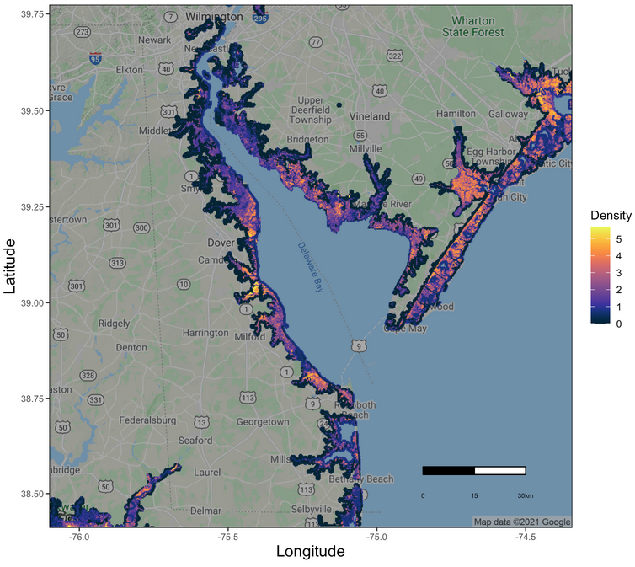

Figure 1. Predicted density of Saltmarsh Sparrow in Delaware Bay.

HURRICANE SANDY FUNDING

Grant Amount: $1,085,000
Goal: Several salt marsh restoration projects focused on marsh resiliency and Saltmarsh Sparrow
- Rum Pointe in Sinepuxent Bay, $40,000- install runnels in low and high marsh to facilitate tidal exchange and vegetation recovery
- Supawna Meadows NWR, $450,000 - beneficial reuse of channel dredge material to restore and/or recreate degraded and lost marsh elevation and breakwater refurbishment to improve tidal wetland hydrology
- Bombay Hook NWR, $465,000 - utilization of natural woody material-based wave attenuation mechanisms to trap sediment, rebuild marsh elevations, and improve resilience if onshore habitats
- DBEP and Edwin B. Forsythe NWR, $130,000 - Demonstrating the utility of low-tech, low-cost, and low disturbance salt marsh restoration techniques to protect and increase the resiliency of salt marsh habitat in the Mid-Atlantic.

