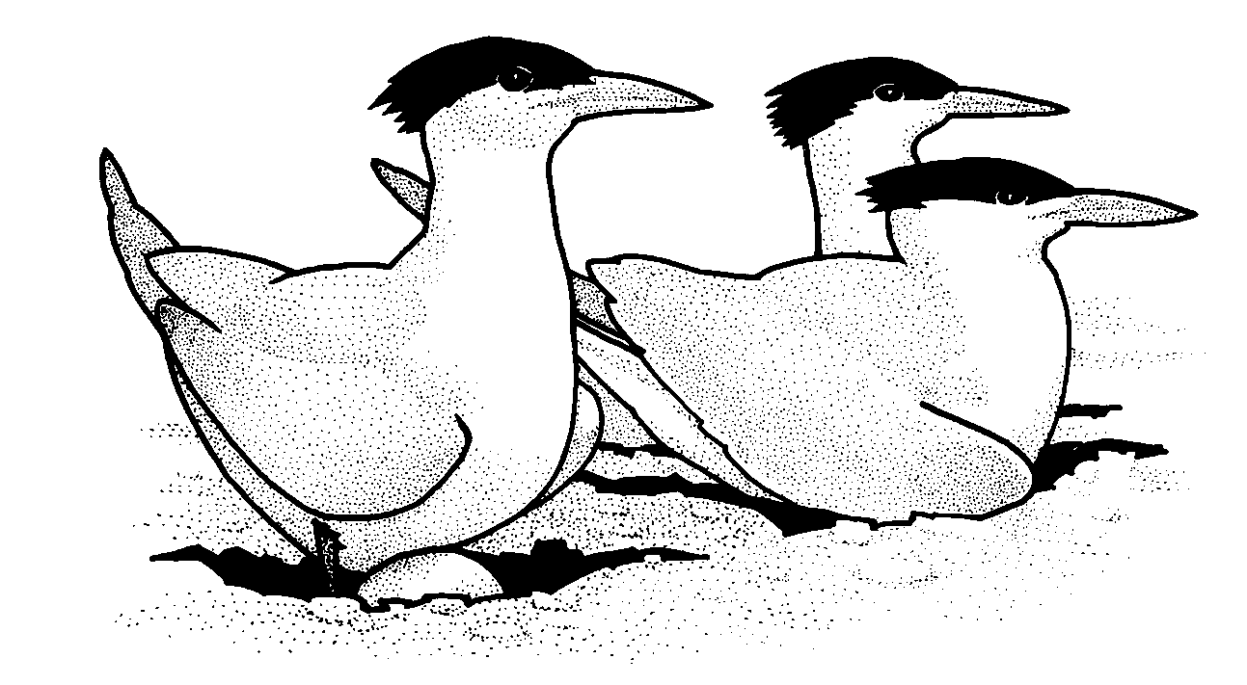
BIRD NESTING AREA

Please don’t disturb

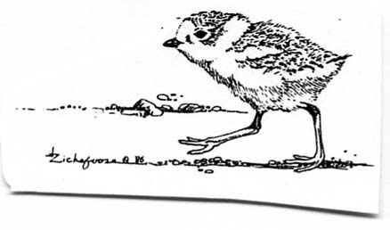

THANK YOU!

